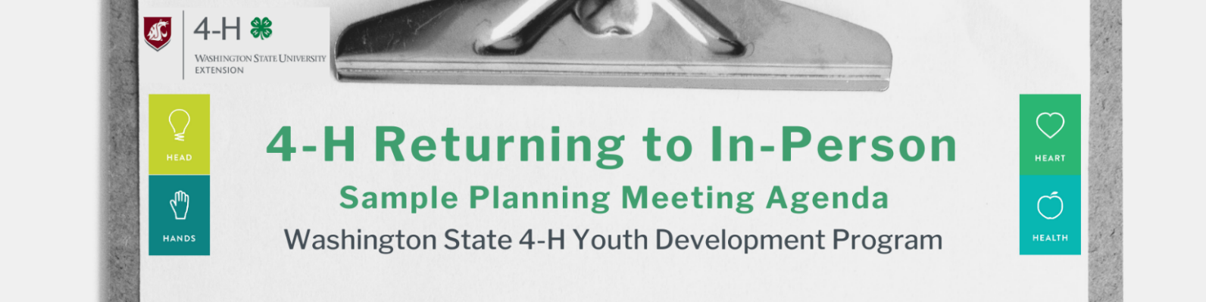
President – Call Meeting to Order
Secretary –
- Roll Call
- Meeting Minutes from _____________ Meeting
Treasurer –
- Treasurer’s Report
President –
Old Business:
  - –
New Business:
  - –
  - –
  - Meeting in Person
Excerpts from the Returning to Ch 5.1 In-Person Programming Checklist

Planning for Success
- Identify the goals of hosting the face-to-face meeting
- Review limits on number of people present. How many can be present at the same time in your county, based on its Safe Start phase?
- Will extra individuals (parents, siblings, etc.,) be able or allowed to remain at the gathering?
- Where will the gathering occur? Is there adequate space for physical distancing? (preferably outdoors; in phases <2 must be outdoors)
- Ensure adequate supply of prevention supplies inventory, signage, and their use/placement
- Discuss arrangements for participation and accessibility for all (some may choose to attend virtually)
- Discuss exposure possibilities and response following a possible exposure
- Review your communication plan to keep everyone updated on the meeting or activity
- Plan for absences of critical individuals (e.g. Who is back-up if leader gets a flat tire?)
- Ask members how they would like to be reminded of proper protocols (distancing, masks, etc.)

Club information to share with members/families before the first meeting
- Expectation of gathering with no more than 5 people outside your household per week (or 10 in phase 3), as of Nov. 2, 2020.
- Personal protective equipment (approved masks, etc.) and physical distancing requirements
- Temperature check expectations (Below 100.4 F and other health screening criteria)
- Collection of health screening forms (WSU Visitor Attestations)
- Inherent risk to participating
- Pick Up/Drop Off plans
- Who is dropping off and picking up
- Meeting/activity agenda
- Accommodations (alternative meeting style, needs, etc.)
- Responsibility to report to Health Department
- Contact information for reporting to Extension faculty/staff

President –
I will entertain a motion to close the meeting.

