Procedure for cell counting

- Hemocytometer is modified slide with 2 counting grids as shown.
- Clean the surface of the slide with 70% alcohol
- Taking care not to scratch the semi-silvered surface
- Clean the coverslip and wetting the edges very slightly
- Press it down over the grooves and semi-silvered counting area
- When the coverslip is in the correct position, the chamber has a depth of 0.1 mm
- Mix the trypsinized cell with fresh media (15-30 ml)
- Transfer the cell suspension to the edge of the hemocytometer chamber with a Pasteur pipette or micro pipette.
- The area of this central grid where squares are surrounded by triple lines
- The area of this grid is 1 mm² and therefore the volume is 0.1 mm³
- If all the cells in the central area are counted (N):
- N = the number of cells in 0.1 mm³
- Therefore, the number of cells in 1 cm² = N x 10⁴
- Select 10 x objective and focus on grid lines in chamber and count 4 corner square
- In this case : Number of cells/ml = [total number/4] x 10⁴
- Precaution when using the hemocytometer
  - Use only the correct coverslip
  - Ensure that the coverslip is in the right position
  - Whenever possible try to count a minimum of 200 cells, especially if the counts are low (i.e., count several 1 mm² areas)
  - Resuspend cells just before sampling as the method is prone to sampling error due to the settling. Count adherent cells as soon after trypsinization as possible since there is tendency to clamp.

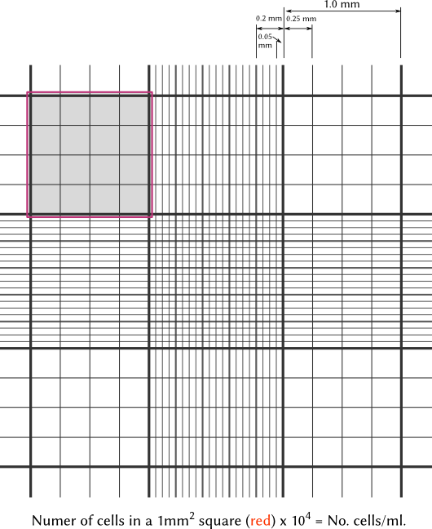
picture credit: http://microbiology.ucdavis.edu/privalsky/hemocytometer

