FALL SEMESTER 2017 - NEW STUDENT ORIENTATION SCHEDULE
AUGUST 4TH, 2017
8:30 a.m. – 4:30 p.m.
915 NORTH BROADWAY, EVERETT, WA
8:30a.m.- 9:00 a.m. ORIENTATION CHECK-IN, MAKE A NAME-TAG & REFRESHMENTS
Students arrive at 8:30pm

9:00 a.m. 9:20 a.m. ICEBREAKER

9:20 a.m. – 9:30 a.m. WSU NPSE FACULTY, STAFF, & STUDENT INTRODUCTIONS
9:30 a.m. – 9:40 a.m. WELCOME
Vice Chancellor, Lynne Varner
9:40 a.m. – 9:50 a.m. BREAK
9:50a.m.-11:00 a.m. LEARNING THE INS AND OUTS OF WSU NPSE: TALES FROM CURRENT
STUDENTS AND STAFF

11:00a.m.-11:40 a.m. FINANCIAL AID WORKSHOP

11:45 a.m. – 1:00 p.m. LUNCH & NETWORKING
1:00 p.m. – 1:30 p.m. ICEBREAKER: YOUR FAVORITE FIVE OF ANYTHING
1:30 p.m. – 2:30 p.m. STUDENT CLUBS/ORGANIZATION FAIR

2:30 p.m. – 4:00 p.m. ACADEMIC DEPARTMENT ADVISING SESSIONS
Mechanical Engineering
Data Analytics
Electrical & Software Engineering
Hospitality Business Management
Integrated Strategic Communication
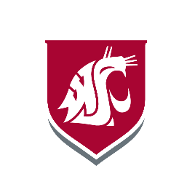

4:00 p.m. CAMPUS TOUR (OPTIONAL)
Lead: Student Ambassadors

