EconS 102: Mid Term 4
Date: July 27th, 2017

Instructions
- Write your name and WSU ID on the answer paper.
- Part 1 has 20 questions. Each question is worth 1 point. Answer all questions.
- Part 2 has 10 questions. Each question is worth 2 point. Answer all questions.
- Part 3 is extra credit. Each question is worth 3 points. If you get the question wrong you get NEGATIVE POINTS, i.e., -2 points. If you do not answer the question you will get 0.
- You have 70 minutes.
- This test is out of 40 points + 15 points extra credit.
- Write the answer you choose (A, B, C or D) on the answer sheet provided to you.
- You are allowed two A4 size paper as a cheat sheet. The contents must be HAND WRITTEN.
- You can use calculators. However, do not use your phone, iPads and other such devices as calculators.
- Good luck!!

Part 1 has 20 questions. Each question is worth 1 point. Answer all questions.

1. In terms of the production possibility frontier, inefficient use of available resources is shown by a(n):
A) increase in the labor force growth rate.
B) movement from one point to another along the production possibility frontier.
C) inward shift of the production possibility frontier due to the lack of opportunity.
D) point inside the production possibility frontier.
Answer: D) Inside the PPF, all resources are not being used

2. If the price of a commodity increases, you would expect its:
A) supply to increase.
B) quantity supplied to increase.
C) quantity supplied to decrease.
D) supply curve to shift to the right.
Answer: B) As price increases, “quantity supplied” (and not supply itself) increases as per law of supply.

3. The market price of airline flights increased recently. Some economists suggest that the price increased because jet fuel is much more expensive than before. They believe that in the market for flights:
A) supply increased.
B) supply decreased.
C) demand increased.
D) demand decreased.
Answer: B) They believed Jet fuel being expensive made supply shift inward (decrease). This would increase equilibrium price

4. Within the circular-flow diagram, the value of household income, the sum of wages, dividends, interest, and rent plus transfer payments equals the sum of:
A) the value of household tax payments.
B) consumer spending, private saving, and the value of household tax payments.
C) the money supply.
D) transfer payments and household tax payments.
Answer: B) Both are ways to calculate GDP, and are theoretically equivalent.

Use the following to answer question 5.

Table: Price and Output Data
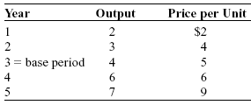

5. (Table: Price and Output Data) According to the Table: Price and Output Data, nominal GDP in year 5 is:
A) $1.29.
B) $16.
C) $45.
D) $63.
Answer: D) Nominal GDP has nothing to do with base years. It is simply 7*9=63.

Use the following to answer question 6.

Figure: The Minimum Wage

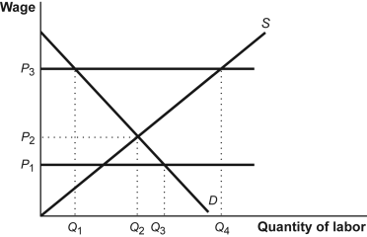

6. (Figure: The Minimum Wage) Look at the Figure: The Minimum Wage on the labor market. Which of the following is a binding minimum wage?
A) P₁.
B) P₂.
C) P₃.
D) 0.
Answer: C) For minimum wage to bind, it has to be above the equilibrium price.

7. Diminishing returns to physical capital suggests that:
A) when the amount of human capital per worker and the state of technology are fixed, successive increases in the amount of physical capital per worker lead to a smaller increase in productivity.
B) physical capital increases lead to drops in productivity when the amount of human capital per worker and the state of technology are fixed.
C) increases in technological progress lead to decreases in productivity.
D) physical capital must be increased less than human capital and technological progress for growth to occur.
Answer: A) This is the law of diminishing returns to capital. See slides.

8. When the government invests in building roads, ports, and a reliable power grid, the government is investing in a nation's:
A) private property.
B) human capital.
C) technological progress.
D) infrastructure.
Answer: D) These are all infrastructure

9. A liquid asset:
A) can be easily converted into a loan.
B) can be easily converted into cash with little or no loss of value.
C) are the only assets with which financial markets work.
D) carries no financial risk.
Answer: B) By definition

Use the following to answer question 10.

Figure: Consumption and Disposable Personal Income

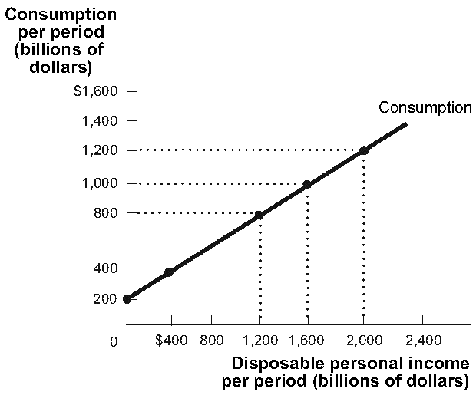

10. (Figure: Consumption and Disposable Personal Income) According to the Figure: Consumption and Disposable Personal Income, when disposable personal income is $2000 billion, consumption is _______ billion.
A) $400
B) $1000
C) $1200
D) $1600
Answer: C) The graph shows this clearly.

11. The aggregate expenditure line has a slope:
A) greater than 1.
B) less than 1.
C) equal to 1.
D) less than 0.
Answer: B) Because it is upward sloping but the tilt is less than 45 degrees.

12. Expansionary monetary policy leads to:
A) lower interest rates, an increase in planned investment spending, and an increase in equilibrium GDP.
B) lower interest rates, a decrease in planned investment spending, and an increase in equilibrium GDP.
C) higher interest rates, an increase in planned investment spending, and an increase in equilibrium GDP.
D) higher interest rates, a decrease in planned investment spending, and a decrease in equilibrium GDP.
Answer: A) Expansionary monetary policy simply increases supply of money, reducing interest, which in turn will mean people will borrow more to invest. This will increase GDP. In the long run money is neutral, meaning the interest and GDP will go back to its original position but out of these 4 options this is the most correct.

13. If the Federal Reserve conducts an open market purchase, holding everything else constant there will be:
A) an increase in the aggregate price level in the long run.
B) an increase in the aggregate output level in the long run.
C) a decrease in unemployment in the long run.
D) no effects on output, unemployment, or the price level in the long run.
Answer: A) In the long run, price level will go up. Since only money supply is changing and money is neutral.

14. All are regulations designed to prevent bank runs EXCEPT:
A) asset bubbles.
B) capital requirements.
C) reserve requirements.
D) provisions that allow banks to borrow from the Fed's discount window.
Answer: A) Asset bubbles are not a tool used for this.

15. If the United States exports $100 billion of goods and services and imports $150 billion of goods and services and there is no other factor income or transfers, the balance on the current account is:
A) $250 billion.
B) –$250 billion.
C) $50 billion.
D) –$50 billion.
Answer: D) Current account in this case is 100-150=-50.

16. A currency has depreciated when:
A) that currency buys fewer foreign goods than it did previously.
B) that currency buys more foreign goods than it did previously.
C) one unit of that currency buys more units of a foreign currency than it did previously.
D) domestic goods become more expensive to holders of that currency.
Answer: A) It is now weaker in the foreign market in terms of its ability to buy goods.

17. Countries that follow floating exchange rate regimes:
A) tend to insulate themselves from economic fluctuations in other countries.
B) give up the ability to use monetary policy as a stabilization tool.
C) find that they are more susceptible to economic fluctuations in other countries.
D) give up the ability to use fiscal policy as a stabilization tool.
Answer: A) They do this to protect themselves for fluctuations in other countries.

18. All factors determine investment spending EXCEPT:
A) expected future real GDP.
B) expectations about future disposable income.
C) the market interest rate.
D) production capacity.
Answer: B) Expectations about future disposable income affects demand, not investement.

19. The use of online banking would ________ the ________ cost of a high inflation rate.
A) increase; menu
B) decrease; shoe leather
C) increase; unit of account
D) decrease; unit of account
Answer: B) This makes it easier to access money as and when needed ,which reduce shoe leather costs.

20. All will increase the economy's potential output EXCEPT:
A) an increase in physical capital.
B) a decrease in the aggregate price level.
C) an increase in human capital.
D) technological innovation.
Answer: B) Decrease in aggregate price level will not do this.
Part 2 has 10 questions. Each question is worth 2 point. Answer all questions.

21. If during 2011, the country of Sildavia recorded a GDP of $65 billion, interest payments of $15 billion, imports of $13 billion, profits of $7 billion, exports of $15 billion, and rent of $7 billion, wages during 2011 in Sildavia were:
A) $36 billion.
B) $38 billion.
C) $51 billion.
D) $64 billion.
Answer: A) GDP = 65 billion. By factor payments method, GDP = interest + profits + rent + wages. We have all the others, hence we calculate wages as $36 billion.

22. A depreciation of the domestic currency below the exchange rate fixed by the government can be countered by all of these measures EXCEPT by:
A) decreasing capital flows out of the country.
B) limiting the domestic purchase of foreign financial assets.
C) decreasing capital flows into the country.
D) decreasing foreign exchange reserves.
Answer: C) Decreasing capital flowing into the country will reduce appreciation, not depreciation.

23. The inflation rate
A) is equal to the price level.
B) is the annual rate of increase in the price level.
C) is always increasing when the overall price level is increasing.
D) will be zero when prices are increasing at a constant rate.
Answer: B) By definition

24. If the MPS is 0.1, then the tax multiplier is:
A) exactly 0.1.
B) more than 10.
C) less than 10.
D) exactly 10.
Answer: C) This is a slightly tricky one. The key is tax multiplier. I did not teach you the formula for it (which is why I did not ask the specific value) but I did say tax is less effective than fiscal policy as far as the multiplier goes. The multiplier of G would be 10. There on tax it is less than 10.

25. Suppose that the United States and European Union are the only trading partners in the world. If the European Union imposes some import tariffs on U.S. goods, we would expect the:
A) supply of the euro to decrease, depreciating the euro.
B) demand for the dollar to decrease, depreciating the dollar.
C) demand for the dollar to increase, appreciating the dollar.
D) supply of the dollar to decrease, depreciating the dollar.
Answer: B) Now the EU would buy less US goods as they are more expensive. This would decease demand for the dollars. Inward shift of demand would reduce value of the dollar against the Euro, causing depreciation

Use the following to answer question 26.

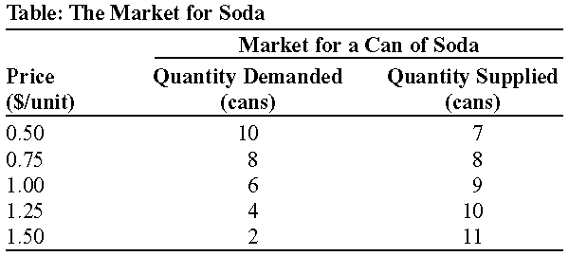

26. (Table: The Market for Soda) Look at the table The Market for Soda. If the government imposes a price ceiling of $1.00 per can of soda, the quantity of soda supplied will be:
A) 7 cans.
B) 8 cans.
C) 9 cans.
D) 10 cans.
Answer: B) At equilibrium level (demand = supply), price is less than the ceiling. Hence, it is non-binding. Supply will be 8

27. A shift away from taxing asset income and toward taxing consumption would lead to a:
A) larger demand for loanable funds, a higher interest rate, and slower economic growth.
B) larger supply of loanable funds, a lower interest rate, and faster economic growth.
C) larger government budget deficit and slower economic growth.
D) smaller supply of loanable funds, a higher interest rate, and faster economic growth.
Answer: B) It would mean people consume less since taxes are not on consumption. This increases supply of loanable funds, decreasing interest rate and making investment more favorable. Hence, the economy would grow faster.
Use the following to answer question 28.

Table: Balance Sheet
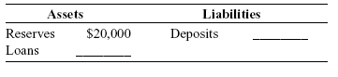

28. (Table: Balance Sheet) Refer to the information in the Table: Balance Sheet. If the reserve ratio is 25 percent and the bank is exactly meeting its reserve requirement and the bank is exactly meeting its reserve requirement, loans are:
A) $5000.
B) $15,000.
C) $60,000.
D) $80,000.
Answer: C) If the reserves are 20k, and the reserves are 25%, the total is 80k. The loans are then 60k.

29. Assuming that ice cream is a normal good, which statement could cause an increase in the demand for ice cream?
A) A decrease in incomes
B) A sudden spell of unexpectedly cold weather
C) An increase in the price of complements for ice cream, such as cherries and flavored toppings
D) An increase in the price of substitutes for ice cream, such as frozen yogurt
Answer: D) Since price of substitutes increase, demand for since cream will increase as it is relatively cheaper.

Use the following to answer question 30.

Figure: Aggregate Supply

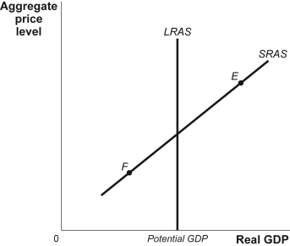

30. (Figure: Aggregate Supply) According to the Figure: Aggregate Supply, if the economy is at point E, which describes the likely adjustment process?
A) Nominal wages increase, and the short-run aggregate supply curve shifts left until actual and potential output are equal.
B) Nominal wages increase, and the short-run aggregate supply curve shifts right until potential output is greater than actual output.
C) Nominal wages decrease, and the short-run aggregate supply curve shifts right until actual and potential output are equal.
D) Nominal wages decrease, and the short-run aggregate supply curve shifts right until potential output is less than actual output.
Answer: A) Long run adjustment. This question is from a previous mid-term.
Part 3 is extra credit. Each question is worth 3 points. If you get the question wrong you get negative points, i.e., -2 points. If you do not answer the question you will get 0.

Use the following to answer question 31.

Figure: Short-Run Equilibrium

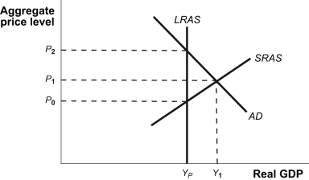

31. (Figure: Short-Run Equilibrium) The Figure: Short-Run Equilibrium shows the economy in short-run equilibrium. To move the economy to potential GDP, the government should reduce government spending by an amount equal to:
A) $(Y_{1} – Y_{P})$
B) $\frac{\left(Y_{1} – Y_{P}\right)}{(1 – MPC) }$
C) $\left(Y_{1} – Y_{P}\right)*MPC$
D) $\left(Y1 – Y_{P}\right)*(1 – MPC)$
Answer: D) To move it from Yp to Y1, The gov can spend a lesser amount than Yp-Y1 thatnks to the multiplier effect. Just spending $\left(Y1 – Y_{P}\right)*(1 – MPC)$ is enough. Since MPC is between 0 and 1, $\left(Y1 – Y_{P}\right)*\left(1 – MPC\right)<\left(Y1 – Y_{P}\right)*\left(1 – MPC\right)$. You can look at the multiplier formula to see exactly how this works.
Use the following to answer question 32.

Table: International Transactions
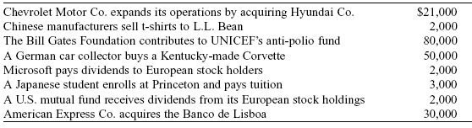

32. (Table: International Transactions) Refer to the information in the Table: International Transactions. What additional capital inflows are needed to equilibrate the balance of payments?
A) –$29,000
B) $20,000
C) $29,000
D) $80,000
Answer: D) Foreign expenditure: 21k + 2k + 80k + 2k + 30k = 135
Amount spent by foreign countries = 50k + 3k + 2k = 55k
Net = Exp by other countries – US exp = 135-55=80k.
Hence, 80k more is needed.

33. If Japanese buyers demand more U.S. dollars, then the dollar will:
A) appreciate, the yen will depreciate, the U.S. balance of payments on current account will rise, and the U.S. balance of payments on financial account will fall.
B) depreciate, the yen will appreciate, the U.S. balance of payments on current account will rise, and the U.S. balance of payments on financial account will fall.
C) appreciate, the yen will depreciate, and both the U.S. balance of payments on current account and the U.S. balance of payments on financial account will rise.
D) appreciate, the yen will depreciate, the U.S. balance of payments on current account will fall, and the U.S. balance of payments on financial account will rise.
Answer: D) Since Japanese demand more USD, USD appreciates. This reduces exports and increases imports, causing CA to drop, but an equivalent rise in FA.
Use the following to answer question 34.

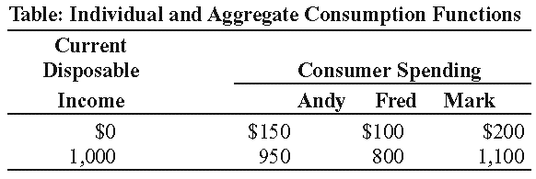

34. (Table: Individual and Aggregate Consumption Functions) According to the Table: Individual and Aggregate Consumption Functions, the marginal propensity to consume in the aggregate consumption function is:
A) 0.5.
B) 0.7.
C) 0.8.
D) 0.9.

Answer: C) Calculate each of their CPIs individually, then take the average. It is 0.8

35. In a labor market, the demand for labor is given by $W = 20 – \frac{1}{100}L$ and the supply of labor is given by $W = 4 +\frac{1}{100}L$ where $W$ is the wage rate, and $L$ is the number of workers. Suppose government decides to impose a minimum wage of $15 in this market. What effect will this minimum wage have on the market?
A) The wage will have no impact since it is below the equilibrium wage.
B) The wage will create a shortage of workers since it is above the equilibrium wage.
C) The wage will create surplus of workers since it is above the equilibrium wage.
D) The wage will result in increases in wages for workers who were employed at the equilibrium wage only.
Answer: C). At equilibrium, W is fixed. Equate the two equations. You will get a value for L. Now take any equation and resubstitute L, you will get W. Based on equilibrium W, you can get the answer. The equilibrium W is 12 and the answer is C, since 12 is less than 15.

Rough Work

