Standard Operating Procedure for working with pressurized gas cylinders
Created by: Yuzhan Li, 02/01/2016
OVERVIEW
This standard operating procedure describes how to work with pressurized gas cylinders.

SAFETY
Gas cylinders must be secured at all times to prevent tipping.
Restrain cylinders of all sizes, whether empty or full. Use straps, chains, or a suitable stand to prevent them from falling.
Emergency Protocols
Immediate danger
- If something happens and you think you, others, or the building is in immediate danger do not hesitate to call 911 and activate the building alarm while evacuating the building.
Emergency Contact Information

Dr. Michael Kessler – Principal Investigator
Office: 509-335-8654
Mitch Rock – Lab Manager
Cell: 515-520-1660
michaelr.kessler@wsu.edu
darman.rock@wsu.edu

PROCEDURE
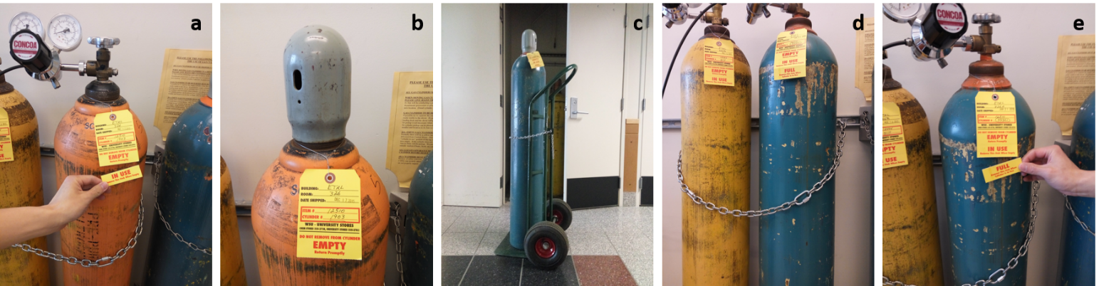
  - Remove the “IN USE” tag from empty gas cylinder.
  - Remove pressure regulator and put on safety lid.
  - Use wheeled cart to move empty cylinders to ETRL 326B and replace with new ones stored at ETRL 326A.
  - Move full cylinders to the place needed and secure using chains.
  - Remove the “FULL” tag before use .

