Instrument: Q400 TMA (ETRL 322)
Last updated 06/27/2014
Pre-test system checks:
1. Open valves and check gas level. Replace cylinders if they are empty or at low gas level.
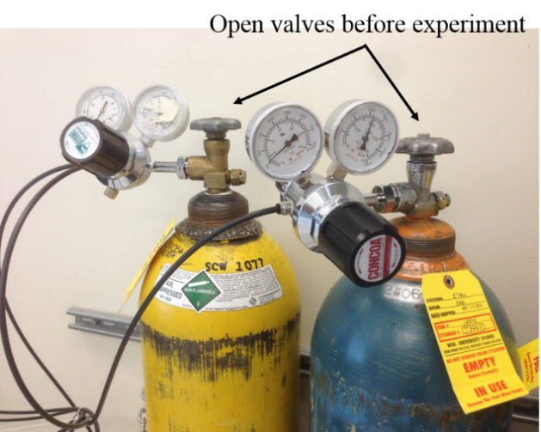
Purging gas cylinders. Left: Air (for cooling) Right: Nitrogen (cell purge)

2. Double click TA Instrument Explorer icon on the desktop. Then double click Q400-1216@Mfg-tma icon to open QSeries software. 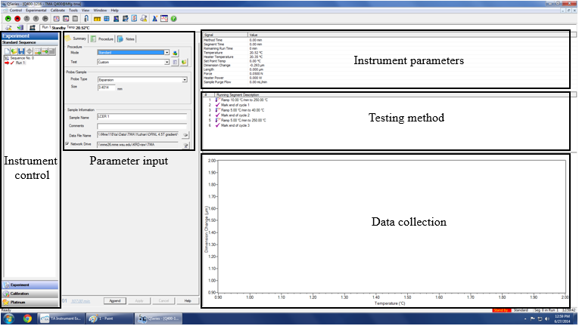

3. Check sample purge flow, should be around 50ml/min
Use touchscreen to control the instrument
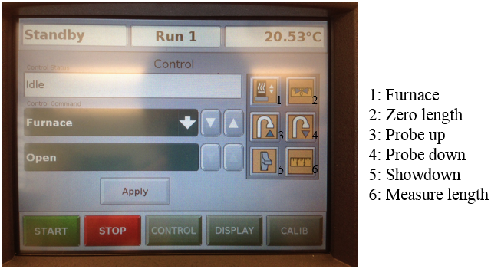
1. Press Furnace, then press Apply to open the furnace
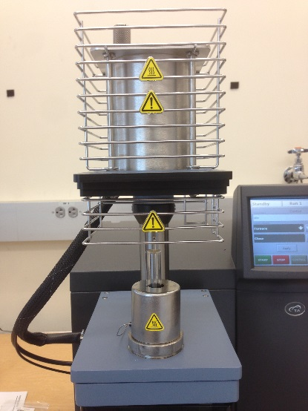
2. Press Zero length to setup a based line. Make sure the stage is clean.
3. Press Probe up and place sample on the stage
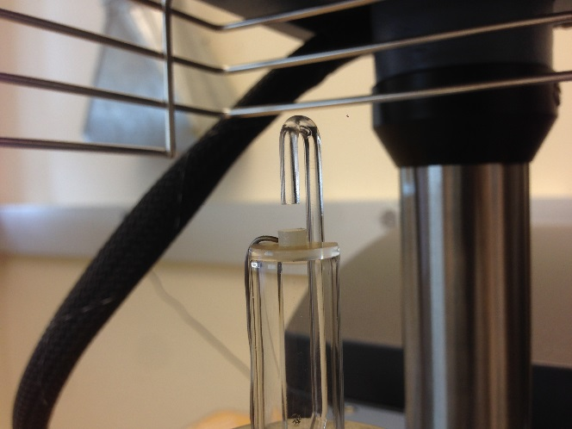
4. Press Probe down to lower the probe. Make sure the probe has a good contact with the sample then press Measure. The height of the sample should be displayed on the screen.
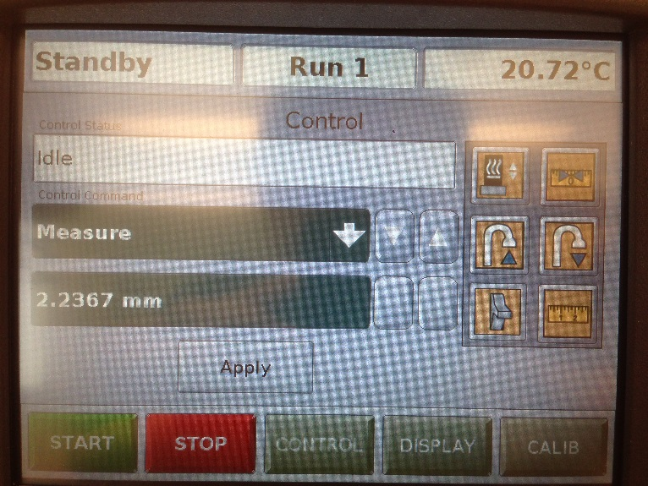

Software input
1. Under Summary tab, verify sample height information
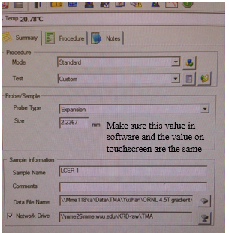
3. Update sample name and data file name.
4. Go to Procedure tab and define a running method.
5. Go to Notes tab and update operator information.
6. Click on the green arrow, , to start experiment.
Post-test
1. Press Probe up and remove sample.
2. Press Probe down to lower the probe.
3. Press Furnace to close the furnace.
4. Turn off gas (Note: Please make sure no one is using the purging gas for TGA or DSC)
