Glassware Cleaning Standard Operating Procedure

PPE: Safety Goggles, Gloves, Lab Coats

Purpose: To provide a clear explanation for proper cleaning of laboratory glassware.

Scope: Ground glass is commonly used in laboratories. Any abrasion reduces the strength of glass, making it more susceptible to breakage. Additionally, thermal shock may result from sudden changes in temperature. To avoid accidents, follow these tips for safely cleaning glassware.

General Precautions
- Careful handling and storage should be used to avoid damaging glassware.
- Inspect the glassware before each use and discard if scratched on inner surfaces, chipped, cracked or damaged in any way.
- Use only plastic core brushes that have soft non-abrasive bristles or soft, clean sponges/rags. Use brushes to clean inside of deep glassware.
- Do not reach inside of glassware while cleaning to prevent cuts should the glassware break.
- Rubber sink and counter mats can help reduce the chance of breakage and resultant injury.
- Do not overload sinks or soaking bins.
- Do not place metal or other hard objects, such as spatulas, glass stirring rods, or brushes with metal parts, inside the glassware. This will scratch the glass and cause eventual breakage and injury.
- Never use strong alkaline products and hydrofluoric acid as cleaning agents. These materials dissolve glass, leading to damage and eventual breakage.
- Do not use any abrasive cleansers, including soft cleansers (e.g., Ajax, Comet, Old Dutch, Soft Scrub, etc.), as these will scratch the glass and cause eventual breakage and possible injury. Scotch Brite and similar scouring pads will scratch glass and should not be used.
- Do not use heat as a method to remove carbon residues. Heating glassware to temperatures > 800 °F will cause permanent stresses in the glass and eventual breakage.
- Use proper drying racks for fully cleaned glassware.
- Tongs, a dust pan, and a broom are the best tools for cleaning up broken glass. If hands are used to pick up glass, only handle large pieces of glass and wear heavy leather gloves to protect the hands. Broken glass must be packaged in labeled, rigid, and sealed containers before disposal.
- Proper instruction should be provided in the use of glass equipment designed for specialized tasks, which can represent unusual risks for the first-time user.

Types of Cleaning
- Cleaning glassware before a chemical reaction is started.
  - Involves inspection of glassware and cleaning any inadvertent contamination.
  - Proceed to Cleaning Type 1 in the SOP for further instructions.
- Cleaning glassware after a chemical reaction is complete.
  - Involves neutralization and disposal of unwanted byproducts.
    - Proper understanding of Organic Waste Disposal SOP.
    - Proper understanding of Acidic and Basic Solution Neutralization SOP.
  - Proceed to Cleaning Type 2 in this SOP for further instructions.
- Stubborn chemical residues and films
  - Verify Cleaning Type 1 or 2 does not work.
  - Cleaning specs for metallic or organics that are not easily removed.
  - Proceed to Cleaning Type 3 in this SOP for further instructions.

Cleaning Type 1: Before Reactions

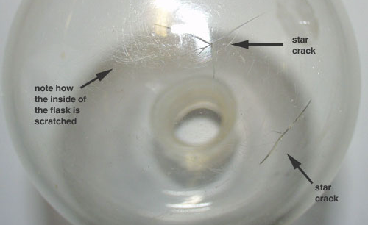
Purpose: By inspecting glassware and cleaning any inadvertent contaminations, a safer and more confident reaction can be run.

Pre-Equipment Check
- Inspect glassware for damage:
  - Scratches on inner surfaces
  - Chips, dings, holes, star cracks, or anything compromising the integrity of the glassware.
Discard if defects are found

Note: Standard taper glassware, especially the round bottom flask, is susceptible to star cracks.

Proper Cleaning Procedure - Should only require gentle cleaning
- Inspect for residue
  - Water spots – Left from common tap water or dried condensation
    - Distilled or deionized water will remove these
  - Chemical deposits – missed from cleaning after reaction
- For Chemical residue removal
  - Use a detergent solution designed for lab glassware.
  - Soak dirty glassware in a basin of warm lab detergent.
  - Scrub with a good soft brush until removed.
  - Rinse thoroughly with tap water and then with distilled or deionized water.
- Place on drying rack to air dry

Note: Stubborn residues may require a solvent cleaner or a base bath soaking to clean. See Cleaning Type 2 in this SOP for specifics on these instructions.

Cleaning Type 2: After Reactions

Purpose: To properly clean contaminated glassware after a reaction is finished. Proper steps for cleaning the glass in the most effective way can be utilized by cleaning after the reaction is finished because the chemical residues are known.

Proper Cleaning Procedure
- Dispose of the byproduct excess
  - Proper understanding of Organic Waste Disposal SOP.
  - Proper understanding of Acidic and Basic Solution Neutralization SOP.
- Water soluble solutions
  - (e.g., sodium chloride or sucrose solutions)
  - Rinse with tap water and distilled water.
- Water insoluble solutions
  - (e.g., solutions in hexane or chloroform)
  - Rinse with ethanol or acetone
  - Then rinse with distilled water.
- Vacuum greased joints
  - Dissolve by rinsing joints with hexanes.
  - Visually confirm greased joint is clean by observing that the joint has an even frosty look to it before any necessary base bath cleaning.
- Place on drying rack to air dry

Cleaning Type 3: Stubborn Chemical Residues

Purpose: To properly clean contaminated glassware from stubborn chemical films and residues that Cleaning Type 1 and 2 are incapable of properly removing.

General Precautions
- Baths are quite hazardous to unprotected skin and especially eyes.
  - Always use eye protection, and thick black gloves when manipulating glassware around the baths.
- Only glassware should go in the baths, AND, only if glassware is completely glass.
  - No ceramic/glass funnels or things of the like.
- Rinse gloves after use to prevent spreading solution all over your work area.
- Base bath can severely damage glass; do not leave soaking any longer than necessary.
- Always separate glass joints before soaking.
  - A base bath can actually chemically bond them together permanently.
- Organic solvent need to be disposed in special waste containers if it is used.

Proper Cleaning Procedure
- Contaminant is a metal-containing compound (use Acid Bath)
  - Immerse glassware in concentrated HCl or H₂SO₄ till apparent solid has dissolved under the fume hood.
    - Note 1: Always put acid into water!
    - Note 2: Always neutralize solution before moving to the next step.
  - Rinse with plenty of tap water. (At least 5 times, thoroughly)
  - Final rinse with distilled water or deionized water. (At least 5 times, thoroughly)
- Contaminant is organic (use BASE Bath)
  - Soak glassware in a saturated solution of sodium hydroxide or potassium hydroxide in ethanol or isopropanol (BASE Bath).
  - Rinse with plenty of tap water.
  - Final rinse with distilled water or deionized water.
  - *No NMR tube is allowed to wash in base bath. Base can make the tube wall thinner, and such tubes have more potential to shatter.
- Place on drying rack to air dry
Base Bath Solution
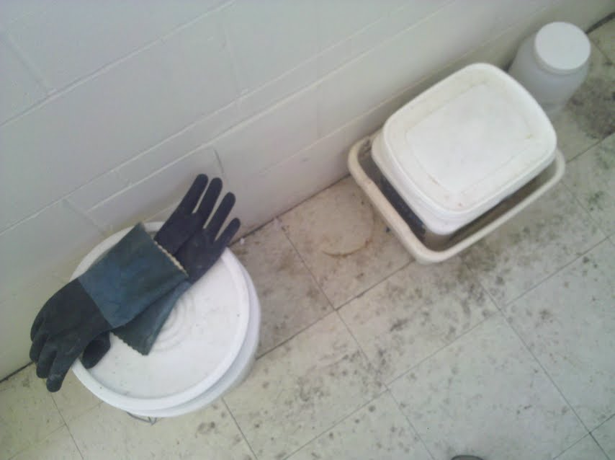
Heavy Duty Gloves

BASE Bath Solution
- Get a large plastic container (~5 gallon)
- Add approximately 200-300g of solid KOH pellets (or NaOH)
- Add 4 L of ethanol (or isopropyl alcohol)
- Carefully add 1L of deionized water
- Leave the plastic container in secondary contain (i.e. sink) until KOH is dissolved and it has cooled back to room temperature before storing
- Replace cover to plastic container.
- Label container with current date and a sign that says:
  - “DANGER: BASE-BATH SOLUTION, HIGHLY CAUSTIC!”

