Instrument: Discovery DSC (ETRL 322)
Last updated 08/20/2014
Pre-test system checks:
1. Open valves and check gas level. Replace cylinders if they are empty or at low gas level.
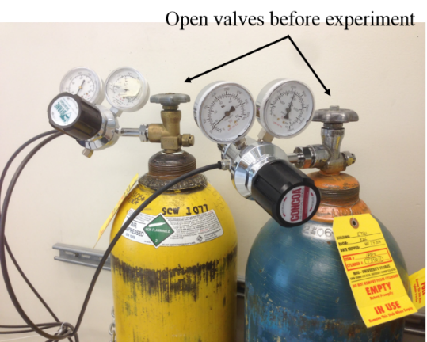
Purging gas cylinders. Left: Air; Right: Nitrogen.

2. Double click TRIOS icon on the desktop. Then double click Discovery DSC @lab icon to open TA software. 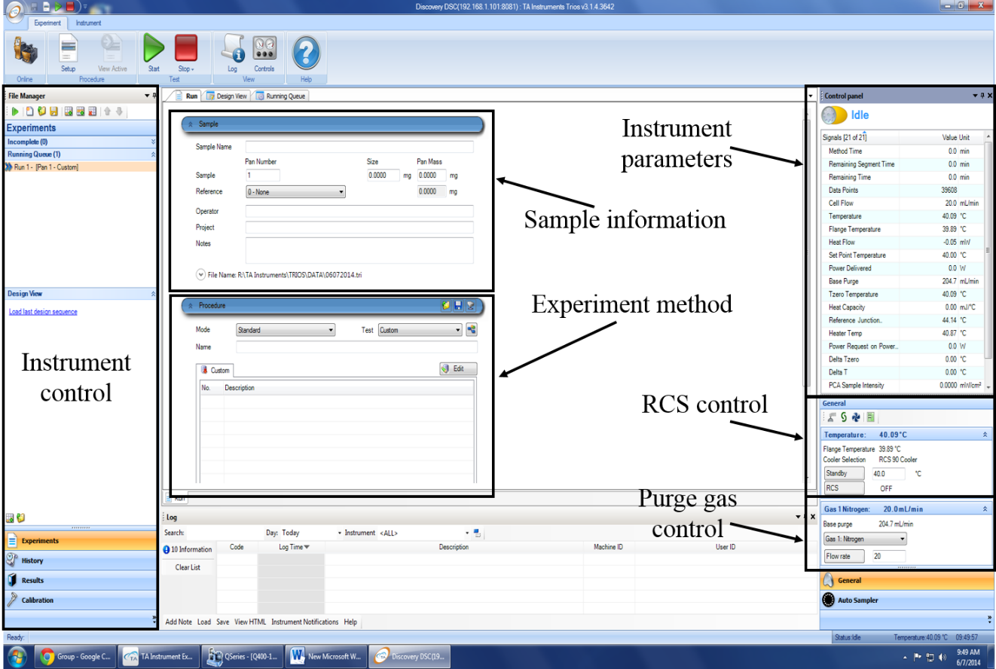
TA TRIOS software
3. Check instrument parameters
a. Cell flow (50ml/min)
b. Temperature (40°C)
c. Base purge (300ml/min)
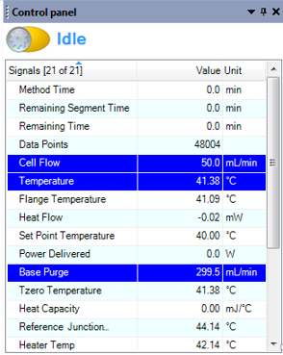
4. Turn on RCS cooler by clicking RCS button. When the Flange Temperature decreases to about -80°C, the instrument is ready for experiment.
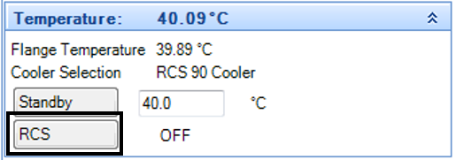
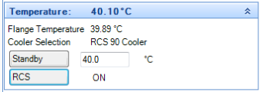
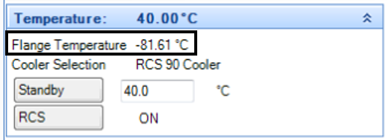
Sample preparation
1. Types of pan and lid
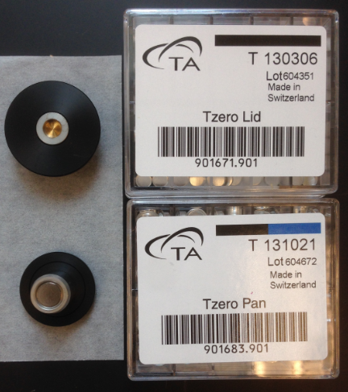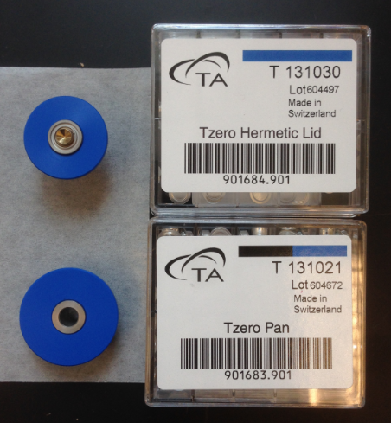
Left: Tzero Aluminum set
Right: Tzero Hermetic Aluminum set

Tzero Aluminum set is an excellent choice of the majority of applications where elimination of volatiles is not an issue.
Tzero Aluminum Hermetic set is recommended for applications whenever volatiles generated by the sample during the experiment interfere with the transitions of interest.

2. Determining sample size
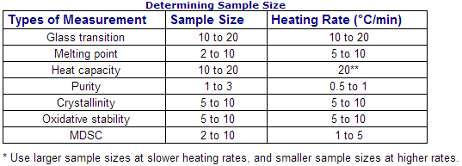

3. Using press to prepare a reference (empty pan) and record mass.
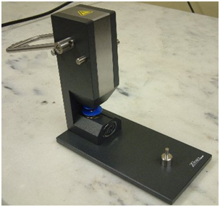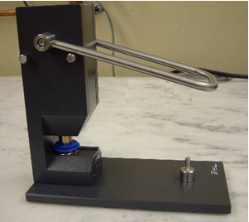
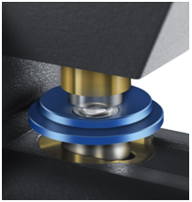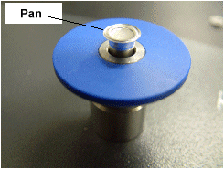
Select the desired sample pan and matching lid and obtain the matching die set. Weigh the empty pan and lid. Place the pan in the lower die and position the matching lid in place. Place the lower die into the press. Rotate the die slightly to ensure that it is seated properly. Pull the handle forward slowly until it stops to seal the lid to the pan. Move the handle back and remove the sealed pan.
4. Prepare solid sample: cut sample to fit Tzero pan, lay sample flat on bottom of the pan, cover with Tzero lid, clamp closed using black die. Record mass
5. Prepare liquid sample: deposit one drop of liquid in bottom of Tzero pan, cover with Tzero Hermetic Lid, clamp closed using blue die. Record mass (Note: this also can be used for solid samples)
6. Sample loading: use tweezers to place reference and sample pans in the autosampler tray. (5 reference positions, 50 sample positions)
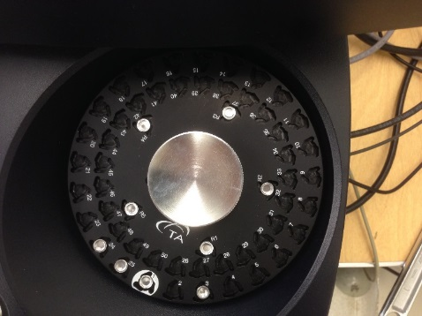
Software input
1. Sample information
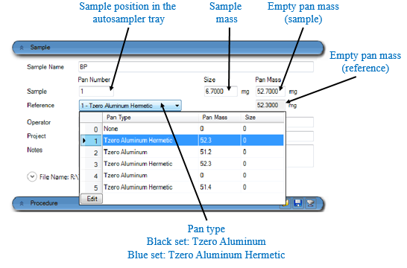
2. Experiment method
a. choose Mode (Standard, Clibration, Modulated)
b. choose default Test method or use Custom
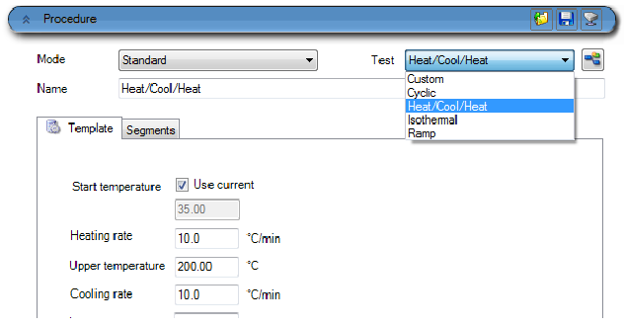
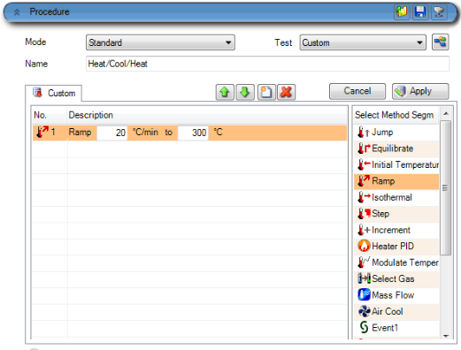
3. Start experiment
Double check system parameters (base purge, cell purge, cell temperature, flange temperature, sample information, method information.) Press green button to start the experiment.
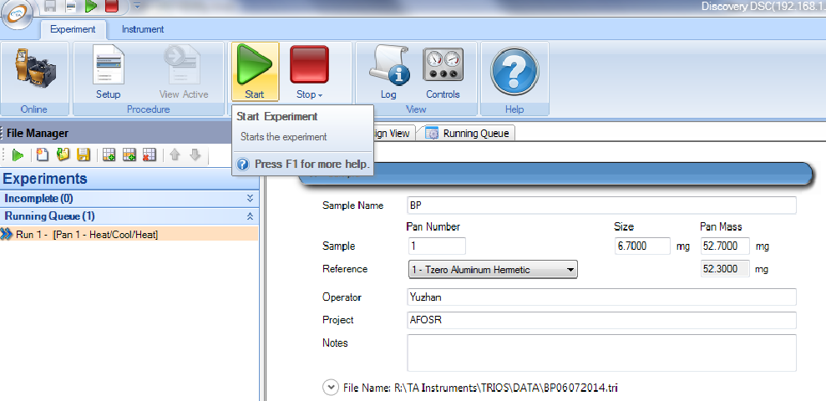

After the start button is pressed, autosampler arm starts to place sample pan and reference pan to the DSC cell.
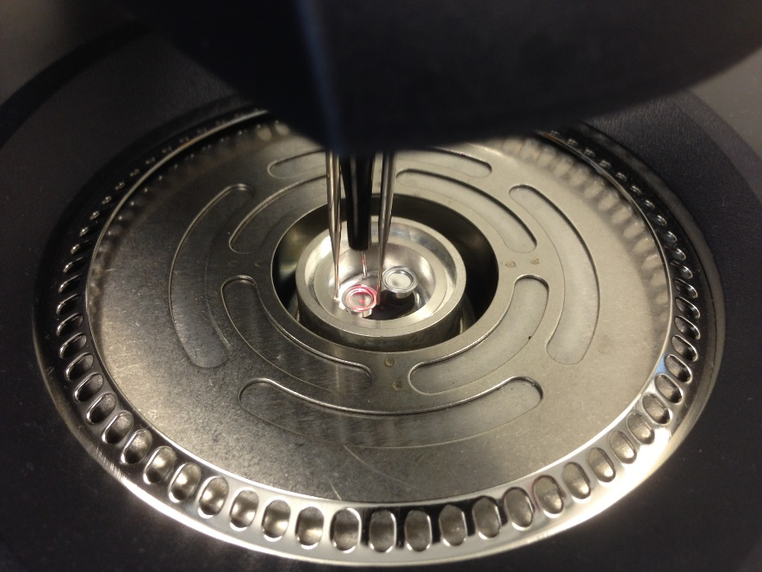

Real time data will be displayed in the TRIOS software.
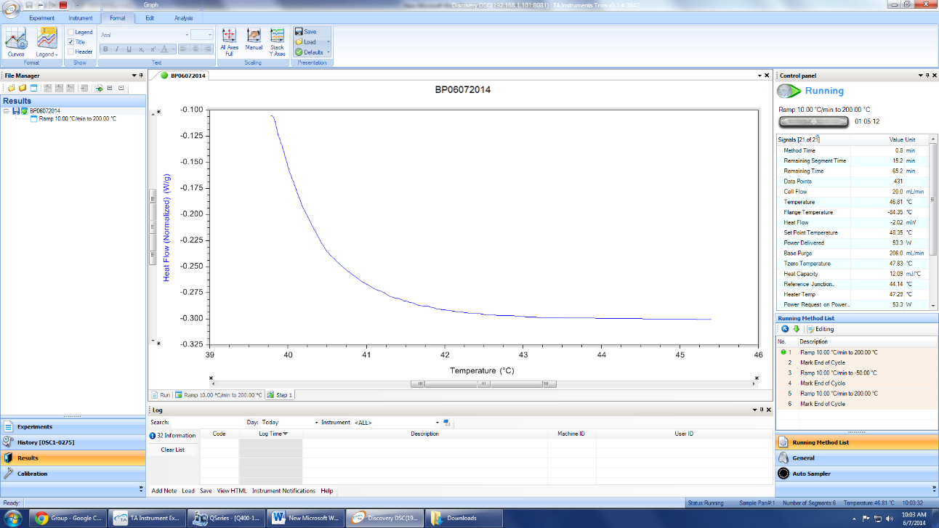

Post-test
1. Check the autosampler tray, make sure the experiment is finished and both sample pan and reference pan are transferred from DSC cell to the autosampler tray.
2. Press RCS button to turn off the cooler.
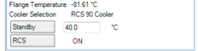
3. Wait until the flange temperature goes back to standby temperature (40°C)
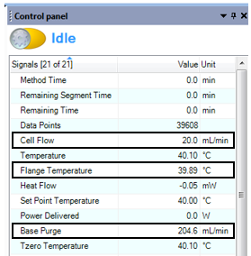
4. Turn off gas (Note: Please make sure no one is using the purging gas for TGA or TMA)
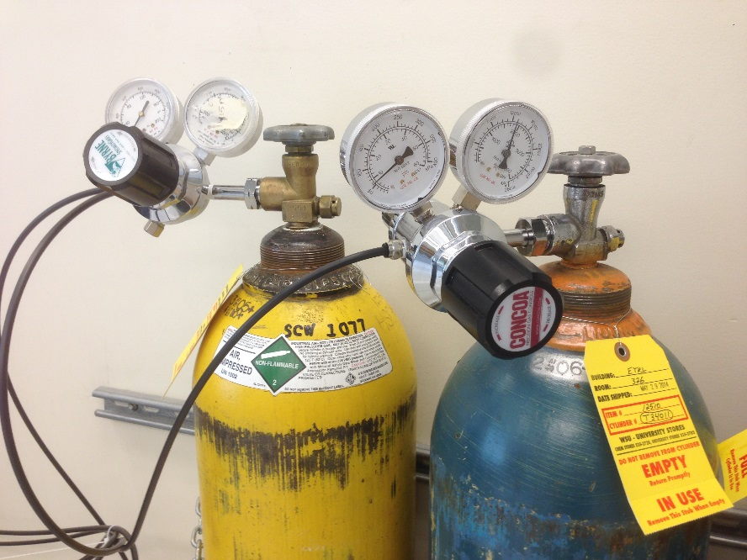

References
Trios online help for the Discovery DSC.

