
File
Review Procedures
For 2021-2022

Last Updated: May 2021
Table of Contents
What is File Review? 5
What are the Basics? 5
What websites do I use? 5
Basic Information for V1 Verification 6
The Basics 6
What are we verifying? 6
COVID-19 Updates 7
EA April 3, 2020 7
EA August 21, 2020 7
Letter 3538 7
V1 Verification Processes (Forms 23, 24, 25, 28, and 29) 8
Dependent Student: 24, 25, and 28 Forms and Independent Student: 23 and 29 Forms 8
V4 Verifications (Forms BN and SI) 18
Form BN 18
Form SI PLEASE SEE COVID-19 UPDATES FOR NEW INFORMATION! 20
V5 Verification (Forms 23, 24, 25, 28, and 29) 21
Forms 26 and 27 - Student and Parent Amended Tax Returns 22
Form 05 – Visa Status Verification 24
Steps to process 24
Does Not Match 24
Does Match 26
Pending Status 28
Eligible Status 28
Non-Eligible Status 29
Form 1D – Drug Conviction Form 30
Steps to Process 30
Form 43 – Previous Degree 31
Steps to Process 32
Currently have or will have my first bachelor’s degree before the beginning of fall term. 32
I will NOT have my first Bachelor’s degree and I will not be enrolled in a graduate program before the beginning of fall term. 32
Form 68 – Veteran Status Clarification 36
Steps to process 36
Form AW – Parent Asset Verification 38
Steps to Process 38
Form AX – Student Asset Verification 39
Steps to Process 39
Form DC – Dependency Update/Homeless Verification 40
Steps to Process 40
Form IL – Graduate or Professional Status Verification 41
First Bachelor’s Degree 41
Second Bachelor’s Degree 41
Masters/Graduate/Vet Med/Pharmacy/Medicine Degree 42
Form IN – Independence Verification 43
Steps to Process 43
Made a Mistake 43
Foster Care, a Dependent/Ward of the Court, or Their Parents Passed Away 43
Emancipated Minor 44
Legal Guardian 44
Form LD – Legal Dependent Verification 45
Steps to Process 45
I made a mistake 45
I do support a legal dependent 45
Form LS – Social Security Match 47
Steps to Process 47
Form MM – NSLDS Mismatch 49
Form NZ – Citizenship and Date of Birth Verification 51
Steps to process 51
Form QE – Questionable Enrollment 52
Steps to Process 52
359 Code 52
360 Code 52
Form UA – Selective Service Match 55
Male, U.S. citizen/eligible non-citizen, born after 12/31/60, 18, but not yet 26 55
Male, U.S. citizen/eligible non-citizen, born after 12/31/60, never registered 55
Female 56
Transgendered Students 57
Armed Services on Active Duty 58
Not 18 years old, born before 1960, or resident of Federated States of Micronesia/Marshall Islands/Palau 58
Male, released from active duty before turning 26 59
Non-US citizen who entered US after turning 26 59
Quality Control (Internal) Queries and Processes 61
Student 1040 Compare Query 61
Assistant Director Reporting on V4 and V5 61
BE Initiated and Verification Pending Query 62
98’s with Comments 63
FA_QE’s – NSLDS box has not been checked 63
ISIR Suspense Reason Code 2 65
ISIR Suspense Reason Code D 67
Form Submission Counts 67
Audit: Correct Checklist Nomenclature Review for Doc Review Staff 68
Packaged/Verification Not Completed 68
CYE Checklist Clean Up and Review 69
Contact Information 69

What is File Review?
File review is the act of completing verification. You may have to make changes to a student’s ISIR and send out corrections to the Dept of Education.

What are the Basics?
If you are uncertain of the basics of file review, we HIGHLY recommend double-checking the Document Review Procedures. File review is the next step after document review. You should not be doing file review until you have a strong foundation of document review. These procedures will NOT go over all of the basics of document review. This is specifically for file review.

What websites do I use?
My.WSU (https://login.wsu.edu/)
Imaging (https://webcenter.it.wsu.edu/imaging/faces/Authentication/Login.jspx)
NSLDS (https://sa.ed.gov/cas/CASWeb/pages/Authentication.faces)
Selective Services (https://www.sss.gov/Registration/Check-a-Registration/Verification-Form)
Dept of Homeland Security SAVED System (https://save.uscis.gov/web/vislogin.aspx?JS=YES)
You will also need a copy of the applicable year’s Pub 17 and the Tax Transcript Decoder. Both of these can be found under the aid year’s verification procedures section on SFS411.wsu.edu.

Basic Information for V1 Verification

The Basics
Remember, V1 verification is for students that were federally selected for verification for student income, household size, and parent income (if dependent). Before proceeding with V1 File Review, confirm that the student is actually V1 selected. Go to My.WSU, Financial Aid, Federal Application Data, Correct 20XX-XX ISIR Records. On the 4th tab (EFC\DB Matches\Corr), under the Database Matches\Flags, on the left-hand column, you will see , if they were V1 selected. If they were not V1 selected, but have the income/household checklists, then they were institutionally selected.

What are we verifying?
With V1 verification, we are double checking information the student provided on the FAFSA regarding*:
Information to be verified | Document where this information is located
Adjusted Gross Income | IRS Data Retrieval Tool, Tax Return, Tax Return Transcript, or Tax Extension (Form 4868).
U.S. Income Tax Paid | IRS Data Retrieval Tool, Tax Return, Tax Return Transcript, or Tax Extension (Form 4868).
Untaxed Portions of IRA Distributions | Tax Return or Tax Return Transcript
Untaxed Portions of Pensions | Tax Return or Tax Return Transcript
IRA Deductions and Payments | Tax Return or Tax Return Transcript
Tax-Exempt Interest Income | Tax Return or Tax Return Transcript
Education Credits | Tax Return or Tax Return Transcript
Household Size | Parent Household Form (28) or Student Household Form (29)
Number in College | Parent Household Form (28) or Student Household Form (29)
Income Earned from Work (Non-Filers) | W-2
*Please refer to page 3 of the tax transcript decoder (of the applicable tax year) for exact line items. The decoder lists both the tax return line items of where to find info as well as the tax transcript. The decoder is updated every year and is the most comprehensive and accurate information.

If we have conflicting information that we are trying to clear, we may request a copy of any of the additional documentation:
W-2 Income Statement | Marriage Certificate
Birth Certificate | Social Security Card
Legal Guardianship/Emancipated Minor Form | Legal Guardianship Paperwork
Legal Emancipated Minor Paperwork | Ward of Court or Foster Care Paperwork
Homelessness or At-Risk for Homelessness Paperwork | Veteran DD214 Paperwork
1099/1040 Tax Return to verify IRA/Pension Rollover | Asset Information Worksheet

COVID-19 Updates
Because of the COVID-19 Outbreak, the Department has relaxed some guidance regarding verification.

EA April 3, 2020
Per the Electronic Announcement from April 3, 2020, the following verification requirements have been affected:
05- Visa Status Verification
NZ – Citizenship and Date of Birth Verification
SI – Statement of Educational Purpose
The requirement for having either a signature from WSU SFS or a Notary has been temporarily relaxed. At this time, we do NOT need to have these – we can accept the first part of the form (where the student completes it) and their appropriate photo identification. We are ALSO allowed to accept expired documentation that would normally need to be unexpired, IF it expired after March 1, 2020.

EA August 21, 2020
Per the Electronic Announcement from August 21, 2020, the above guidance now applies through the end of the payment period that includes December 31, 2020 or the end of the payment period that includes the end date for the federally declared qualifying emergency related to COVID-19, whichever occurs later.
Update from November 20, 2020: we just got notification that the EA from August 21, 2020 is now applied towards the 2021-2022 academic year.

Letter 3538
We have come across a new hurdle due to Stimulus Checks during the 2020 year. The hurdle is someone can order an IRS transcript or use the DRT and it only shows $1 AGI. There are 3 different scenarios that can occur, according to AskRegs KA-34988.
Scenario 1 – Tax Filers // If someone used the Data Retrieval Tool and it was “Transferred, Not Changed” and it shows all 0s and an AGI of $1, we could accept the signed 2019 tax return to make the corrections.
Scenario 2 – Nontax Filers // If we have a tax transcript from someone trying to order the IRS Letter of Non-Filing, and it shows an AGI of $1. They will need to contact IRS Customer Service at 1-800-829-1040 and explain that they used the Non-Filers: Enter Payment Info Here Tool, are unable to obtain a LONF, and request IRS Letter 3538.
Scenario 3 – Tax Filers Who Filed a Tax Return Solely to Claim the Recovery Rebate Credit // If we have a tax transcript showing $1 of interest income, $1 of total income, and a $1 AGI, then they truly did file taxes and should be reported as tax filers on the FAFSA. They should be verified as any other tax filer would be, in accordance with the Federal Register containing the verification documentation requirements for the applicable award year.

V1 Verification Processes (Forms 23, 24, 25, 28, and 29)

Dependent Student: 24, 25, and 28 Forms and Independent Student: 23 and 29 Forms
In this section, you will need to verify that if the student indicated on the FAFSA that their parent is married/remarried, we have both parents listed on the Household Form; if the student indicated on the FAFSA their parents are divorced/separated, we only have one on the Household Form. The best way to do this first, is to check the “Parent” tab on the “Correct 20XX-20XX ISIR Pages” to see what marital status they put for the parent. If the marital information doesn’t match the Parent Household form, and we do not have clarification, you may need to have the student make a FAFSA correction. We cannot update marital status.
ProVerify Update: Because we now have ProVerify working, this process orders the IRS Record of Account Transcript. We do not have guidance on reading this transcript, but please see the section in Forms 26 and 27 (Student and Parent Amended Tax Returns) to review guidance we received from ProEd.
COVID-19 Update: Because the IRS was closed and people were having issues receiving the IRS Letter of Non-Filing, we have allowed people to upload a Word document (and W-2s, if applicable) in lieu of IRS Letter of Non-Filing. We also have Forms SN and PN (Student and Parent Non-Filing Letters). These are all methods that can be used for the IRS Letter of Non-Filing.
COVID-19 UPDATE: Please see Letter 3538 for more information on if DRT or IRS Tax Transcript have an AGI of $1.
Electronic signature update: We now have guidance from ED that we can accept electronic signatures on tax returns.
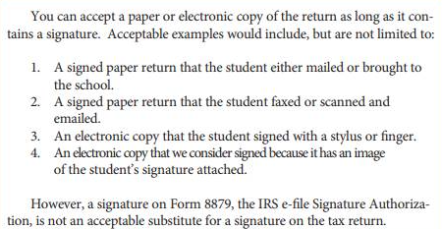
Once you have verified that parent marital status is matches for both FAFSA and Parent Household form, you can go ahead and get started on completing this section of verification.
- You will need to have two screens open: One for Imaging to see the verification forms submitted by the student and myWSU on the other.
- In myWSU, you will need to go to Manage Verification Pages (Financial Aid>Verification>Manage 20XX-20XX Verification
- On the first screen, you will be able to see if the student/parent used the IRS Data Retrieval Tool:
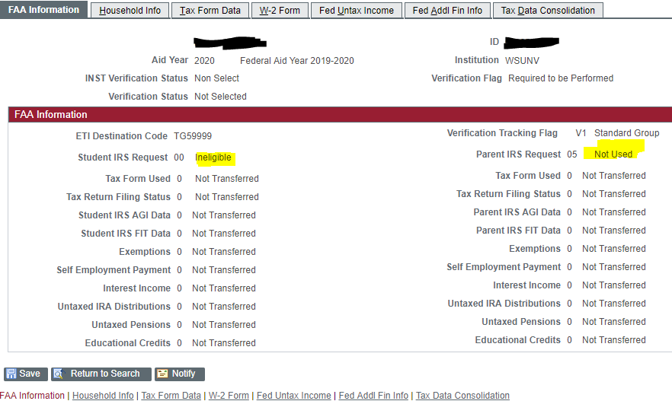
In the above example, we can see the student was ineligible to use the IRS Data Retrieval Tool, and the parent did not use it.
- Click on the Household Info Tab> Get Fed Data Button> View All
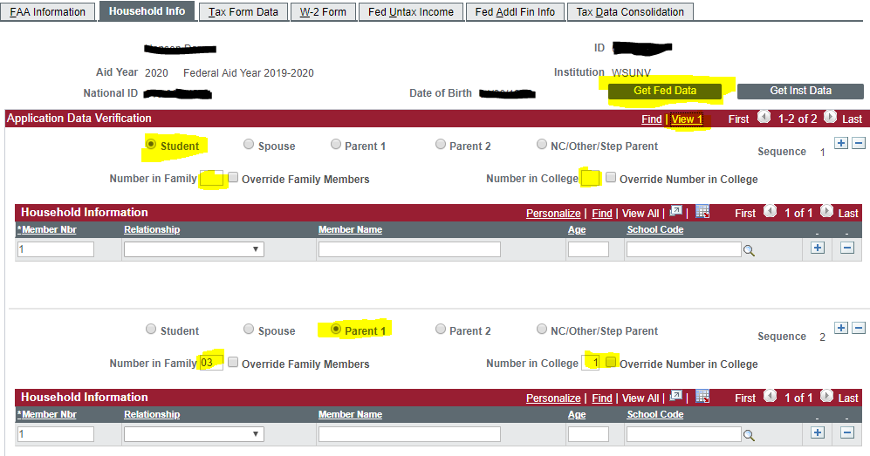
In the above example, we can see that in the “Student section” there is no number in family or number in college. This is because this is a dependent student, so those numbers are listed under the “Parent section.” If the student was Independent, the numbers would be in the “Student section” and would be blank in the “Parent section.” Remember, we do not count siblings in US Military Academies OR Foster Youth in Household size. Also, Running Start students do NOT count as being enrolled in college.
- Look at the Parent Household form, and make any changes if needed. Make note of these changes.
- Click on the “Tax Form Data” Tab.
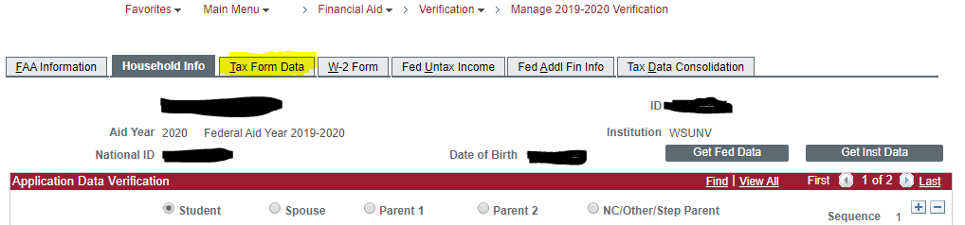
In the student income forms (23/24), you will need to make sure you have all of the pertinent information based on what the student indicated for their filing status. Example: For a DEP student, if they worked, but didn’t file taxes, we need all W-2s in addition to the completed form. For an IND student, we need W2’s (if they worked and didn’t file) plus or the IRS letter of non-filing. IND students have to supply the letter of non-filing (or approved alternative), but DEP do not.
In the parent income form (25), you will need to make sure you have all of the pertinent information based on what the student indicated for their filing status. Example: Signed tax returns for parent(s), or IRS Letter of Non-Filing (or approved alternative) and the Income/Expense Worksheet for parents who didn’t work or file taxes. Additionally, and W2’s or 1099 if parent did work but didn’t make enough to file.
- Please review EVERY line item for accuracy.
  - For example, if a student DID work, but DIDN’T file taxes, you would make sure the tax return filed says “will not file”, but that the wages are reflected in the “wages” area. Be careful, because adding wages here will populate the AGI field automatically fill. Remove the data if the student didn’t file taxes. (AGI only needs to be filled if taxes were filed).
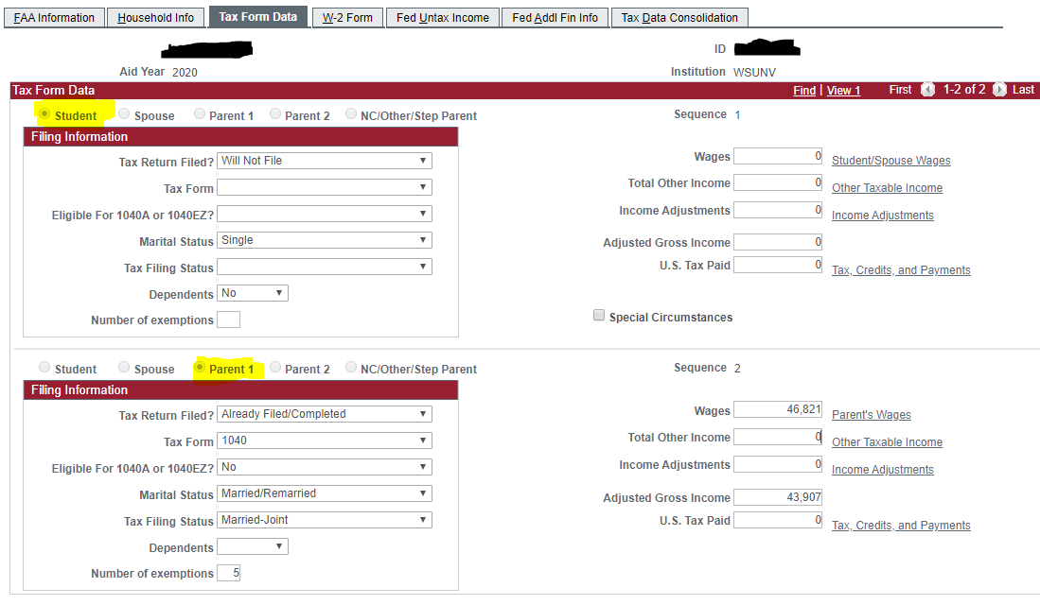
- We can see the student section is listed up top and the parent section is listed below. You will need to use the applicable year’s Tax Transcript Decoder to complete this section of the verification process.
  - Because the student didn’t work or file taxes, we will want to make sure this is reflected as such.
  - The parent filed taxes, so we want to use the Tax Transcript Decoder to complete the process correctly.
  - All data elements that are incorrect need to be corrected – even simple items.
  - If a student qualifies for an Automatic Zero EFC or Simplified Needs Test, we do not need to list asset information on the FAFSA – it will skip over that section as the student completes it.
    - In order to qualify for Auto Zero or SNT as a DEPENDENT student, anyone in the parents’ household size must have received benefits in 2019 or 2020 from means-tested federal benefit programs (TANF, SSI, SNAP, WIC, or Free and Reduced-Price School Lunch Program) OR the parent filed a 1040, but not Schedule 1 OR not required to file a tax return or parent is a dislocated worker AND the combined 2019 income of parents is $49,999 or less.
    - In order to qualify for Auto Zero or SNT as an INDEPENDENT student, anyone in the student’s household size must have received benefits in 2019 or 2020 from means-tested federal benefit programs (TANF, SSI, SNAP, WIC, or Free and Reduced Price School Lunch Program) OR the student (and spouse) filed a 1040, but not Schedule 1 OR not required to file a tax return or student (or spouse) is a dislocated worker AND the combined 2019 income of student (and spouse) is $49,999 or less.
  - Splitting income (filed jointly, but now divorced/separated/widowed): You will need all of the W-2s of the student/spouse or parent who is listed on the FAFSA. In some cases, we may not be able to get the spouse’s w-2s, so we can proceed with just the primary parent’s W-2s or Wage and Income Transcript.
    - List the wages in the “wages” section.
    - Look at Pub 17 for the applicable tax year. You will need to figure out what the Standard Deduction is based off of how the taxes would have been filed (ie: going from MFJ to HoH or Single).
    - Subtract the Standard Deduction from the wages.
    - Using that number, you will need to find the 1040 Tax Tables for the applicable tax year. You will use this chart to find the number you got from the above step, along with the appropriate filing status. This number is what you will put in the “U.S. Tax Paid” section.
  - Adding income (filed separately, but now married): You will need both tax returns.
    - Add the wages together and add them to the “wages” section.
    - Look at Pub 17 for the applicable tax year. You will need to figure out what the Standard Deduction is based off of how the taxes would have been filed (ie: going from HoH to MFJ).
    - Subtract the Standard Deduction from the wages.
    - Using that number, you will need to find the 1040 Tax Tables for the applicable tax year. You will use this chart to navigate to the number to find the correct taxes paid for the filing status. This number is what you will put in the “U.S. Tax Paid” section.
- Once all the information is correct, you can click on the “Tax Data Consolidation” tab.
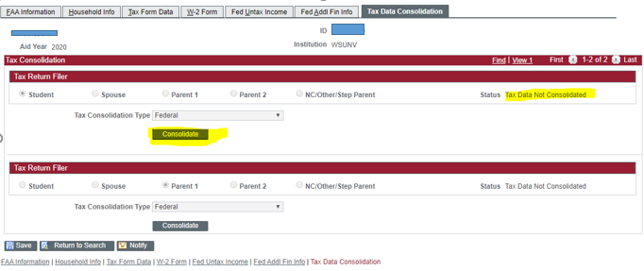
- Click on “Consolidate”. Once it processes, it will change from “Tax Data Not Consolidated” to “Tax Data Consolidated”.
- Navigate to “Perform Auto Verification” (Financial Aid>Verification>Perform Auto Verification).
- Click “Perform Compare”.
- You will have either two Results: Passed or Failed.

Passed
  - If the compare passed (see below), then click “Save” and navigate to the View Packaging Status Summary screen.
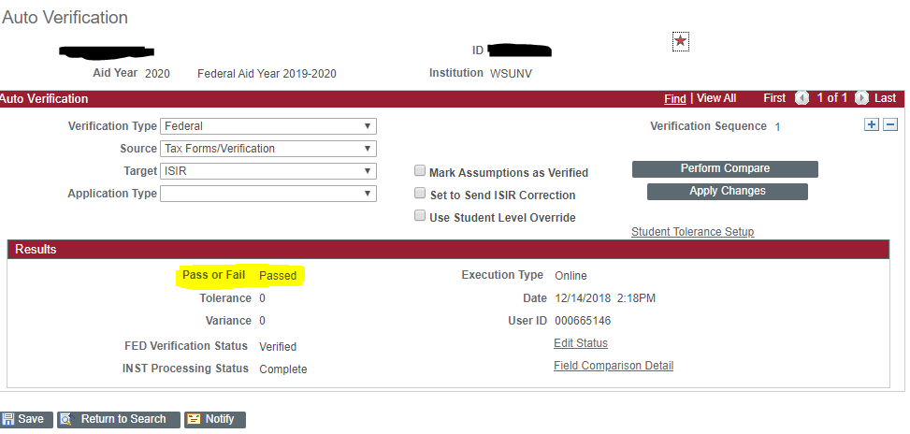
  - You can change the checklist from “Review Pending” to “Review Complete”. Click Save.
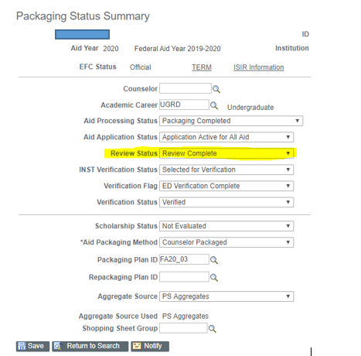
  - Go into the View FA Status Screen, and complete the FR checklist.

Failed
- If it failed, then you will need to click on “Field Comparison Detail”.
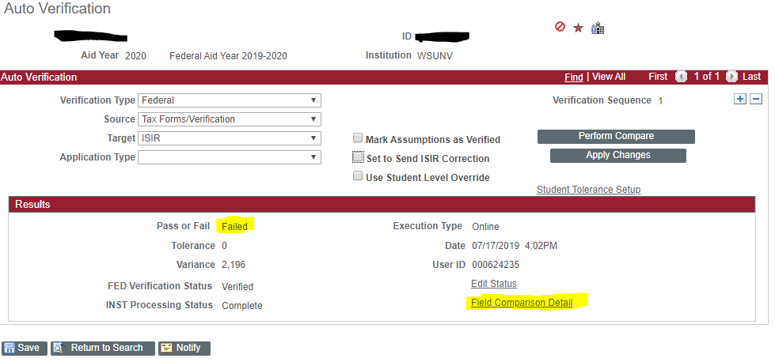
- Click everything that you changed.
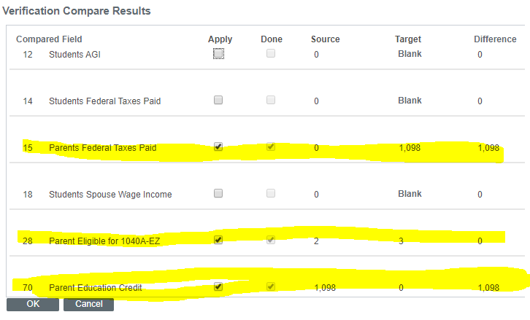
- Check the “Set to Send ISIR Correction” box and click “Apply Changes”. 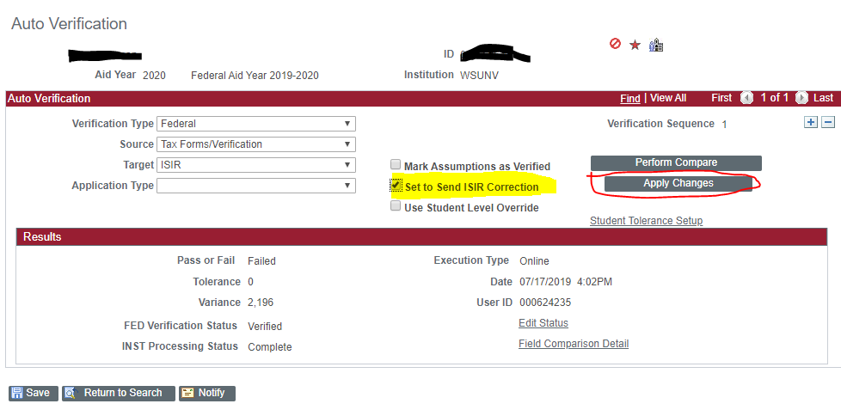
- Click “Save”.
- Navigate to the View FA Status screen. Complete the FR checklist. Initiate the BE checklist (FA1_BE for ODD year, FA2_BE for EVEN year), noting the changes you made. (Example: “FR complete: Changes made to HHS from 4/2 to 3/1. Changes made to student wages. Changes made to parent taxes paid. ISIR Correction sent.”) Copy this comment from the checklist and paste it into a VER comment.

In Case of Emergency: Make Corrections on ISIR pages instead of VERIF pages
If VERIF pages is not working, then you can complete File Review on the ISIR Pages.
- Go to applicable year ISIR pages and click the big, blue plus sign.

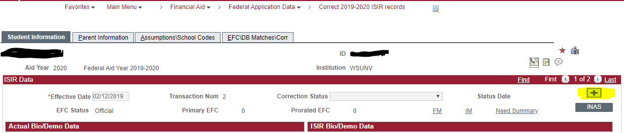
- This will allow you to modify the ISIR. You will need to make any necessary changes, just like on the VERIF pages (Start at Step 1 of V1 Verification).
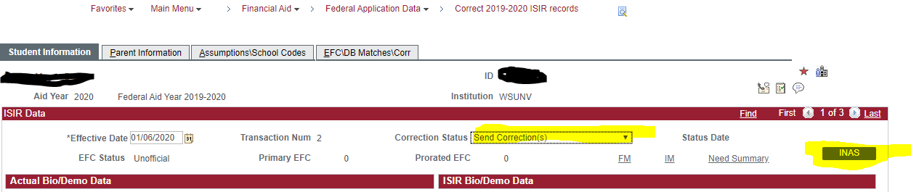
- Once finished making the necessary changes, change the correction status from “Corrections Pending” to “Send Corrections” and click the INAS button. Don’t forget to save the document.
- Make sure to go to the View FA Status screen, complete the FR checklist, set the BE checklist, and make a comment as to the changes made (example: “FR Complete: VERIF pages not working, corrections made to ISIR pages. Changes made to parent AGI, Taxes Paid, and Exemptions. ISIR correction sent.”).

V4 Verifications (Forms BN and SI)

Form BN
- You will need to look at Imaging to see the documentation submitted.
- If the student said they have their high school diploma, you will want to make sure this was submitted to Admissions. You can do this one of two ways.
  - You can check Imaging to see if the high school transcript is on file. You will need to go to Student Service Center, and Admissions tab. To the right, you can see “Graduation Date”. Under External Education, you should see the FINAL high school transcript on file (see example below).
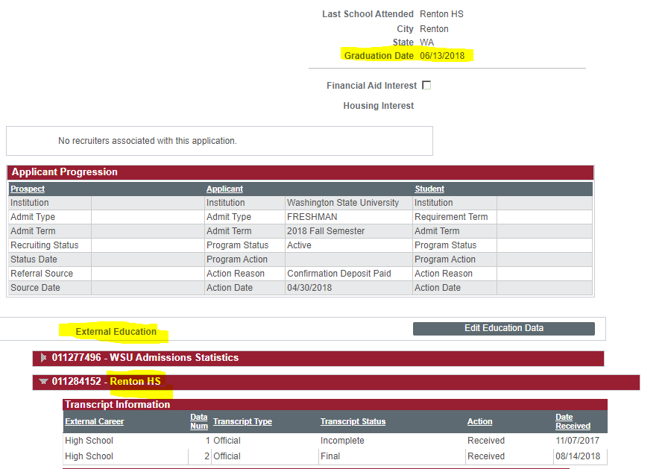
- You will also need to check the “Ability to Benefit” page (Financial Aid>Ability to Benefit>Manage Ability to Benefit. (see below) 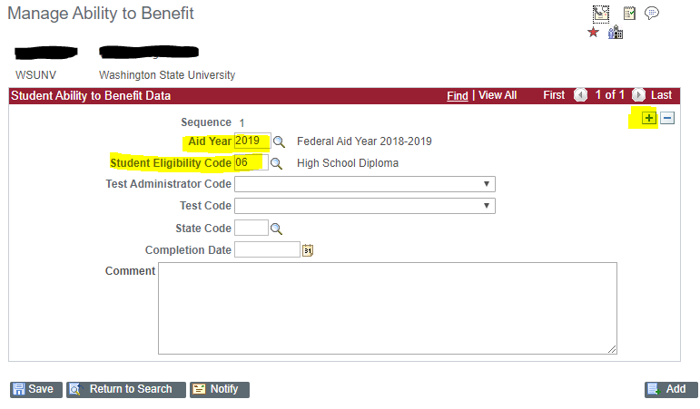
  - If there is not a page for the specific aid year you are working in, you will need to click the + sign to add a new page. Make sure you add the Student Eligibility Code that matches what the student said on the BN/SI forms.
  - If there is a page for the aid year, there is nothing further you need to do for this screen.
- Next, you will need to navigate to the “Correct 20XX-20XX ISIR Pages” and confirm the education section on the student’s ISIR.
  - Look at the information the student said in the “Student Data – Background Info” section.
    - If they said they have their HS diploma, you can move to step 5.
    - If they did not list that they have their HS diploma, you will need to send an ISIR correction. Click the + Sign at the top, click the radio button that says they have a HS diploma, set the correction status to “Send Corrections” and click the INAS button. Click SAVE before exiting this screen. On the View FA Status screen, complete the FR checklist, and set the BE checklist. You will also need to post a comment to make sure you list what changes you made.
- If the student listed that they have received a HS diploma, then you can proceed to complete FR.
- Go to View Packaging Status Summary page. Click on Database Matches. Click the NSLDS Match Box. Click ok. Change review status from “pending” to “review complete”. Go to the View FA Status screen and change the FR checklist to complete.

Form SI
PLEASE SEE COVID-19 UPDATES FOR NEW INFORMATION!
- Look at Imaging to confirm the student signed the Statement of Educational Purpose, had it signed by a SFS staff member or notarized (this part is temporarily removed – see COVID-19 updates), and that we have a copy of the photo identification.
- If yes, you can go to View Packaging Status Summary Page. Click on Database Matches.
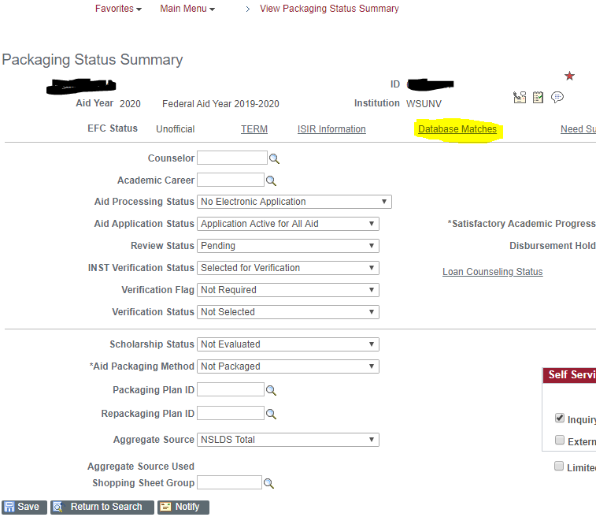
- Click the Override box next to NSLDS Match and click okay. Click Save.
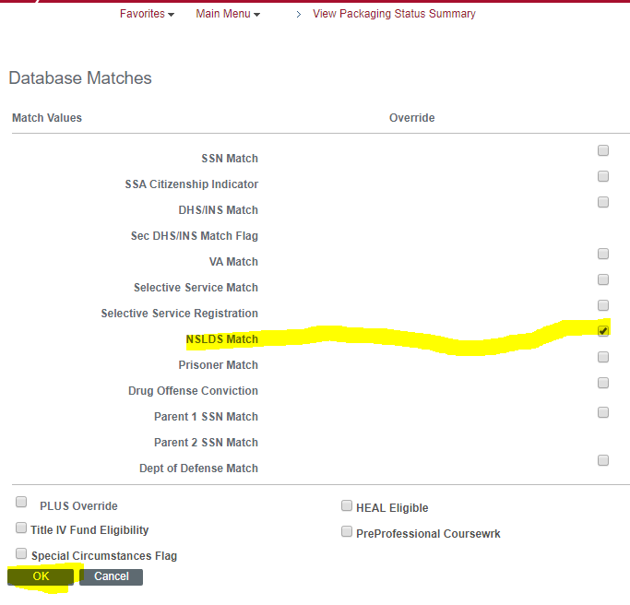
- Go to View Financial Aid Status Screen. Change the FR checklist to complete.

V5 Verification (Forms 23, 24, 25, 28, and 29)
V5 verification is when you have both V1 and V4 checklists. You will need to follow all of the steps for both V1 and V4 to complete the verification for them.

Forms 26 and 27 - Student and Parent Amended Tax Returns
These forms can be part of V1 and V5 verification, but we have split them out here for the sake of documentation.
We know if someone amended taxes one of two ways: they self-identify on the income form or they use the DRT and it comes back as amended.
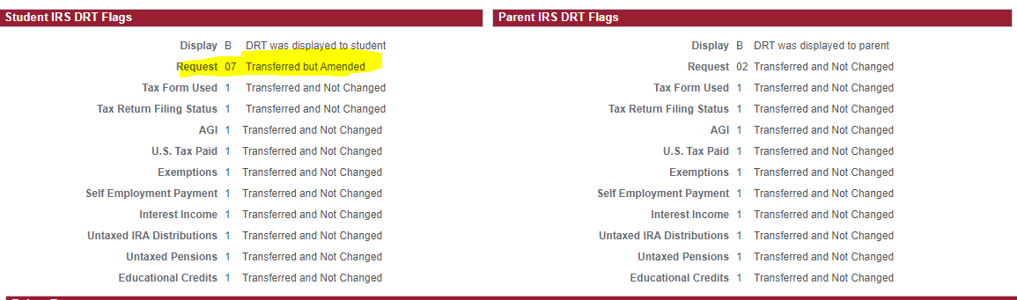
If they used DRT and it came back with the “07 Transferred but Amended” code, then the 26 or 27 should be initiated automatically. We are required to have a copy of the original and the 1040X (Amended Tax Return). If they successfully used DRT, then the information that pulls in will be the original tax return. The TRT doesn’t update with amended information, so if the student gets a copy of it, it will be the same as the original tax return.
The 1040X will tell us what changes were made.
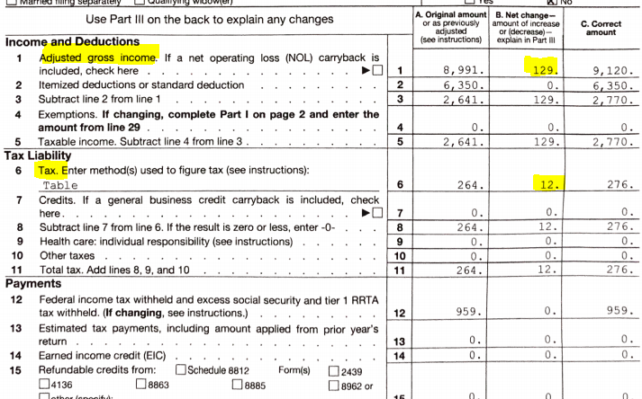
Here, we can see that the AGI increased from $8,991 to $9,120, and that taxes paid went from $264 to $276. We need to make sure these changes are reflected on the ISIR. You make these changes by following the steps as in regular V1 or V5 verification.

We know that the IRS will sometimes make changes on behalf of the tax filer. If they make the change, they will send a letter to the tax filer letting them know what changes were made. If they still have a copy of that letter, we need it. If not, we can accept the Record of Account Transcript. We do not have guidance from ED or NASFAA on how to read Account Transcripts, but some people at ProEd do know how to read it.
Some guidance we’ve had from ProEd regarding the Record of Account Transcript is as follows:
- The Tax Return Transcript at the bottom of the Record of Account Transcript shows ORIGINAL information, but not what was changed.
- In the below example, we can see that on May 28, 2018, the IRS reduced the taxes owed to 0 (original amount showed taxes owed as $1,405 on Februrary 19, 2018). The IRS doesn’t provide an explanation and this account transcript does not show that the student submitted a 1040X (which backs up the claim that the student did not amend the taxes). The $1,405 was refunded to the tax filer, along with the $1,000 credit from April 14, 2018 (refund totaling $2,405).
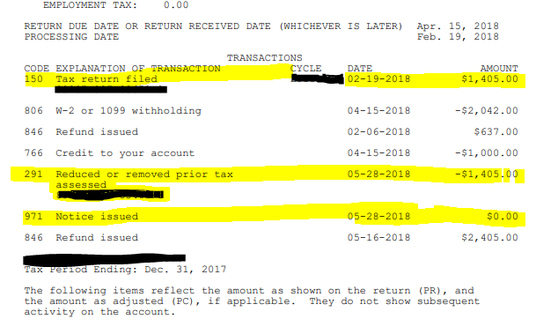

Form 05 – Visa Status Verification
This form is triggered, because CPS could not confirm the student is a U.S. citizen (Comment Code 146) and when the SSA Citizenship Flag is either not A or blank. This form can only be processed if you have access to the Dept of Homeland Security (DHS) SAVE System; this is called Third Step Verification. PLEASE SEE COVID-19 UPDATES FOR NEW INFORMATION!

Steps to process
- Check to see if you actually need to use Third Step Verification.
  - If you see that DHS Match is Citizenship confirmed, you can complete File Review (as long as there are no other VER checklists) by moving to the “Eligible Status” section.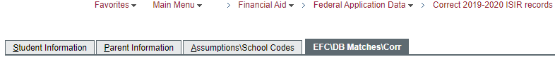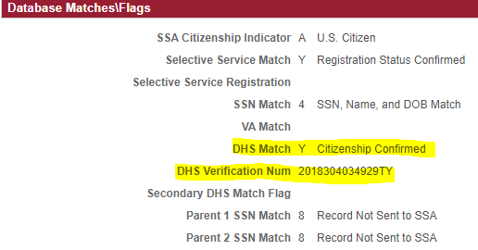
  - If DHS Match is not confirmed, proceed with the next steps.
- You will need to look at the documentation the student uploaded with the 05 form. You will also want to confirm that the Name, DOB, and SSN/ARN match the FAFSA as the documentation provided.

Does Not Match
  - If something does not match, you will need to log into FAA Access and update whatever is wrong.
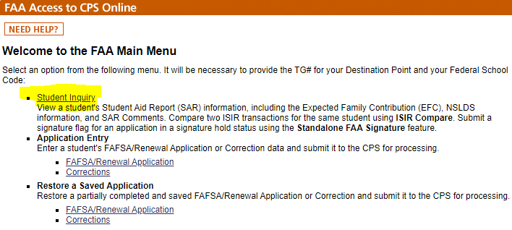
  - Select whatever transaction you want to correct.
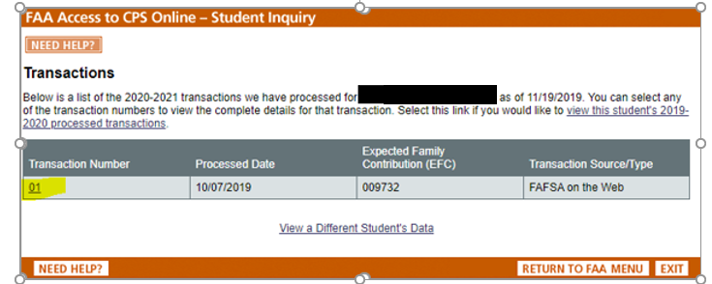
  - Then click on the section you need to updated (for this case, it should be student information).
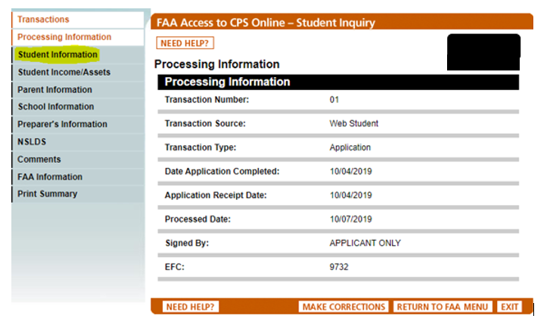
  - Scroll to the bottom and click “make corrections”

  - Make sure you are ONLY correcting items were not correct based on Name, DOB, or Alien Registration Number/SSN. If you do not need to correct, leave as blank.
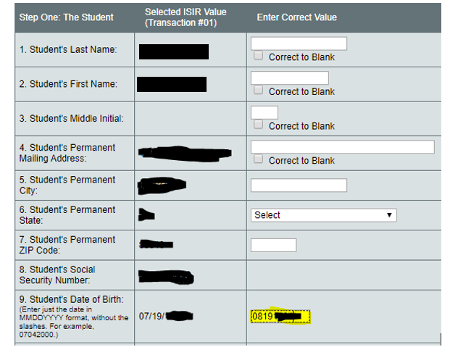
  - Once you make all of the necessary corrections, calculate the EFC, and then click submit.
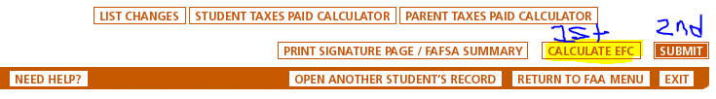
  - Then, do not complete the FR checklist, but set the BE checklist. Make a comment of what you did. By making these changes, we may not need to do Third Step Verification. The system will re-run the student through the DHS system to let us know if their status has been confirmed or not. If it is confirmed when the new ISIR comes in, you can complete FR and the BE checklist, and follow the steps for Eligible Status. If it is not confirmed, continue the following steps.

Does Match
If everything does match, proceed to the next step.
- At this point, you will need to log into the DHS SAVE system to check the student’s citizenship status. Please use the SAVE System Instructions from the US Dept of Education (https://ifap.ed.gov/sites/default/files/attachments/2019-11/SAVEInstructions30Final.pdf). It is our policy to follow the most current version of the SAVE System Instructions from the US Dept of Education.
  - You will need the student’s date of birth and DHS Verification Number (see below).
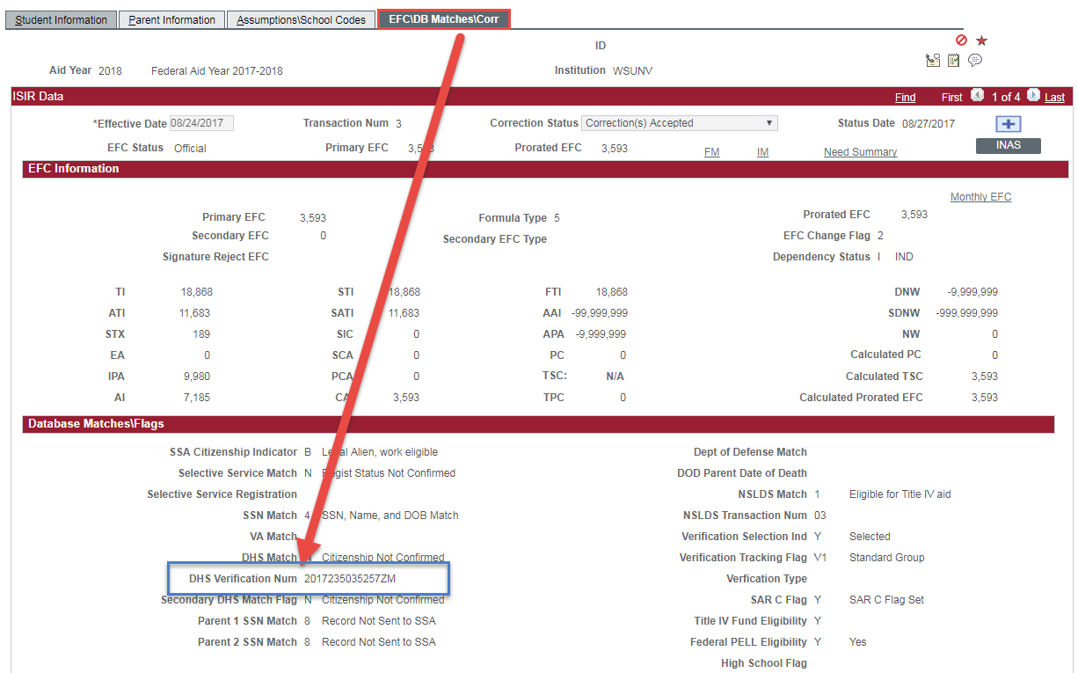
- Once in the system, click on Search Case on the right hand side under Quick Links.
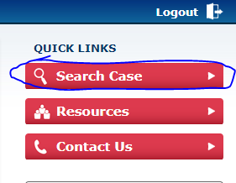
- Enter the DHS Verification Number and Date of Birth.
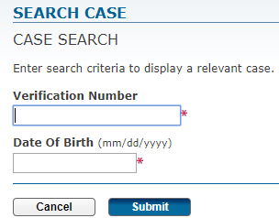
- From here, you will see one of 5 SAVE Responses:
  - “Resubmit Doc” – Case Status: “Case Closed”
  - “Resubmit Doc” – Case Status “Case Returned”
  - “Applicant Status” “Application-Pending” “Parolee-Expires” “Parolee-Indefinite” “Non-Immigrant” or “Other” with “Still not sure?”
  - “Case Under Review”
  - “Applicant Status: [status]” or “Applicant is a [status]” final response
- Based on which SAVE Response you receive, follow the corresponding procedure listed on the SAVE System Instructions for US Dept of Education, starting on page 24.

Pending Status
- If we have uploaded information to the DHS system, the student is not eligible to receive financial aid until we get confirmation back from them that says they are eligible. It will take 3-5 business days for the SAVE system to update with the documentation you uploaded. Set a calendar reminder for yourself to double-check the SAVE system on the 5th business day.
- You will also need to put a comment on the account stating that you uploaded documentation to the SAVE system and are waiting for a reply. Send the student a FIN communication letting them know we have sent documentation to DHS and are waiting for a reply. Until the status comes back as one that is eligible for aid, the student is not eligible to receive any financial aid.

Eligible Status
- If the student is in an eligible status, you can complete FR. Navigate to the Packaging Status Summary Page. Click on Database Matches. Check the “DHS/INS Match” and “SSA Citizenship Indicator” boxes. Click okay.
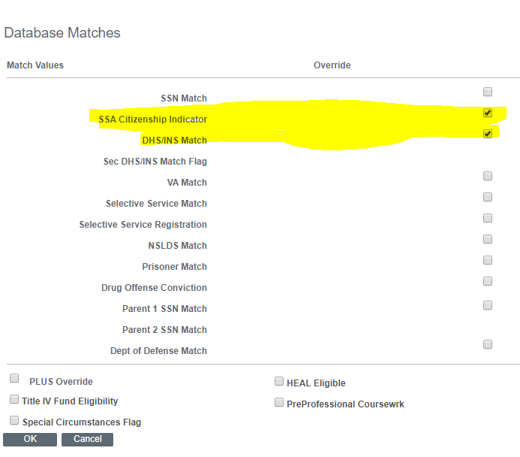
- Change the Review Status from Pending to Complete. Click Save.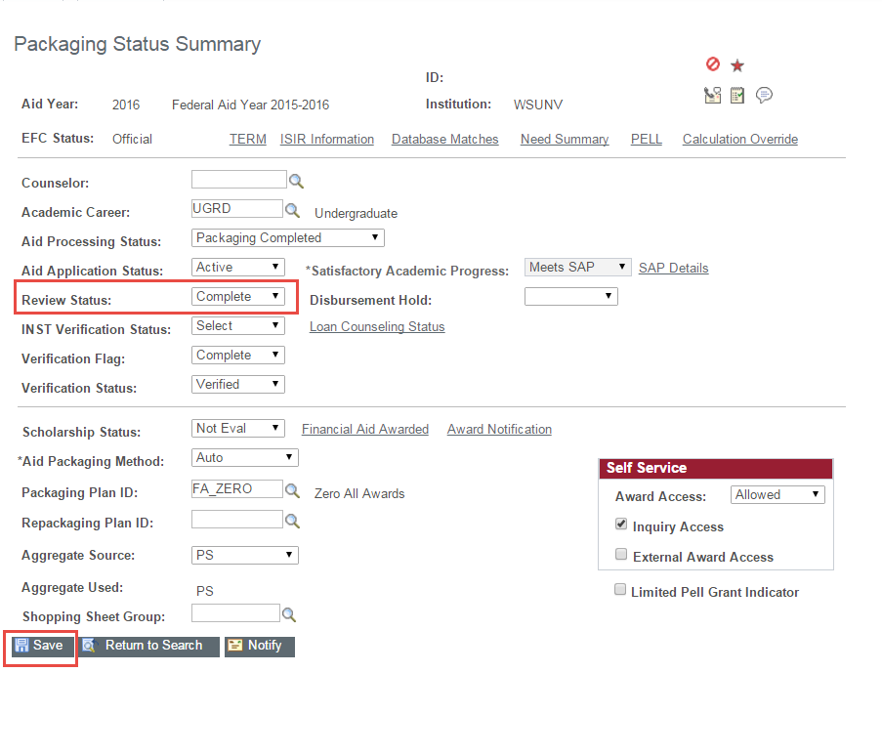
- Complete the FR Checklist on the View FA Status Screen.

Non-Eligible Status
- If the student is determined to be in a non-eligible status, the student is not able to receive any financial aid. You will need to send an email communication (FA_FIN) letting them know they are not eligible to receive any financial aid at this time.
- Do not complete the FR checklist. This will need to stay as “initiated”.

Form 1D – Drug Conviction Form
This form is triggered based on the response to Question 23 (Have you been convicted for possession or sale of illegal drugs while you were receiving federal student aid?). If the question is left blank or answered as “yes”, or has C Codes 53, 54, 56, or 58, then the checklist is generated.

Steps to Process
- Look at the completed form in Imaging.
- As long as everything is completed, go ahead and complete the FR checklist, as long as there are no other verification checklists.
- Go to the View Packaging Status Summary Page. Click on Database Matches.
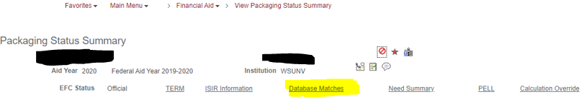
- Click the “Drug Conviction” box and click ok. Save your changes.
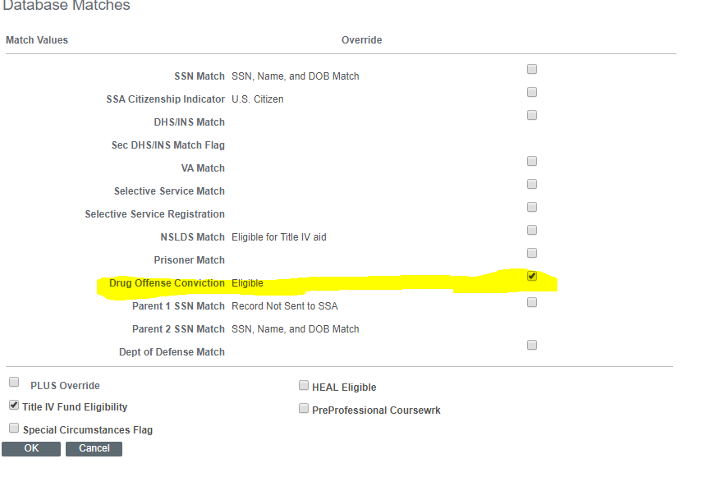

Form 43 – Previous Degree
This form is triggered based on the student selecting “Yes” to having their first bachelor’s degree on the FAFSA prior to the July 1 (before Fall starts) AND the Student Center Career is UGRD.
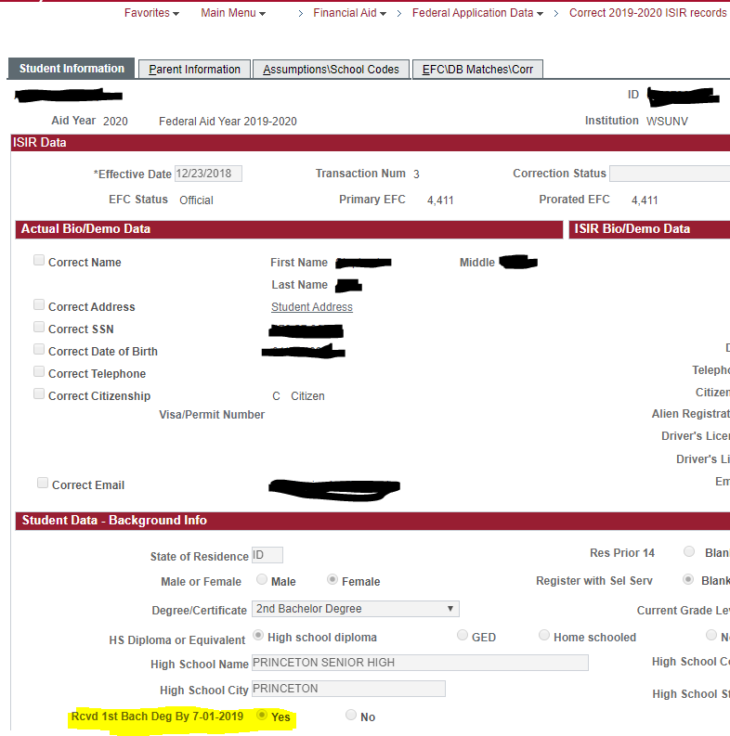
________________________________________________________________________________
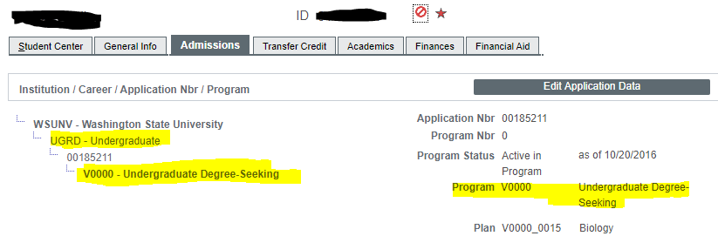

Steps to Process
- Look at the document in Imaging to see which option they indicated.

Currently have or will have my first bachelor’s degree before the beginning of fall term.
- You will need to review the FA Term / Financial Aid Info tab to ensure that the NSLDS Loan Year shows 5th Year+ or Graduate Professional. You can find this by clicking on “Financial Aid”, “Financial Aid Term”, and then “Maintain Student FA Term”. You will then click the 4th tab “Financial Aid”.
- You will also need to review the Academic Level section of the Academics tab in the Student Service Center to see if their level shows “Post-Bacc”.
  - If the term is not updated, you will need to make a comment on the account that you cannot complete FR at this time. Once the student is reflecting as a post-bacc, then you will be able to complete FR. Student is not eligible for aid at this time.
  - If the term is updated, you can complete the FR checklist, if there are no other checklists.
    - Then, go to View Packaging Status Summary Page and change the Review Status to “Complete”.
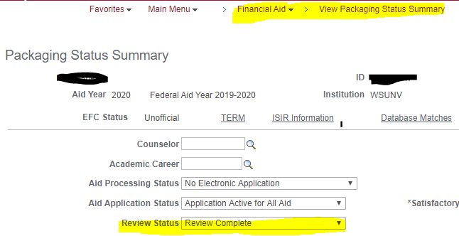

I will NOT have my first Bachelor’s degree and I will not be enrolled in a graduate program before the beginning of fall term.
- If the student indicated they made a mistake on the FAFSA, then you MAY need to make a correction to the FAFSA on the ISIR pages. This may mean that the student is going from IND to DEP status.
- Go to the Correct 20XX-20XX ISIR Record Pages. Check to see if the student would be going from IND to DEP. If so, check to see if there is parent information listed in the 2nd tab (Parent Information). Also, check the 3rd tab (Assumptions\School Codes) to see if both the student and parent signed the FAFSA.
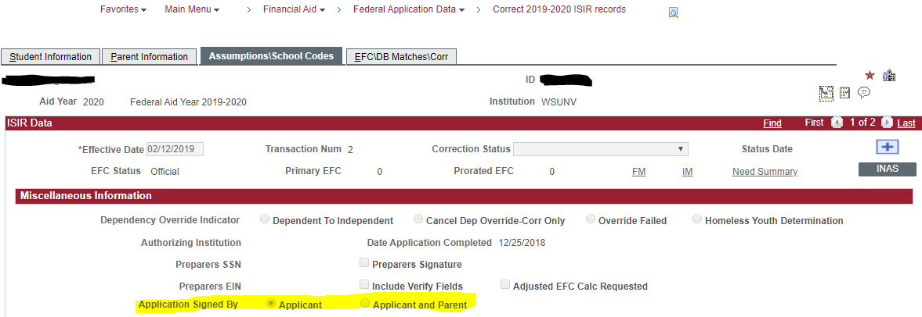
- If we have all parent information and parent signature, we can make this correction for the student. If we don’t, move to step 4.
  - Click on the + button at the top of the page.
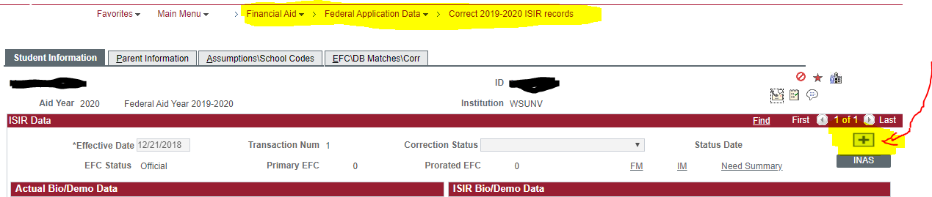
  - Change the appropriate radio button (see below). Also, please make sure to delete the student number in family and number in college. Since we have parent information, this will be listed on the parent tab. If not, cancel ISIR correction, and move to step 4.
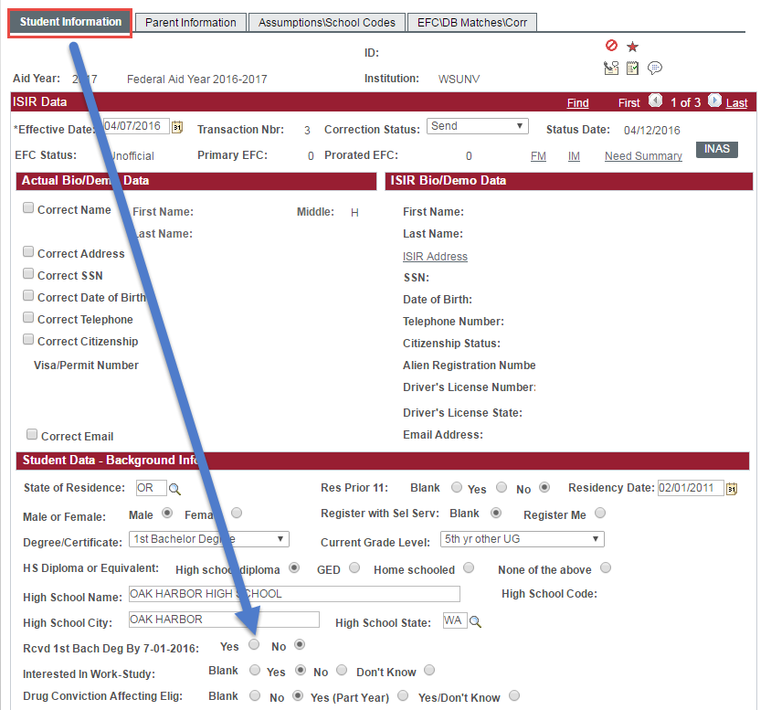
  - Change the correction status from “Corrections Pending” to “Send Corrections” and then click on the “INAS” button.
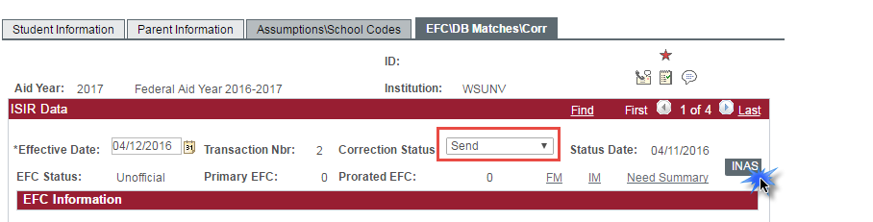
  - Once you make a correction, you will need to complete the FR checklist, and initiate the BE checklist. Please make sure to put a comment in both the checklist section and the comment section and list what changes you made.
- If you do not have parent information, the student will need to make all the necessary changes from being an IND student to a DEP student. If this is the case, do not complete the FR checklist, but you will need to initiate the EE (IND to DEP) Checklist. PLEASE ALSO CHANGE THE 43 CHECKLIST FROM COMPLETED to CANCELLED!! Make a note in both the Checklist and Comment sections.

Form 68 – Veteran Status Clarification

Steps to process
- Look at the documentation provided by the student on Imaging. If they are a veteran, they should have supplied a copy of their DD-214 form (see next page).
- The “Member 4” form shows the Character of Service. Any character of service other than “Dishonorable” is acceptable. Look at the amount of active service – one day or more of active duty service qualifies the student as a veteran.
- A member of the National Guard or Reserves who served on active duty for purposes other than training might not have a DD-214. In that case, a letter from a superior officer that documents the call-up to active duty and which indicates that the character of service was anything but dishonorable is sufficient. The student’s “Original Orders” might be informative, especially if it indicates a call to “involuntary active duty”. If a DD-214 is available, it should indicate that the student was called to active duty in accordance with Title 10 of the US Code and the “Type of Separation” should indicate something other than “active duty training”.
- After reviewing the DD-214, if the student is a veteran, go to the Packaging Status Summary. Change the Review Status from Pending to Complete. Go to View FA Status and complete FR.
- If you determine the student is not a veteran, they are not independent.
  - PLEASE ALSO CHANGE THE 68 CHECKLIST FROM COMPLETED to CANCELLED!! Cancel FR, and initiate the EE Checklist, so we can obtain parental information on the FAFSA if not provided. Student will need to change their answer on the FAFSA from Yes to No and have the parent sign.
- If box 2 on the DD-214 shows “R” in the Dept branch (example: “AR”, this means they were in the Army Reserves), this does NOT count as an eligible Veteran status. “RA” means Regular Army and WOULD be eligible as an IND Veteran. The DD-214 below is an eligible veteran, because they were enrolled in the Army and the US Army Reserves. Because they were in the Army for more than 1 day and were honorably discharged, they qualify as a veteran.
- If a student is in the Reserves and is called up for a National Emergency, student could provide Title 10 Active Duty Call Up Letter to confirm Active Duty status, and would be able to indicate as such on the FAFSA.
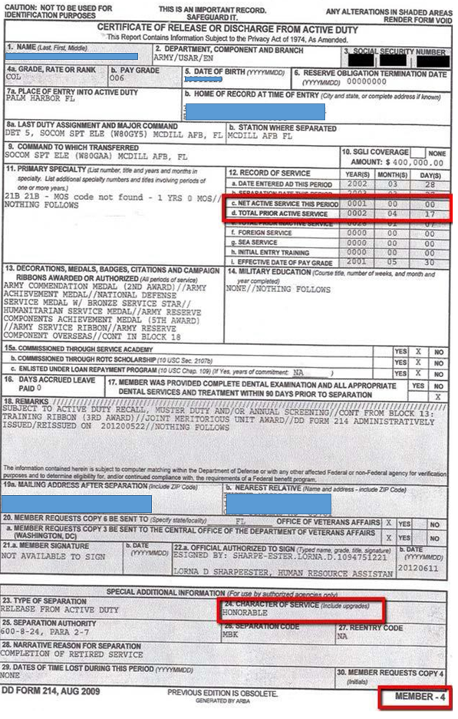

Form AW – Parent Asset Verification
This form is triggered when after we complete verification, it is determined that the parent no longer meets the simplified needs test, and now has to list asset information. Previously, they were not required to list asset information, and that section was skipped in the FAFSA.

Steps to Process
- Look to see what dollar amounts they listed for each asset section on the form.
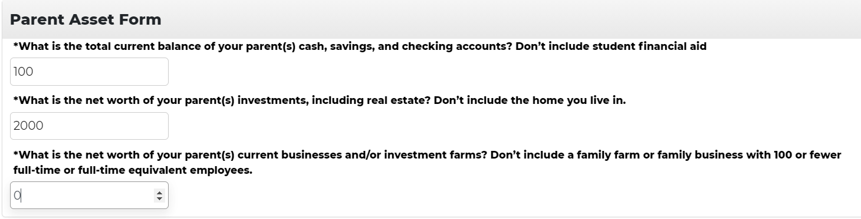
- On myWSU, under the Correct 20XX-20XX ISIR Record, click on the Parent information tab.
- At the bottom of the page, you will see “Cash Savings”, “Investment Net Worth”, and “Bus/Farm Net Worth”.
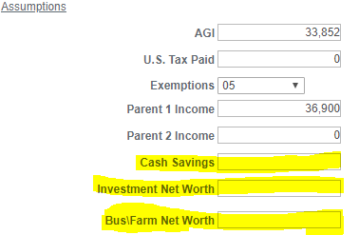
- Even if the dollar amount is “$0”, you will need to list it on the FAFSA, instead of blank spots.
- At the top of the screen, click on the “+” sign, and add the corresponding dollar amounts to the correct spots.
- After you make all changes needed to the ISIR pages, you will need to change the “Correction Status” bar at the top to “Send Corrections” and then click on the “INAS” button. Click Save.
- In View FA Status screen, complete the FR checklist, initiate the BE checklist, and add a “VER” comment.

Form AX – Student Asset Verification
This form is triggered when after we complete verification, it is determined that the student no longer meets the simplified needs test, and now has to list asset information. Previously, they were not required to list asset information, and that section was skipped in the FAFSA.

Steps to Process
- Look to see what dollar amounts they listed for each asset section on the form.
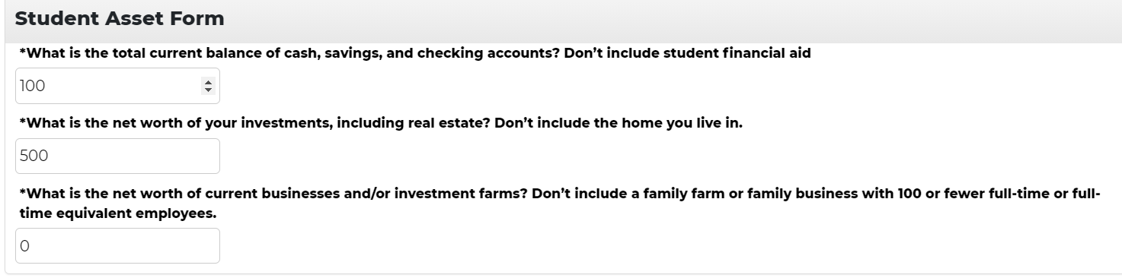
- On myWSU, under the Correct 20XX-20XX ISIR Record, click on the Student information tab.
- At the bottom of the page, you will see “Cash Savings”, “Investment Net Worth”, and “Bus/Farm Net Worth”.
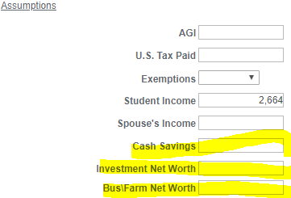
- Even if the dollar amount is “$0”, you will need to list it on the FAFSA, instead of blank spots.
- At the top of the screen, click on the “+” sign, and add the corresponding dollar amounts to the correct spots.
- After you make all changes needed to the ISIR pages, you will need to change the “Correction Status” bar at the top to “Send Corrections” and then click on the “INAS” button. Click Save.
- In View FA Status screen, complete the FR checklist, initiate the BE checklist, and add a “VER” comment.

Form DC – Dependency Update/Homeless Verification
Since we no longer use the HM checklist, we have partnered with Gloria to use the DC checklist. This checklist is initiated if a student previously answered “Yes” to the Unaccompanied Youth as determined by School District Liaison (McKinney Vento), Unaccompanied Youth as determined by HUD, or at risk of homelessness questions, but are not able to answer yes due to the way the FAFSA is worded. These students will have the IND – HOM service indicator. As of right now, this is a manual process. We are working on trying to get this automated.

Steps to Process
- We will not load the rejected ISIR until after we know if the student is still considered IND. So, we will first add the DC checklist when we know the student has the IND – HOM service indicator.
- If the student selected the response “My situation has changed and I no longer should be considered an independent student based on my current situation and living circumstances.”
  - Mark the DC checklist as CANCELLED!
  - Initiate the EE checklist
    - After the student adds parent information, their ISIR should automatically load.
- If the student selected the response, “I certify that my current living situation has not changed from the first time I filed the FAFSA and that my Independency Status is still valid.” Note: The process is the same whether they marked they are “homeless”, “at risk of being homeless”, “an unaccompanied youth”, or “other”.
  - We need a statement from them clarifying their situation has not changed (found under “Personal Statement”) and is applicable to the situation they marked.
  - Complete the DC checklist.
  - Load the rejected ISIR.
  - On the ISIR pages, you will need to click the + button to make a change to the ISIR.
    - Tab 1 - Add student household size and number in college.
    - Tab 3 – Since these students are homeless youth students, you will mark the Dependency Override Indicator as “Homeless Youth Determination”.
  - Set correction status to “Send Corrections”, click “INAS”, and Save.
  - Set the BE checklist.

Form IL – Graduate or Professional Status Verification

First Bachelor’s Degree
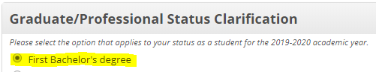
- If the student selected they are working on their first bachelor’s degree, cancel the FR checklist and initiate the EE checklist. PLEASE ALSO CHANGE THE IL CHECKLIST FROM COMPLETED to CANCELLED!! The student will need to log back into the FAFSA, change the answers to the dependency and all graduate-level questions, and add parent information to the FAFSA.

Second Bachelor’s Degree
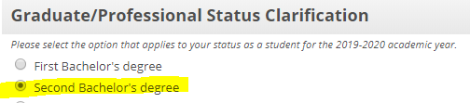
- If the student selected they are working on their second bachelor’s degree, you will need to log into myWSU, Student Service Center, Academics tab to make sure they are enrolled in a Post-Bacc Degree program. You will also need to look that the Correct 20XX-20XX ISIR Pages, Student Tab to make sure they listed they have earned their first bachelor’s degree.
  - 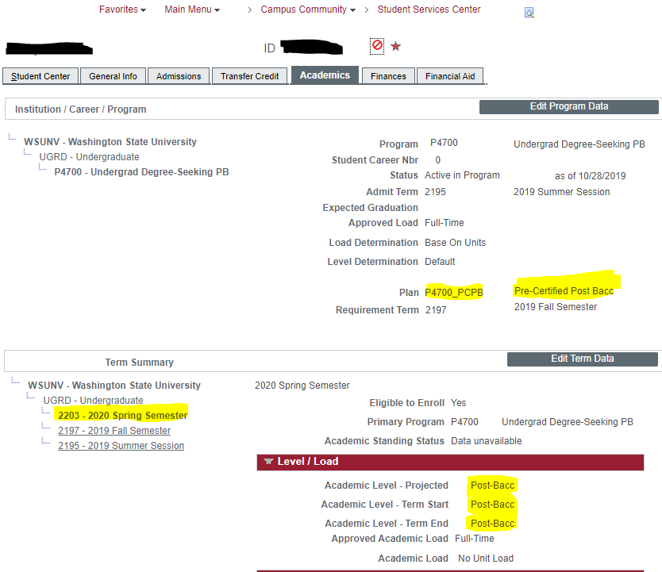
- If everything matches, you can complete FR as long as there are no other verification checklists.
- If everything doesn’t match, you will need to wait for myWSU to update to show they are enrolled in an eligible Post-Bacc program. Make sure you do not complete FR, but you leave a comment.

Masters/Graduate/Vet Med/Pharmacy/Medicine Degree
With these options, you are really looking at what the student said on the form versus where the student is on the FAFSA and Academics Tab of Student Services Center.
- If the student said they were approved by the department, and you can see they are enrolled in a graduate/profession program (Student Service Center, Academic tab), then you can complete FR as long as there are no other verification checklists.
  - 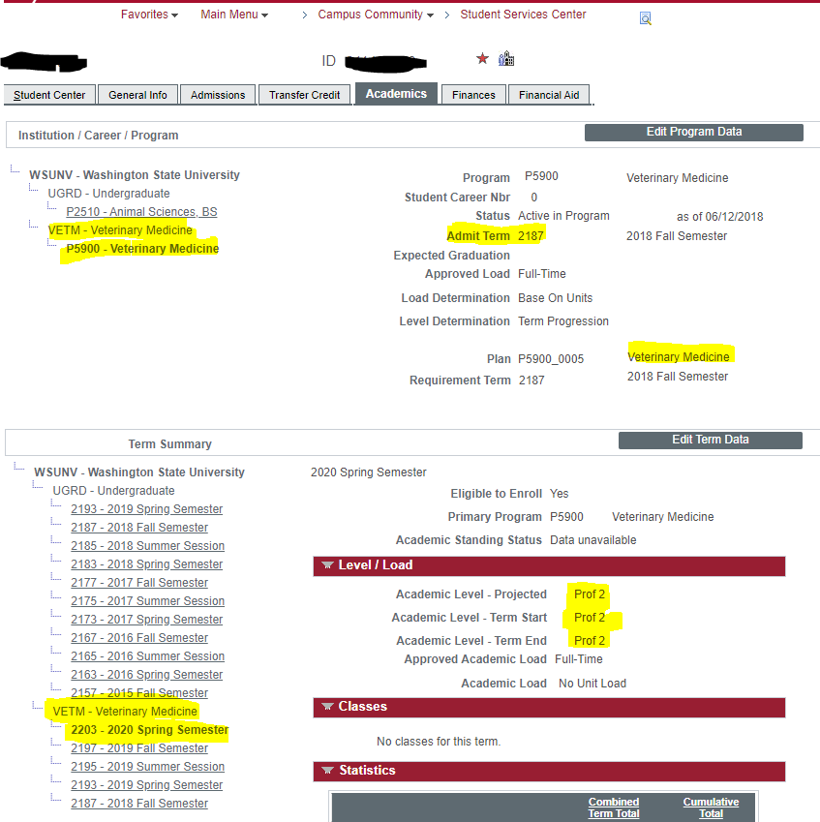
- If the student has not been approved by the department or submitted an application, and you can see they are not accepted into a graduate/professional program, you cannot do anything until they have been accepted into the program. Leave FR as initiated. You will need to make a comment on the account stating they have not been accepted into the graduate/professional program, and are not eligible for financial aid until their Student Service Center shows they have been accepted.

Form IN – Independence Verification
This form is triggered when a student indicated “Yes” to Orphan/Ward of Court/Foster Care question or marked “Yes” to the emancipated minor question and no to other independency questions. If a student has documentation showing they are actually IND, we will accept it, even if it is wrong on the FAFSA. For example, if a student said they have a legal guardian on FAFSA/verification form, but uploads a McKinney Vento letter, we will count that. Go ahead and make the correction on the ISIR pages and add the HM service indicator (in this case).

Steps to Process

Made a Mistake
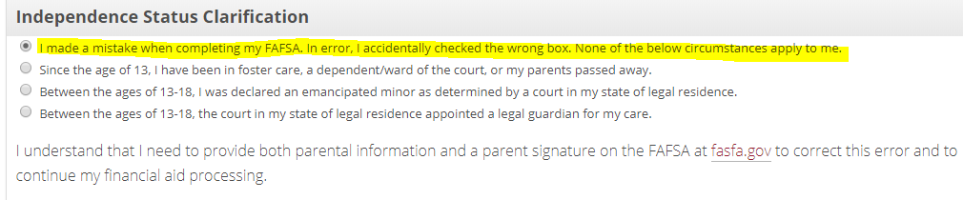
- If the student indicated they made a mistake on the FAFSA and they do not qualify for IND status, then cancel BOTH the IN and FR checklists, and initiate the EE (IND to DEP) checklist. The student will need to change the answers to the IND questions and add parent information to the FAFSA.

Foster Care, a Dependent/Ward of the Court, or Their Parents Passed Away
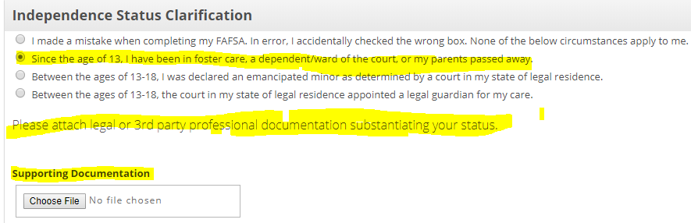
- If the student indicated this, we will need supporting documentation proving this status. This could be a court document showing foster status or dependent/ward of the court paperwork, or a death certificate for the parent(s).
  - If everything is valid, you can complete file review, as long as there are no other verification checklists.

Emancipated Minor
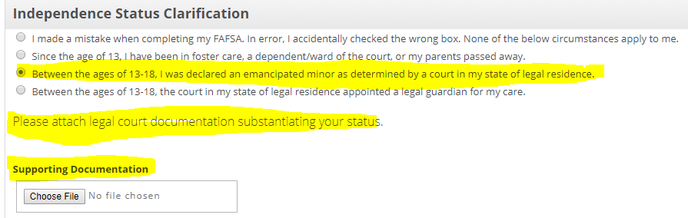
- If the student indicated this, we will need supporting documentation proving this status. This could be a court document showing the emancipation of the student.
  - If everything is valid, you can complete file review, as long as there are no other verification checklists.

Legal Guardian
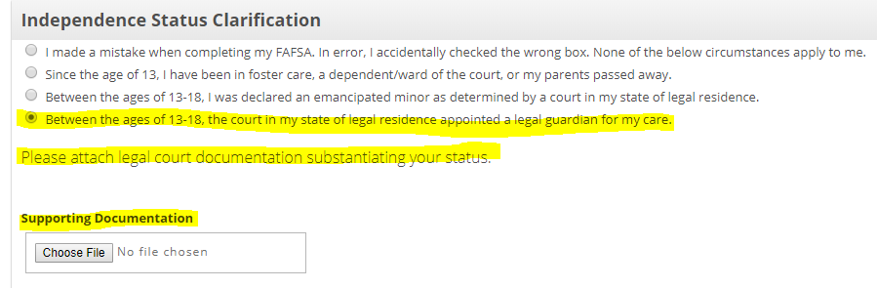
- If the student indicated this, we will need supporting documentation proving this status. This could be a court document showing the appointment of a legal guardian for the student.
  - If everything is valid, you can complete file review, as long as there are no other verification checklists.

Form LD – Legal Dependent Verification
This form is triggered when a student selects “Yes” to the “Do you have children you support?” or “Do you have legal dependents other than children or spouse?” AND no to other independency questions.

Steps to Process

I made a mistake
- If the student indicates they made a mistake and they do not support a legal dependent, you will need to cancel FR and initiate the EE checklist, so they can provide parent information. PLEASE ALSO CHANGE THE LD CHECKLIST FROM COMPLETED to CANCELLED!!

I do support a legal dependent
- If the student indicates they do support a legal dependent, look at the information they listed for the person they support.
- You will need to check the ISIR to make sure that the student had listed an income. If the student does not have at least $500 or more of wages listed, we will need clarification from the student as to how they provide for the legal dependent.
  - If legal dependent receives the support directly or indirectly from the student’s parent, the student does not qualify as being the primary provider for the legal dependent. We will need to cancel FR and initiate the EE checklist, so the student can list parent information. PLEASE ALSO CHANGE THE LD CHECKLIST FROM COMPLETED to CANCELLED!!
- An unborn child can be included as a dependent of the student. The student claiming the dependent must be enrolled in the current academic year and the child’s date of birth must be within the academic year in order for the student to be considered independent by this criterion and the family size increased. If the student was not originally selected for verification of household size, we can update this but must do so using professional judgement. The student must be female or the male student must be the only parent enrolled and will provide more than 50% of the support for the child.
- If a student’s dependent (other than a spouse or questionable relationship) lives in the household, no other review is required and the checklist can be marked as complete.
- If the student indicates the child will not be residing in the household or the student is not providing at least half of the support for the child, then the dependent is not acceptable as criteria for independent status.
- If student does not qualify for independent status, you will need to initiate the EE checklist, so the student can provide parent information. PLEASE ALSO CHANGE THE LD CHECKLIST FROM COMPLETED to CANCELLED!! If the parent information (including signature) is already provided on the ISIR, you can make the changes on “Correct 20XX-20XX ISIR Pages”. Make sure on the Student tab, you mark the IND student Household Size is 0, along with changing the Independency question to “no”.
- In the Assumptions\School Codes Tab, it will tell you if the parent has signed the FAFSA – if it was signed by applicant only, we need to initiate the EE checklist. PLEASE ALSO CHANGE THE LD CHECKLIST FROM COMPLETED to CANCELLED!! If it was signed by both applicant and parent, and we are not missing any parent information, we can make the corrections ourselves. 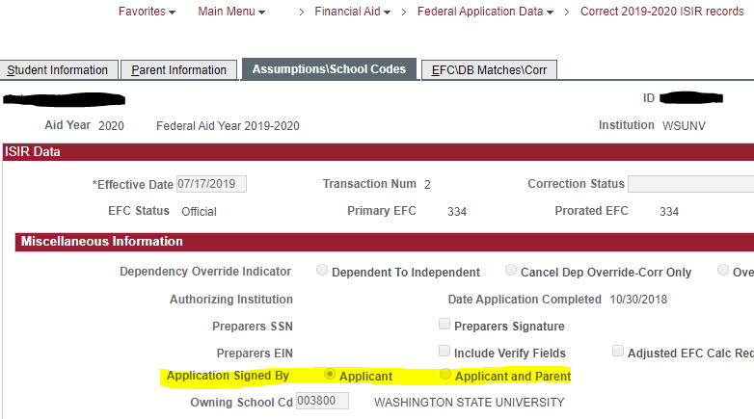

- If the student qualifies for independency, you can complete file review, as long as there are no other verification checklists. In Packaging Status Summary, flip the Review Status checklist to “Review Complete”.

Form LS – Social Security Match
This form is triggered when the student has C codes 59, 60, 61, or 64 on the ISIR (See Correct ISIR Pages, under Assumptions\School Codes).

Steps to Process
- Look at the copy of the Social Security Card provided on Imaging.
- The number on the card must match the number within myWSU (check either under “View Financial Aid Status” [see image ‘A’ below] or Student Service Center, General Info [see image ‘B’ below]). It is also suggested to confirm the SSN on the ISIR.
  - 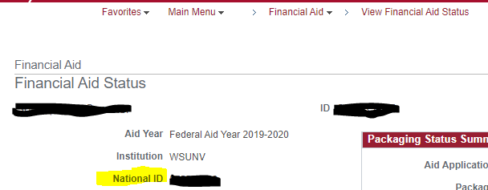

OR___________________________________________________________________________________

  - 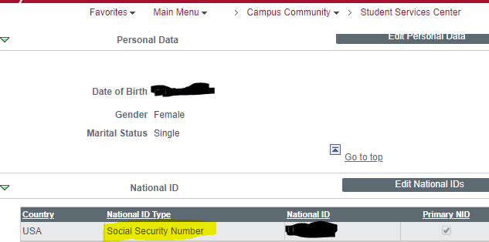
- If the SSN is wrong on the FAFSA, the student will need to submit a new FAFSA (they will need to create a new FSA ID, since it is linked to SSN).
- If the SSN is wrong on myWSU, the student will need to complete the WSU Record Change form through the Payroll Office, so it can be updated with the correct SSN.
- If/Once everything matches, you can complete the FR checklist (if there are no other checklists). Make sure you go to the View Packaging Status Summary page, click on Database Matches at the top. Check the SSN Match override box and save.
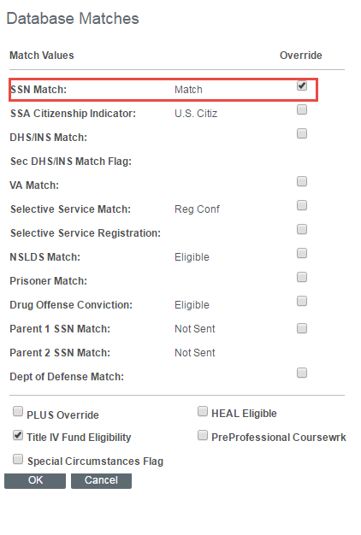

Form MM – NSLDS Mismatch
- Look at the forms in Imaging. The student will have said that they either have had a legal name change or they have not had a legal name change.
  - If they have had a legal name change, we need a copy of their birth certificate, a copy of their Social Security Card, and a copy of their legal name change paperwork.
  - If they have not legally changed their name, we will need a copy of their birth certificate and a copy of their Social Security Card.
- As long as we have all of the documents needed, you will need to print them out to use when you contact NSLDS.
- Contact NSLDS at 1-800-999-8219.
  - Give them your FSA log in ID:
    - Example: kalyn.spens.fsa
  - Provide your OPEID:
    - 00380000
  - Let them know you are providing updated documentation for Legal Name Changes.
    - NSLDS will confirm name, DOB, and SSN.
    - NSLDS will create a ticket for you. Keep track of this number!
    - If the information on NSLDS reflects the Legal Name Change already, no additional action is needed other than documenting the NSLDS ticket number in the “Comments” section of myWSU.
    - If the information is mismatching, you will either need to scan/email or fax the documents to them.
      - Email: This is the preferred method as it is the fastest way for them to process the paperwork. Please note, that WSU blocks password protected emails from being sent out. You will need to get authorization from Crimson Service Desk to have it sent to NSLDS.
        - 1st email: all documents that need to be sent to NSLDS, include ticket # on all documents. Make sure to password protect each document or the file you are sending, and keep note of the password.
        - 2nd email: only include the password for the documentation that you just sent to NSLDS.
      - Fax: 785-838-2154
        - Be sure to include the ticket number on every page.
- Put a “comment” on the account stating that you have submitted the documents to NSLDS, along with the ticket number. We have to wait until NSLDS resolves the conflict before we can complete FR.
- Once NSLDS confirms they have resolved the conflict, you can complete the FR checklist, and go to Packaging Status Summary. Be sure to click “Database Matches” and do the NSLDS override.
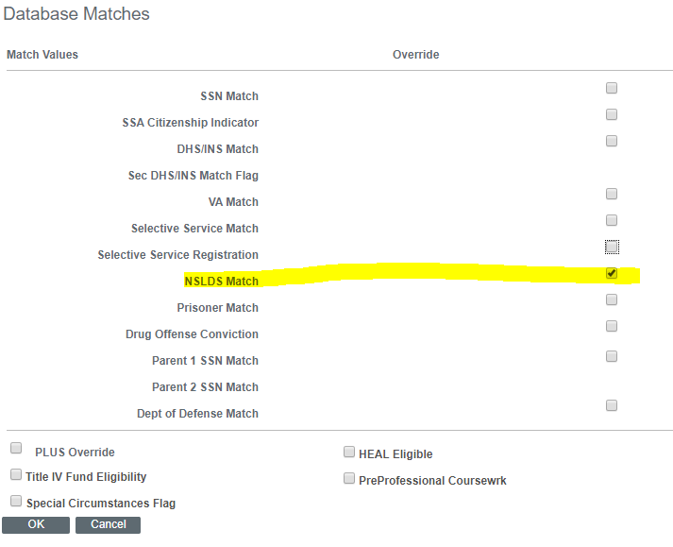
- Make sure you save it, and then flip the “Review Status” from “Pending” to “Review Complete”.
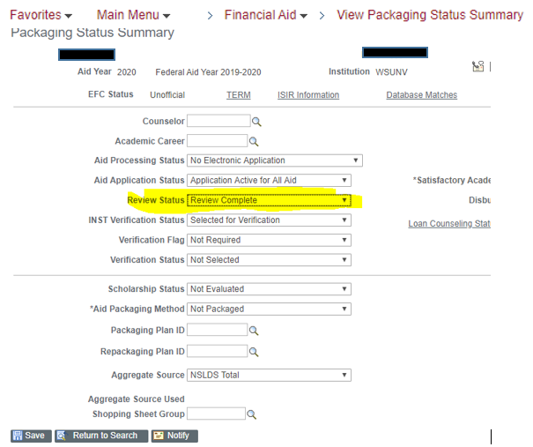
- Click “Save”.

Form NZ – Citizenship and Date of Birth Verification
This form is triggered, because the Social Security Administration could not confirm the student is a U.S. citizen (Comment Code 146) and when the SSA Citizenship Flag is either not A or blank. PLEASE SEE COVID-19 UPDATES FOR NEW INFORMATION!

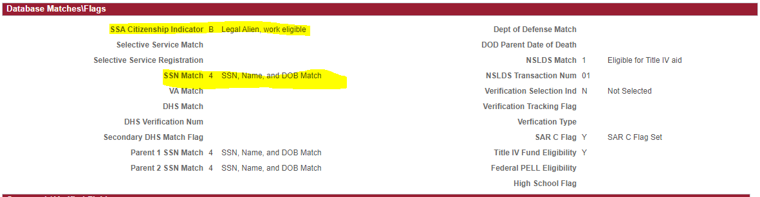

Steps to process
- Look at the documentation provided with the completed NZ form. We are required to have either Birth Certificate, Naturalization Papers, or U.S. Passport (this part has been removed due to COVID-19).
- If we have one of these (along with both pages of the completed form), you will need to see if we are required to do a Secondary confirmation.
- On Correct 20XX-20XX ISIR Pages, on the 4th tab, you will need to check to see if the DHS Match and DHS Verification Number section are filled or blank. If they are blank, you can complete FR.
- Go to the Packaging Status Summary Page, click on Database Matches, and check the “DHS/INS Match” box, and click “ok”, and save.
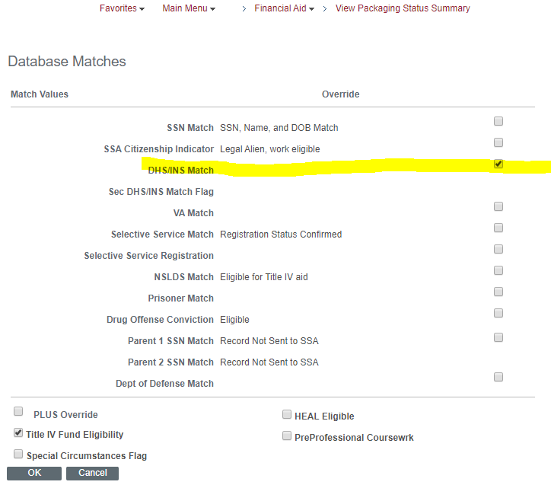

Form QE – Questionable Enrollment
This form is triggered by C codes 359 and 360 on the ISIR or due to the NSLDS Panel UEH Flag showing 2 or 3. This is under “Correct 20XX-20XX ISIR Pages”, under the Assumptions\School Codes section. You must be able to log in to NSLDS in order to clear a QE. There is no actual form for this checklist.

Steps to Process
You will need to check the ISIR to see if they have code 359 or 360.

359 Code
- If the student has received either Pell Grant or Direct Loans from WSU within the past 4 years, we do not need to check for transcripts. You can complete the QE.
- If the student has NOT received either Pell Grant or Direct Loans from WSU within the past 4 years, we need to check the transcripts against the aid received at all schools within the past 4 years.
  - You will need to log in to Imaging, under the “Student Search All” section.
  - In a separate tab, log in to NSLDS, click on “Grants”, and Search by SSN, First Name, AND DOB.
  - We need to determine if the student has earned the aid received at schools from the past 4 AYs. (Example: For 2021-2022 AY, we look at 17-18, 18-19, 19-20, and 20-21 AYs). We need to confirm WSU has transcripts from all schools on NSLDS to determine if they earned received aid.
  - Look at the transcripts within the Imaging system to see if they earned their aid (did they have completed grades).

360 Code
- If the student has a 360 code, we HAVE to check for transcripts against aid received within the past 4 years.
  - You will need to log in to Imaging, under the “Student Search All” section.
  - In a separate tab, log in to NSLDS, click on “Grants”, and Search by SSN, First Name, AND DOB.
  - We need to determine if the student has earned the aid received at schools from the past 4 AYs. (Example: For 2021-2022 AY, we look at 17-18, 18-19, 19-20, and 20-21 AYs). We need to confirm WSU has transcripts from all schools on NSLDS to determine if they earned received aid.
  - Look at the transcripts within the Imaging system to see if they earned their aid (did they have completed grades).

Earned aid
- If we are missing any transcript(s), we need to have a copy of it before we can clear the QE. Cancel the FR checklist and initiate a 98 checklist.
  - Request a copy of the missing transcript(s). For financial aid purposes, we can accept unofficial transcripts. Put a comment on there as to what transcripts we are requesting.
  - Send the FA_FQE communication. In the comments section of this communication, only list the school(s) from which we are requesting transcripts.
  - Send an email to AdmissProcess@lists.wsu.edu so we can let our partners in Admissions know we are missing transcripts.
- If WSU is listed, check the academics tab of the Student Service Center to confirm earned aid.
- If the student earned credits during the 4-year period for each school attending, you can complete the FR checklist, if this is in the only checklist. You will need to put a comment on the account addressing whether or not the student earned aid. See Standard Comments.
- Once cleared, go to Packaging Status Summary, click Database Matches, and check the NSLDS Match box. Click Save.
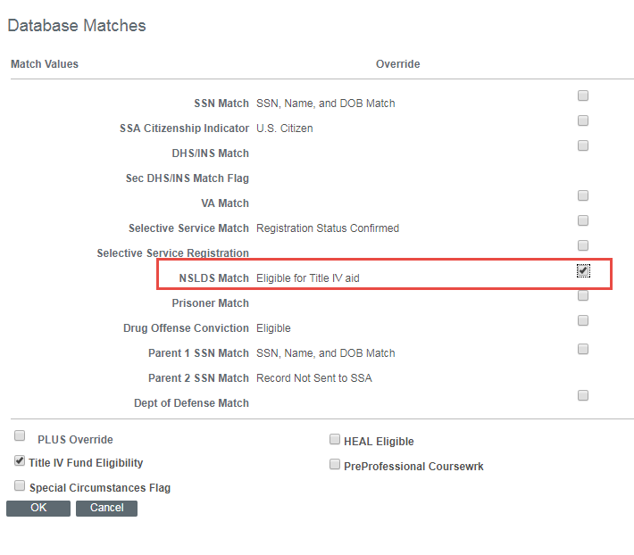

Did not earn aid
- If the student did not earn credits during the 4-year period, AND they only attended WSU during that time frame, they should also be in SAP denial and if they file an appeal, it should address why they didn’t earn any credits.
  - Any student who has a SAP appeal and also the QE checklist will be reviewed by the Assistant Director/Compliance or the Associate Director and not the SAP committee. If it is determined that the student had a valid reason for not earning any credits, the ADC or the AD will place the student on an academic plan for the next term and complete the QE Checklist.
- If the student did not earn any credits during the 4-year period, and did not attend WSU prior to fall of the earliest year during that period, the ADC or the AD will contact the student to get clarification/documentation as to why they didn’t earn any credits at their prior institutions before making a decision as to the student’s eligibility for financial aid at WSU. Basically, the student is submitting an appeal in order to regain their eligibility for financial aid.
- If it is determined that the student does not have a justifiable reason/special circumstance as to why they did not earn any credits during the 4-year period, the student is not eligible for financial aid until they have made academic progress and earn credits towards their degree.
  - In this situation, a comment entered and the student will be notified of their ineligibility for financial aid. The QE will remain outstanding until such a time as the student has made academic progress without federal funding.
- Once the file is cleared, be sure to go into Packaging Status Summary, click Database Matches, and override the NSLDS Match box.

Form UA – Selective Service Match
This form is triggered when a student has C Codes 30, 33, or 57 on ISIR. There are 9 options a student may select on this form. We will also have a section here that talks about transgendered students.

Male, U.S. citizen/eligible non-citizen, born after 12/31/60, 18, but not yet 26
- If the student selected this option, they are required to register for the Selective Service. You will need to confirm that the student uploaded a copy of their registration receipt or you can check their status at https://www.sss.gov/Registration/Check-a-Registration/Verification-Form. We also must have a copy of their ID that has their date of birth.
- If they registered, go to Packaging Status Summary, Database Matches, and make sure to check both “Selective Service Match” and “Selective Service Registration” boxes. Change Review Status from pending to complete. Click Save. Complete FR.
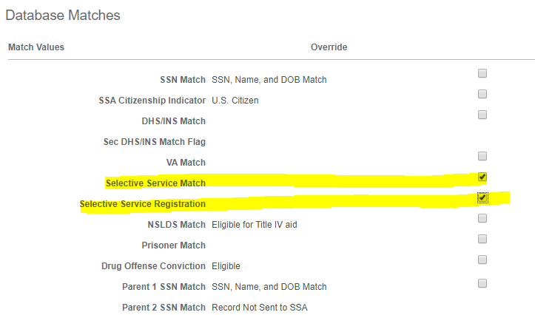

Male, U.S. citizen/eligible non-citizen, born after 12/31/60, never registered
- With this option, it is typically for someone how has failed to register for Selective Service, and is now not able to register. We will need a copy of their Status Information Letter from the Selective Service, along with a detailed letter from the student explaining their failure to register. If the Status Information Letter states they are eligible to receive financial aid, you can complete the FR.
- Go to Packaging Status Summary, Database Matches, and make sure to check both “Selective Service Match” and “Selective Service Registration” boxes. Change Review Status from pending to complete. Click Save. Complete FR.

Female
This option is for students who were born female. See below for information regarding transgendered students.
- If you can see the student is female, you will need to make a correction to her ISIR.
- Go to the Correct 20XX-20XX ISIR Pages, click the + button at the top of the page.
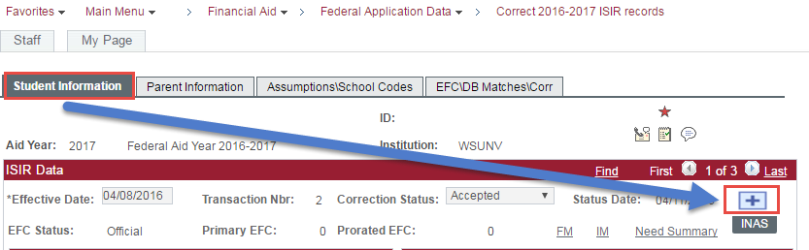
- Change the radio button to show “Female”.
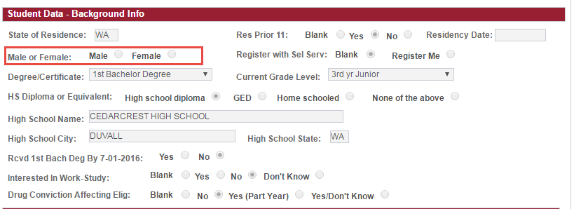
- Change the correction status to “Send Corrections” and click the INAS button. Click Save.
- Go to the View FA Status screen, complete FR, and initiate the BE Checklist. Post a comment explaining the changes you made.

Transgendered Students
The Selective Service office bases required registration on the gender assigned at birth. Students who are assigned “female” at birth are not required to register for Selective Service. Students who are assigned “male” at birth are required to register. If you have a transgendered student in question about whether or not they are required to register, you can direct them to the Selective Service website to obtain a letter that will clarify if they need to register or not. They can contact them at 1-888-655-1825 to obtain the status information letter. They will need to provide a copy of their birth certificate. If an individual is clearly not required to register with the Selective Service, we need to document this (example: original birth certificate), but do not need to collect a Status Information Letter from the Selective Service. If it is unclear that the student is exempt, a Status Information Letter is necessary (KA-33403).

Armed Services on Active Duty
- We will need a copy of the active duty military ID and ID showing their date of birth.
- Go to Packaging Status Summary, Database Matches, and make sure to check both “Selective Service Match” and “Selective Service Registration” boxes. Change Review Status from pending to complete. Complete FR.

Not 18 years old, born before 1960, or resident of Federated States of Micronesia/Marshall Islands/Palau
- If the student indicated one of these three options, the student is not required to register for the Selective Service for this academic year. If they selected not yet 18, confirm student’s date of birth with ID provided.
- Go to Packaging Status Summary and change Review Status from pending to complete. Complete FR.

Male, released from active duty before turning 26
- If the student selected this option, we will need a copy of their DD-214 showing that they were released from active duty.
- Go to Packaging Status Summary and change Review Status from pending to complete. Complete FR.

Non-US citizen who entered US after turning 26
- If the student selected this option, we will need a copy of their official immigration documentation (example: I-94) that shows their first date of entry.
- Go to Packaging Status Summary and change Review Status from pending to complete. Complete FR.

Quality Control (Internal) Queries and Processes
This section discusses the various QC queries the Document Intake Supervisor & Assistant Director run.

Student 1040 Compare Query
For students who listed the same AGI and taxes paid in both student and parent sections of the ISIR.
- Run query FA17_SC_CHK_VS_2 and enter the Aid Year in the prompt.
- Download the report into Excel.
- Review the ISIR.
  - If the AGI and Taxes Paid are the same for the student and parent:
    - Track out the 24 (student income) and 25 (parent income) checklists.
    - Make a comment in the Checklist and Comments sections.
      - Example: Requesting student and parent income information due to the AGI and taxes paid matching for student and parent.
    - Once received, proceed with the 24/25 procedures for File Review.

Assistant Director Reporting on V4 and V5
WSU must report the verification results of identity and high school completion status for students with an ISIR tracking flag V4 or V5 – as selected by CPS, not the school – and request verification documentation.
- Run query FA_VERIF_30_DAY_RPT.
- Open it as an Excel spread sheet. Sort column F (“Complete”) and remove any that have “0”.
- Delete column A (“WSU ID”).
- In column F (now blank), type in the formula “=concatenate(a3,b3,e3)” next to the first student. The result should look similar to “123456789AB1” (combined number). Do so for every student.
- Then, copy all of the combined numbers, and paste them into another sheet of the same Excel file. Save as a CSV-Comma Delimited under Z:>O&C>File Review>Applicable Year Review>Reporting>BN SI Reporting.
- Go to https://faaaccess.ed.gov/FOTWWebApp/faa/faa.jsp and login.
- Once logged in, select Identity Verification Results.
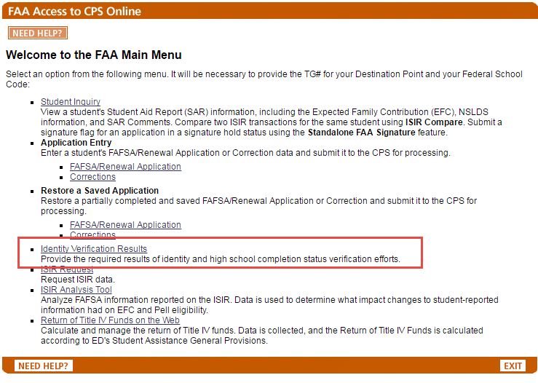
- Enter the TG# (50248), the School Code (003800), and the award year.
- Select either to enter results (manual) or load results (uploaded with excel file).
1—verification completed in person, no issues found
2—verification completed using notary, no issues found
3—verification attempted, issues found with identity
4—verification attempted, issues found with HS completion
5—no response from applicant or unable to locate
- If issues were found with both identity and high school completion status, use code 3. See the 11/13/13 and 11/6/14 electronic announcements for more information. Because the FAA Access website does not store a list of these verification results for you to retrieve, we recommend you print and keep the confirmation page for your records. If there is a change in the result you have already submitted, you can submit the new code using the above process. Instead of using this individual method, you can submit verification results by uploading a flat file with the data for up to 2,000 student.
- Click Results Entry Complete.
- Click Submit.
- Once you submit it, you should see a confirmation page. You will want to copy the results of the confirmation page, and paste them into the Excel spreadsheet, underneath the information we uploaded.
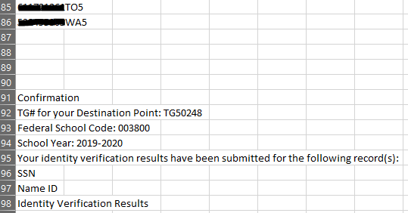

BE Initiated and Verification Pending Query
What this means is that the file reviewer has completed verification, made corrections to the ISIR, but it has been longer than the 3-5 business days and EFC status still shows “unofficial”.
- Run query FA_CHKLST_BE_INIT_VERIF_PEND
- Download the report into Excel.
- Determine if the BE has been outstanding for more than 3-5 business days.
  - On View FA Status screen, if “Correction Status” says anything other than “Correction(s) Accepted” proceed with the next steps.
- If yes, you will need to make the correction in FAA Access (https://faaaccess.ed.gov/FOTWWebApp/faa/faa.jsp)
- Once logged in the FAA Menu, locate bullet that says Application Entry and click on Corrections.
- Enter the TG #50248, Federal School Code 003800, and the aid year of the correction you are making.
- Enter the student SSN, Name, DOB, and which transaction you are correcting.
- Correct the field(s) that were updated during the verification process.
- Click Calculate EFC (this is important to put in your verification note).
- Click Submit (be sure to copy the Confirmation Number for the comments).
- Open an ES Ticket with the following verbiage:
  - Subject: Delete ISIR. I made a correction in FAA Access to an ISIR (updated XX). Can you remove transaction XX where the edits did not go out? Below is the confirmation number of the correction I made. Student ID: 123456789 Butch Coug. The confirmation number is XX.
- Put the comment on the myWSU account. You may need to cancel the BE Checklist.

98’s with Comments
What this means: We are missing information from the student’s original verification form
- Pull query FA_98S_WITH_COMMENT
- Enter the aid year in the prompt.
- This query will indicate what Grade Level the student is (freshman, sophomore, etc), the reason we are asking for additional information (the 98 reason), and their EFC.

FA_QE’s – NSLDS box has not been checked
What this means. File reviewer has completed QE review and has missed checking the NSLDS box in the Packaging Status Summary page.
- Pull query FA_QE_FR_CMPLT_NO_NSLDS_OVRD
  - This shows you a list of students who are FR complete, who had a QE, but the reviewer did not do the Database Match override. Without this override, funds will not package (federal) and will not release.
- Enter student ID in the Packaging Status Summary page. Click on Database Matches.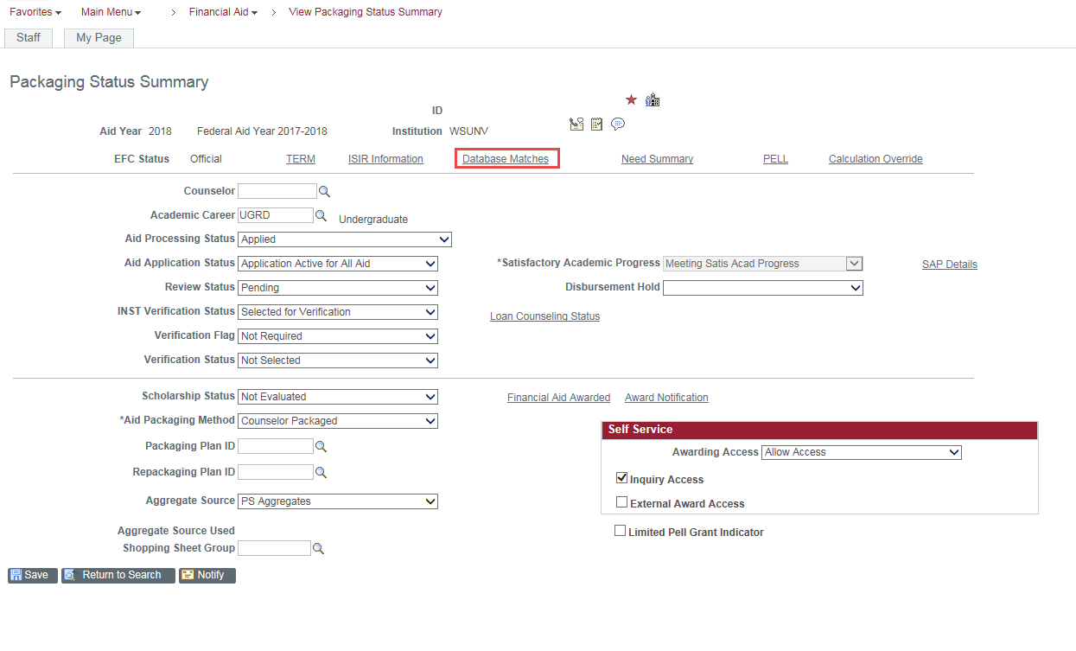
- Click the NSLDS Match and Click OK.
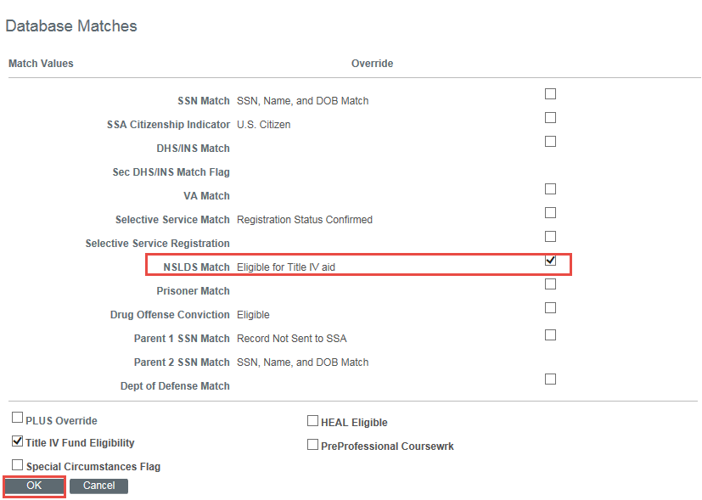

ISIR Suspense Reason Code 2
What this means. File review has been completed and there is an ISIR correction that has been made by either the applicant, school, or CPS. We manually have to review the ISIR to determine if it needs to be loaded.
- Pull Query (FA_ISIR_SUSPENSE_REASON_CD_2)
- Add FAFSA year in the prompt (example: 1920 for 2019-2020 AY)
- Review the students on the list for ISIR flags.
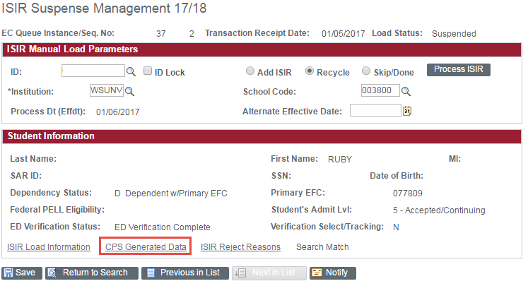
- We are only loading the ISIR if the new ISIR has a C flag change.
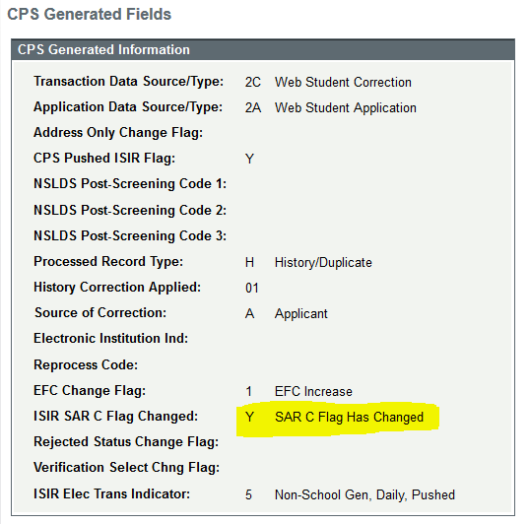
- If the C Flag has changed, we will need to load. Click Lock ID, Add ISIR, Process ISIR, and Save.
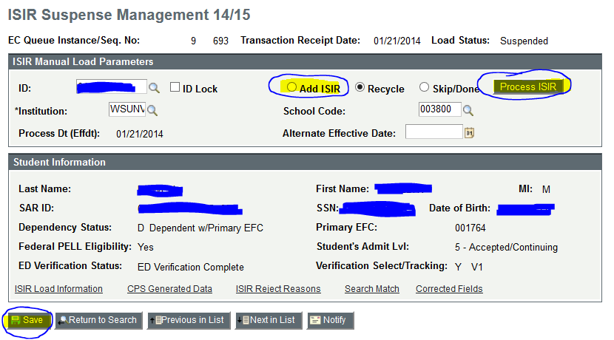
- If the C Flag has not changed, do not load the transaction; mark it as “skip/done”.
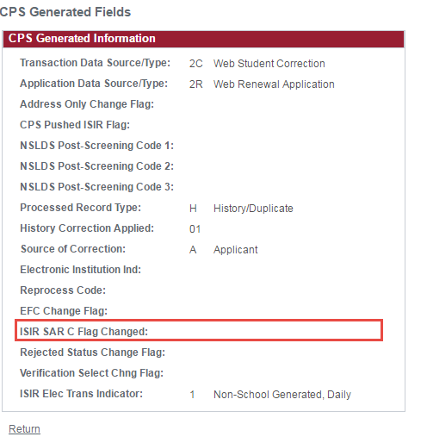
- Select Lock ID, Skip/Done, and Save. This will keep it from popping up on the query the next time you run it.
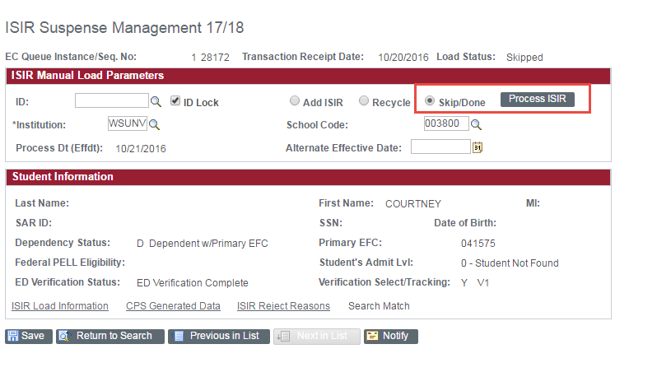

ISIR Suspense Reason Code D
What this means. ISIR is in suspense due to SSN, Name, or DOB not matching within myWSU. We need to run a query to review ISIRs being suspended. We need to determine which is accurate by looking in Student Service Center to compare the information.
- Run Query FA_ISIR_SUSPENSE_REASON_CD_D.
- Add FAFSA year in the prompt (example: 1920 for 2019-2020 AY)
- Review students on the list by comparing first name, last name, date of birth, and SSN on ISIR to what is supplied in Student Service Center, under General Information, only for the students who are “Applicant” or higher.
  - If they are less than “Applicant”, you can mark the ISIR as “skip/done”
    - Select Lock ID, Skip/Done, and Save.
  - If they match, go ahead and load the ISIR, as long as it is not a rejected ISIR.
    - Click Lock ID, Add ISIR, Process ISIR, and Save.
  - If they do not match, the student will need to either make a FAFSA correction or complete the WSU Record Change Form to fix the discrepancy. Which they update will depend on where the error lies.
    - Select Lock ID, Skip/Done, and Save. This will keep it from popping up on the query the next time you run it.
    - Once the information matches, the system should automatically pull it through.
  - If the ISIR shows a “reject” status, you can skip it. We do not load rejected ISIRs.

Form Submission Counts
This is used to get projections. The purpose of this reporting tool is to track the daily automated form submissions from SubmitSFSdocs.
- Go to https://cms.em.wsu.edu/formsubmissioncount/
- Enter the date you are tracking documents and click Go.
- The page will list the count of how many of each type of form was received for the day. Add this to the daily metric tracking to help determine how many hours of review time we need.
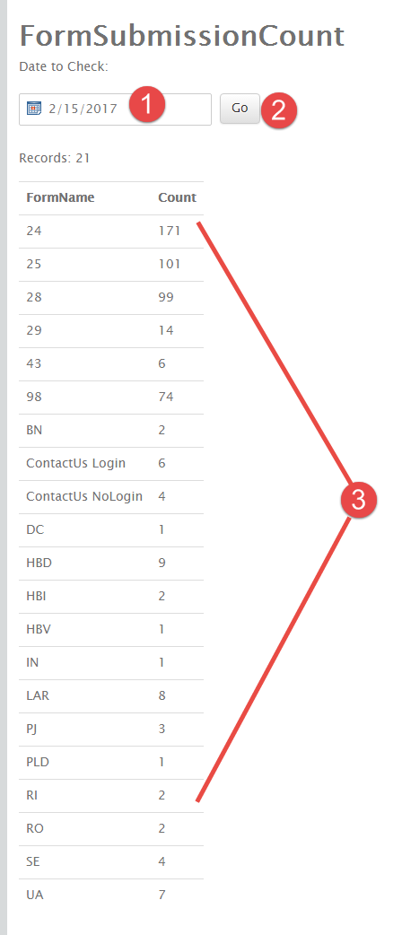

Audit: Correct Checklist Nomenclature Review for Doc Review Staff
The purpose of this audit is to ensure that document review staff are using the proper FA1/FA2 nomenclature when sending files to file review. This is a tool to help coach our staff on the proper expectations of document review.
- Use query FA_FIND_A_CHKLST_BY_STATUS
- Enter the opposite prompts for the aid year.
  - Example: Aid Year- 2018; Status- Initiated; Checklist- FA1_FR (in this particular AY, the checklist should be FA2_FR).
- Review for trends and coach appropriately.

Packaged/Verification Not Completed
This is for students who are still in verification, but have received a financial aid package. You must review the file to determine what the next steps are.
- Pull query FA_PACKAGED_VERIF_NOT_COMPLETE
- Export to Excel.
- Query Student – What is the status of the file?
  - If FR is ready – do the review and cancel the award. The student will need to be re-awarded. If a correction is made, you must wait until a new, valid ISIR is back from CPS.
  - If documents are needed, cancel the award and send an FFD communication outlining the details of what is needed.
  - If FR is complete and the Review Status is just pending, go to Packaging Status Summary to “flip the status” to Review Complete.
    - This will trigger the file to pick up in auto-packaging.
- Based on the situation, DOCUMENT the account accordingly.
  - Example: “QC: Audit on students who are awarded without verif complete. Cancelled 5170 in Pell, 100 in SEOG, and 9369 in WCG until verification complete. Tracked out 98 and sent FFD outlining what documents are needed.”

CYE Checklist Clean Up and Review

Contact Information

