STANDARD OPERATING PROCEDURES FOR HAZARDOUS AND PARTICULARLY HAZARDOUS CHEMICALS
For

Pyridine

1. PROCEDURE /  PROCESS | Pyridine is used in Building, Room.  Insert procedure here:
2. CHEMICAL NAME(S)  and associated  PHYSICAL and  HEALTH  HAZARDS | Pyridine – CAS# 110-86-1; also known as azabenzene, azine, azinine, and 1-azacyclohexa-1,3,5-diene, is a weakly alkaline clear to light yellow liquid with a penetrating nauseating odor (fishy odor).  - Pyridine is a suspected human carcinogen, classified by the IARC as Group 2B: Possibly Carcinogenic to Humans and by the ACGIH as Group A3, animal carcinogen.  - Pyridine is a highly flammable liquid and vapor. May form explosive mixtures in air.  - The substance, which can be absorbed through the skin, is toxic to eyes, skin, respiratory system, blood, kidneys, liver and central nervous system.  - Overexposure causes nausea, headache, nervous symptoms, and increased urinary frequency.  - May be fatal if swallowed and enters airways.  - Causes skin irritation and serious eye irritation.  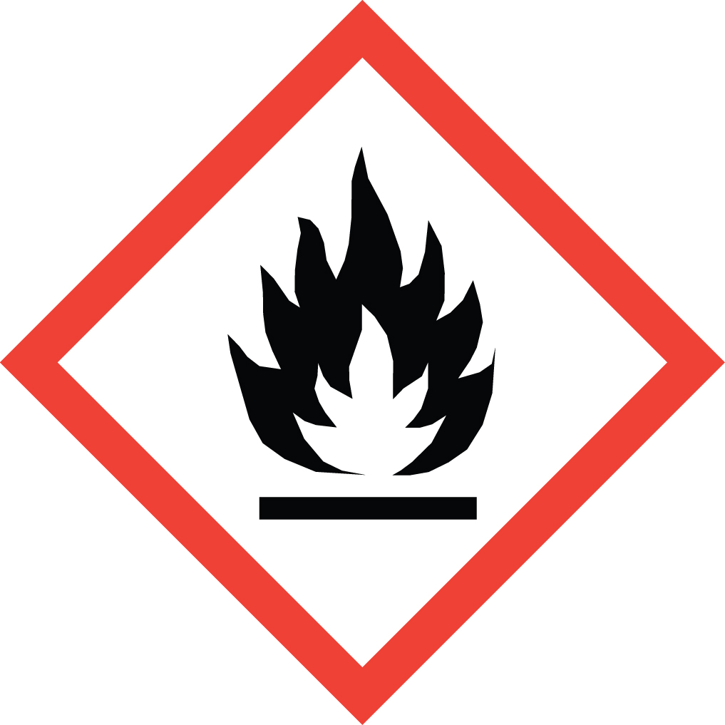 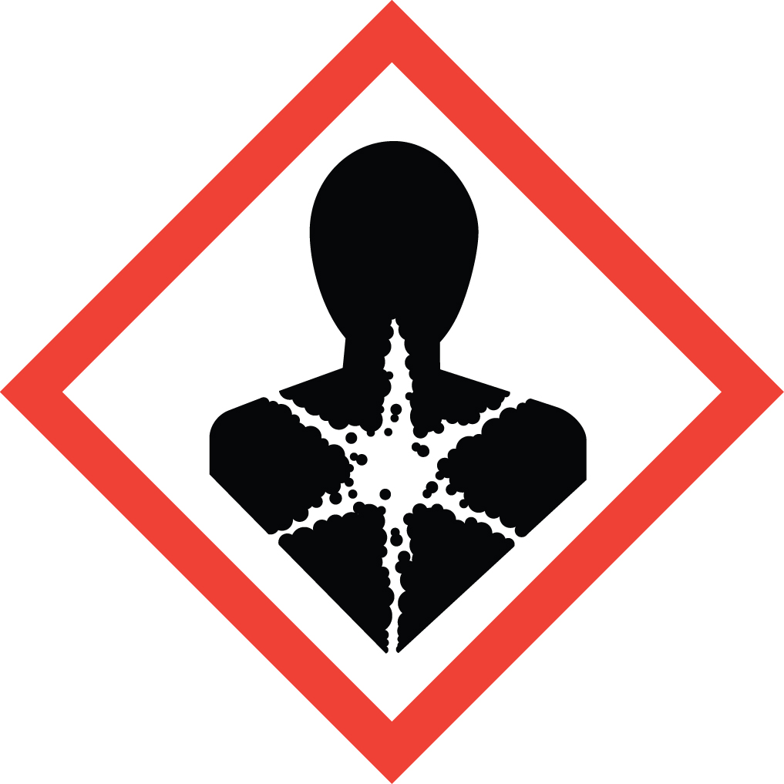 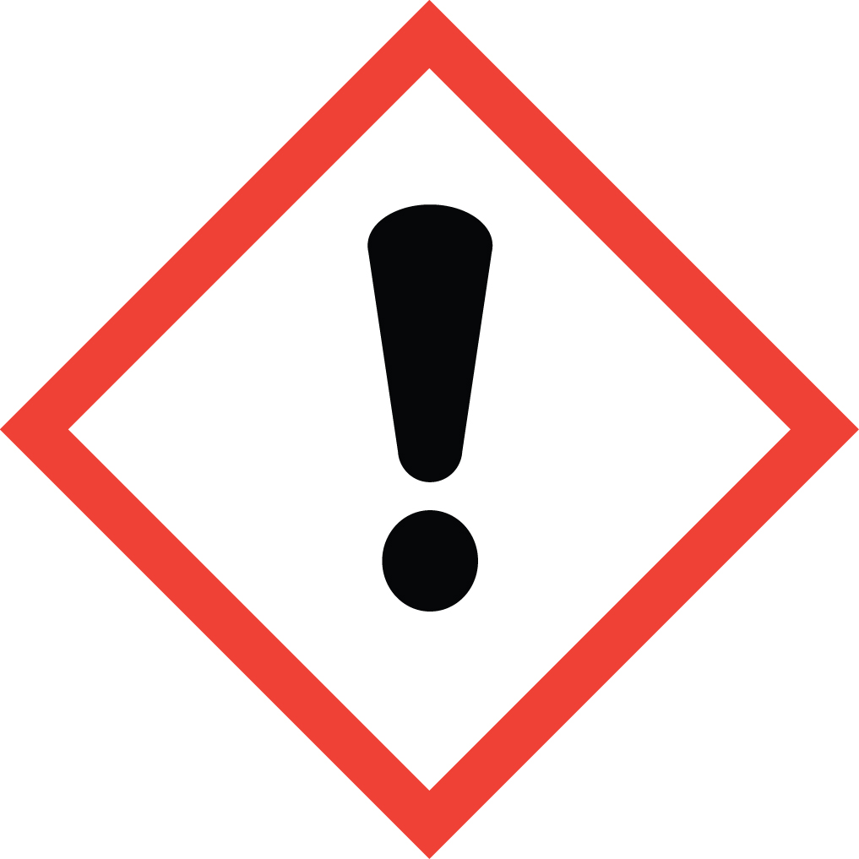 Signal Word: DANGER  Exposure Limits:  DOSH: TWA: 5 ppm; STEL: 10 ppm  NIOSH: TWA: 5 ppm; 15 mg/m³  ACGIH: TLV: 1 ppm; 3.1 mg/m³  Toxicological Data:  ORAL (LD50): 891 mg/kg [Rat]; 1,500 mg/kg [Mouse]  DERMAL (LD50): 1,121 mg/kg [Rabbit]  INHALATION (LC50): 17.1 mg/l 4 hours [Rat - Male]  *Always refer to the Safety Data Sheet for the most detailed information*
3. NAME OF TRAINER /  RESOURCE  PERSON | Principal Investigator Name, Building, Room, Phone Number  Secondary contact Name, Building, Room, Phone Number
- LOCATION OF  HEALTH & SAFETY  INFORMATION | The Safety Data Sheet (SDS) for Pyridine is located in the Laboratory Safety Manual located in Building, Room.  Labeling: In addition to the standard label that identifies contents, hazards, precautionary measures, and emergency contact information, containers should also be marked as a potential cancer hazard.
5. PROTECTIVE  EQUIPMENT | Wear chemical safety goggles, butyl rubber (or PVA) gloves and a fully-buttoned lab coat. Nitrile gloves are not recommended for this chemical (Note: Always check the manufacturer’s glove compatibility chart for proper glove selection.) Wash hands after removing gloves. Always work within a properly functioning certified laboratory chemical fume hood.  An emergency eyewash unit must be within fifty feet and ten seconds of chemical usage area when working with this substance. An emergency shower may also be necessary if potential exists for large areas of the body to be exposed to this substance.
- WASTE DISPOSAL  PROCEDURES | Waste Pyridine must be collected in its pure form and solutions. It should be collected in a sealable, airtight, compatible waste container. The container should be stored away from incompatible materials such as strong oxidizers, acids (especially nitric acid), and bases.  A completed Dangerous Waste label should be attached when waste is first added to the container. When container is full or no longer being used, complete a Chemical Collection Request Form, and deliver to the Waste Accumulation Area Operator at Building, Room, Phone Number.
7. DESIGNATED AREA  INFORMATION | The pyridine is stored and dispensed in Building, Room.  Always work in a properly functioning, certified laboratory chemical fume hood.  The designated area(s) should be shown on the floor plan in Laboratories Chemical Hygiene Plan.
8. DECONTAMINATION  PROCEDURES | Upon Accidental Exposure:  In case of eye contact, flush eyes with copious amounts of water at an emergency eyewash station for at least 15 minutes and seek medical attention.  In case of skin contact, flush skin with copious amounts of water for 15 minutes and seek medical attention. For exposure over a large portion of the body, remove clothing and shoes and rinse thoroughly in an emergency shower for at least 15 minutes. Seek medical attention.  In case of inhalation, move person to fresh air and immediately seek medical attention.  In case of ingestion, immediately seek medical attention and follow instructions on SDS.  Upon Accidental Release:  Large Spill: If a large amount of Pyridine is spilled outside the fume hood, immediately evacuate and secure area and call 911 to contact EH&S.  Small Spill: If a small amount of Pyridine is spilled (it can be cleaned up in 10 minutes) and you have been appropriately trained to clean it up, you may do so. Trained personnel should wear at the minimum chemical safety goggles, butyl rubber (or PVA) gloves and a fully-buttoned lab coat. Nitrile gloves are not recommended for this chemical.  Additional PPE such as respirators may be necessary depending upon material and concentration. (Note: You must be medically cleared, fit tested and enrolled in WSU’s respiratory protection program to wear a respirator). If it is necessary to use a respirator and personnel are not cleared to wear a respirator and not trained to appropriately clean up the spill, the employee should immediately evacuate, secure area, and call 911 to contact EH&S.  Absorb with an inert dry material and place material in an appropriate waste disposal container (resealable bag, etc.) and dispose of as hazardous waste (see above WASTE DISPOSAL PROCEDURES).  As with all accidents, report any exposure as soon as possible to your Principal Investigator or Supervisor. Additional health and safety information on Pyridine can be obtained by referring to the SDS or by calling the EH&S Office (335-3041).
- SPECIAL STORAGE  AND HANDLING  PROCEDURES | Store in a tightly closed container in a secured, cool, dry and well-ventilated area. Store as a flammable material. Store segregated from incompatible chemicals (below). Store away from direct sunlight, heat, sparks, flame or any other source of ignition.  Keep away from incompatible chemicals such as strong oxidizers, acids (especially nitric acid), and bases.

Certification of Hazard Assessment

Is this document a certification of Hazard Assessment for the processes identified within? Yes No
If yes, provide the name of the person certifying the Hazard Assessment and the date it was performed:

____________________________________________________________________________________
Name Date

The location of the Hazard Assessment is indicated in the document preceding this form.

Certificate of Employee Training

Name of person providing training for employees working with this process:

___________________________________________________________________________________
The following employees have been trained in when, where and how to use selected PPE, the maintenance, limitations and disposal of the PPE selected, and have demonstrated the correct use of the PPE selected on the reverse of this certification.
Name Date Trained
________________________________________ _______________________________
________________________________________ _______________________________
________________________________________ _______________________________
________________________________________ _______________________________
________________________________________ _______________________________
________________________________________ _______________________________
________________________________________ _______________________________

