STANDARD OPERATING PROCEDURES FOR HAZARDOUS AND PARTICULARLY HAZARDOUS CHEMICALS
For

Methylamine (aqueous solution)

1. PROCEDURE /  PROCESS | Methylamine is used in Building, Room.  Insert procedure here:
2. CHEMICAL NAME(S)  and associated  PHYSICAL and  HEALTH  HAZARDS | Methylamine – CAS# 74-89-5; also known as methanamine, aminomethane, and monomethylamine, is the simplest primary amine and a derivative of ammonia. It is a colorless gas or liquid with a pungent fishy odor. It is sold as a solution in methanol, ethanol, tetrahydrofuran, or water, or as the anhydrous gas in pressurized metal containers.  - Methylamine is a highly flammable liquid and vapor. May form explosive mixtures in air.  - The substance, which can be absorbed through the skin, is toxic to eyes, skin, respiratory system, lung, liver and central nervous system.  - Causes digestive and respiratory tract burns.  - May be fatal if swallowed and enters airways.  - Causes skin and eye burns.  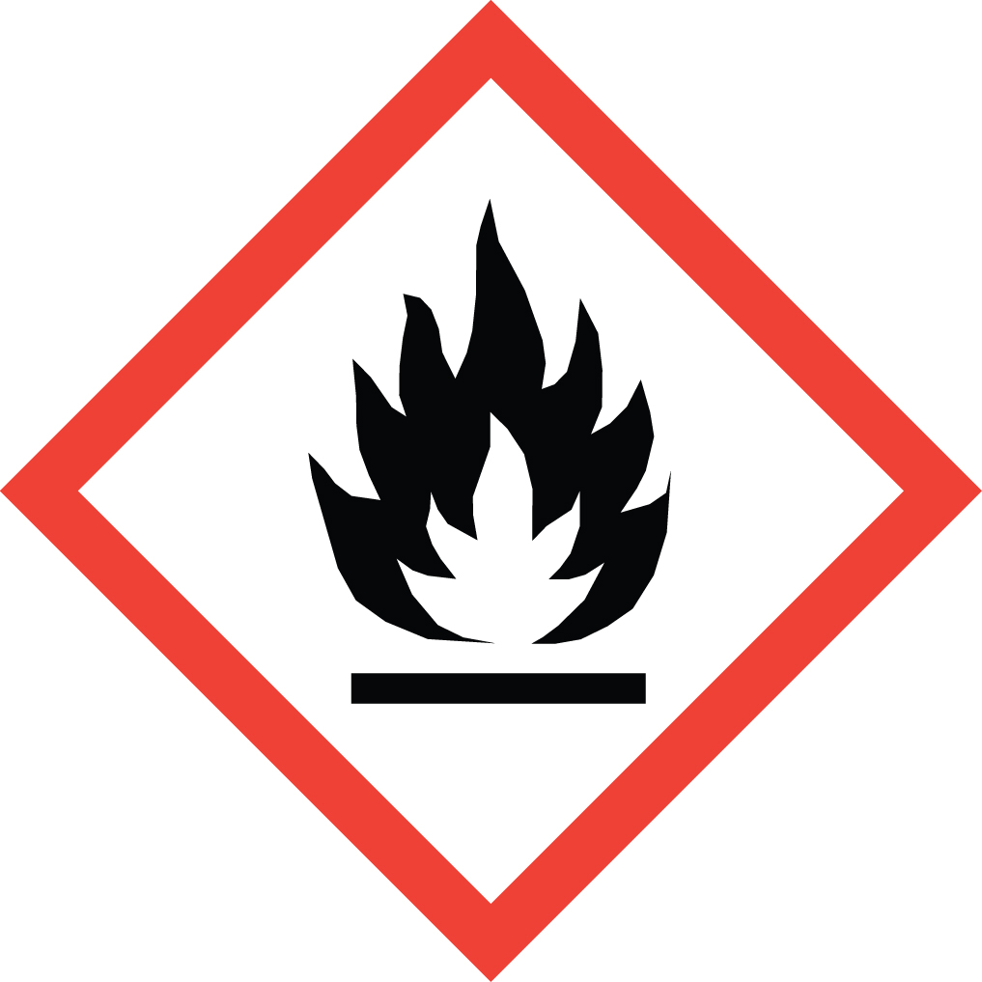 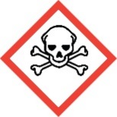 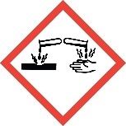 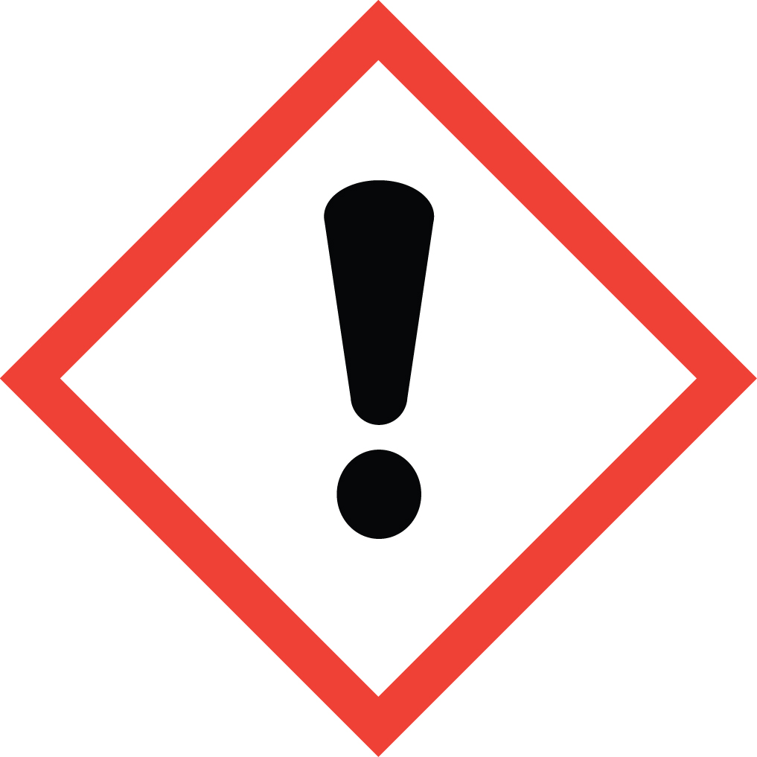 Signal Word: DANGER  Exposure Limits:  DOSH: TWA: 10 ppm; STEL: 20 ppm  NIOSH: TWA: 10 ppm; 12 mg/m³  ACGIH: TLV: 5 ppm; 6.4 mg/m³; STEL: 15 ppm; 19 mg/m³  Toxicological Data:  ORAL (LD50): 698 mg/kg [Rat]  INHALATION (LC50): >2.1 - <2.9 mg/l 4 hours [Rat - Male]  *Always refer to the Safety Data Sheet for the most detailed information*
3. NAME OF TRAINER /  RESOURCE  PERSON | Principal Investigator Name, Building, Room, Phone Number  Secondary contact Name, Building, Room, Phone Number
- LOCATION OF  HEALTH & SAFETY  INFORMATION | The Safety Data Sheet (SDS) for Methylamine is located in the Laboratory Safety Manual located in Building, Room.  Labeling: A standard label should be attached that identifies contents, hazards, precautionary measures, and emergency contact information.
5. PROTECTIVE  EQUIPMENT | Wear chemical safety goggles, nitrile, neoprene, or PVC gloves and a fully-buttoned lab coat. For more than splash contact, wear butyl gloves (Note: Always check the manufacturer’s glove compatibility chart for proper glove selection.) A face shield is also recommended. Wash hands after removing gloves. Always work within a properly functioning certified laboratory chemical fume hood.  An emergency eyewash unit must be within fifty feet and ten seconds of chemical usage area when working with this substance. An emergency shower may also be necessary if potential exists for large areas of the body to be exposed to this substance.
- WASTE DISPOSAL  PROCEDURES | Waste Methylamine must be collected in its pure form and solutions. It should be collected in a sealable, airtight, compatible waste container. The container should be stored away from incompatible materials such as mercury, strong oxidizers, acids, acid chlorides, acid anhydrides, chloroformates, perchlorates, halogenated agents, phosphorus halides and nitromethane. It is corrosive to copper and zinc alloys, aluminum and galvanized surfaces.  A completed Dangerous Waste label should be attached when waste is first added to the container. When container is full or no longer being used, complete a Chemical Collection Request Form, and deliver to the Waste Accumulation Area Operator at Building, Room, Phone Number.
7. DESIGNATED AREA  INFORMATION | The methylamine is stored and dispensed in Building, Room.  Always work in a properly functioning, certified laboratory chemical fume hood.  The designated area(s) should be shown on the floor plan in Laboratories Chemical Hygiene Plan.
8. DECONTAMINATION  PROCEDURES | Upon Accidental Exposure:  In case of eye contact, flush eyes with copious amounts of water at an emergency eyewash station for at least 15 minutes and seek medical attention.  In case of skin contact, flush skin with copious amounts of water for 15 minutes and seek medical attention. For exposure over a large portion of the body, remove clothing and shoes and rinse thoroughly in an emergency shower for at least 15 minutes. Seek medical attention.  In case of inhalation, move person to fresh air and immediately seek medical attention.  In case of ingestion, immediately seek medical attention and follow instructions on SDS.  Upon Accidental Release:  Large Spill: If a large amount of Methylamine is spilled outside the fume hood, immediately evacuate and secure area and call 911 to contact EH&S.  Small Spill: If a small amount of Methylamine is spilled (it can be cleaned up in 10 minutes) and you have been appropriately trained to clean it up, you may do so. Trained personnel should wear at the minimum chemical safety goggles, nitrile, neoprene or PVC gloves and a fully-buttoned lab coat. For more than splash contact, wear butyl gloves. A face shield is also recommended.  Additional PPE such as respirators may be necessary depending upon material and concentration. (Note: You must be medically cleared, fit tested and enrolled in WSU’s respiratory protection program to wear a respirator). If it is necessary to use a respirator and personnel are not cleared to wear a respirator and not trained to appropriately clean up the spill, the employee should immediately evacuate, secure area, and call 911 to contact EH&S.  Absorb with an inert dry material and place material in an appropriate waste disposal container (resealable bag, etc.) and dispose of as hazardous waste (see above WASTE DISPOSAL PROCEDURES).  As with all accidents, report any exposure as soon as possible to your Principal Investigator or Supervisor. Additional health and safety information on Methylamine can be obtained by referring to the SDS or by calling the EH&S Office (335-3041).
- SPECIAL STORAGE  AND HANDLING  PROCEDURES | Store in a tightly closed container in a secured, cool, dry and well-ventilated area. Store as a flammable material. Store segregated from incompatible chemicals (below). Store away from direct sunlight, heat, sparks, flame or any other source of ignition.  Keep away from incompatible chemicals such as mercury, strong oxidizers, acids, acid chlorides, acid anhydrides, chloroformates, perchlorates, halogenated agents, phosphorus halides and nitromethane. It is corrosive to copper and zinc alloys, aluminum and galvanized surfaces.

Certification of Hazard Assessment

Is this document a certification of Hazard Assessment for the processes identified within? Yes No
If yes, provide the name of the person certifying the Hazard Assessment and the date it was performed:

____________________________________________________________________________________
Name Date

The location of the Hazard Assessment is indicated in the document preceding this form.

Certificate of Employee Training

Name of person providing training for employees working with this process:

___________________________________________________________________________________
The following employees have been trained in when, where and how to use selected PPE, the maintenance, limitations and disposal of the PPE selected, and have demonstrated the correct use of the PPE selected on the reverse of this certification.
Name Date Trained
________________________________________ _______________________________
________________________________________ _______________________________
________________________________________ _______________________________
________________________________________ _______________________________
________________________________________ _______________________________
________________________________________ _______________________________
________________________________________ _______________________________

