STANDARD OPERATING PROCEDURES FOR HAZARDOUS AND PARTICULARLY HAZARDOUS CHEMICALS
For

n-Heptane

1. PROCEDURE /  PROCESS | n-Heptane is used in Building, Room.  Insert procedure here:
2. CHEMICAL NAME(S)  and associated  PHYSICAL and  HEALTH  HAZARDS | n-Heptane – CAS# 142-82-5; also known as Heptane, normal-Heptane, Dipropyl methane, and Heptyl hydride. It is colorless liquid with a mild, Gasoline-like odor. It is used as an industrial solvent and in petroleum refining processes.  - Highly flammable liquid and vapor. May form explosive mixtures in air.  - May be fatal if swallowed and enters airways.  - Causes skin and eye irritation.  - May cause drowsiness or dizziness.  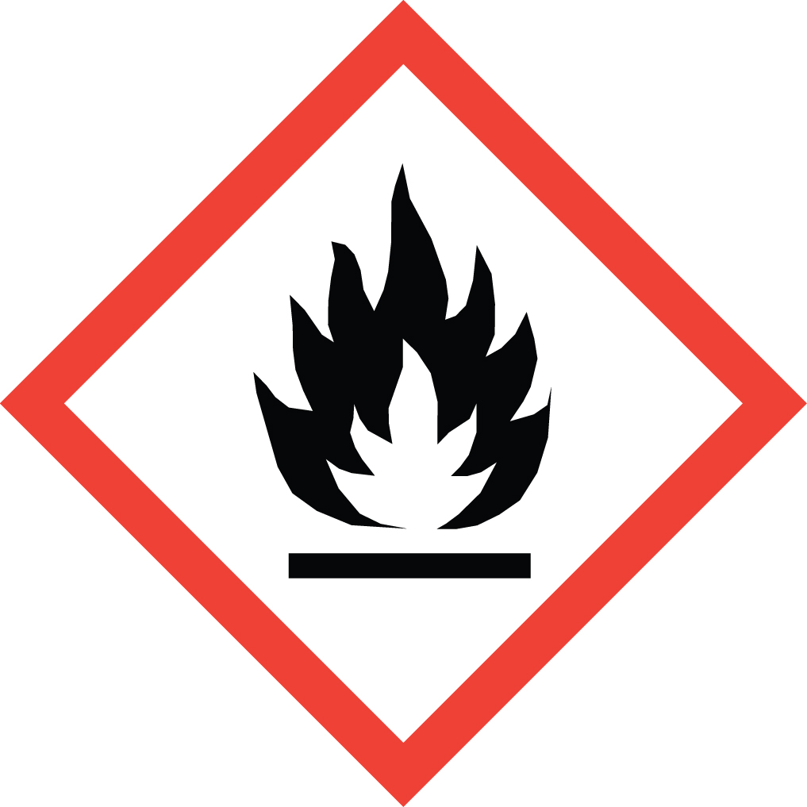 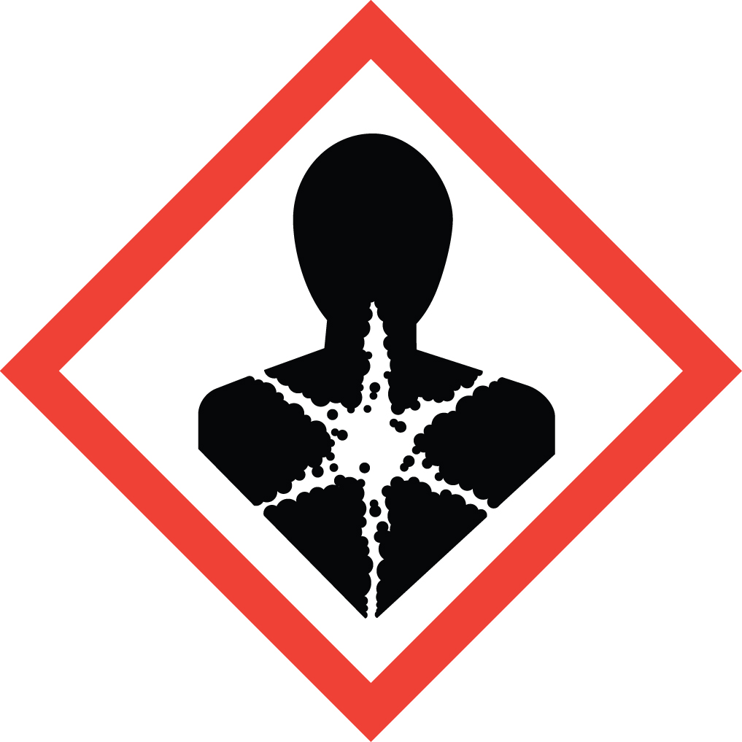 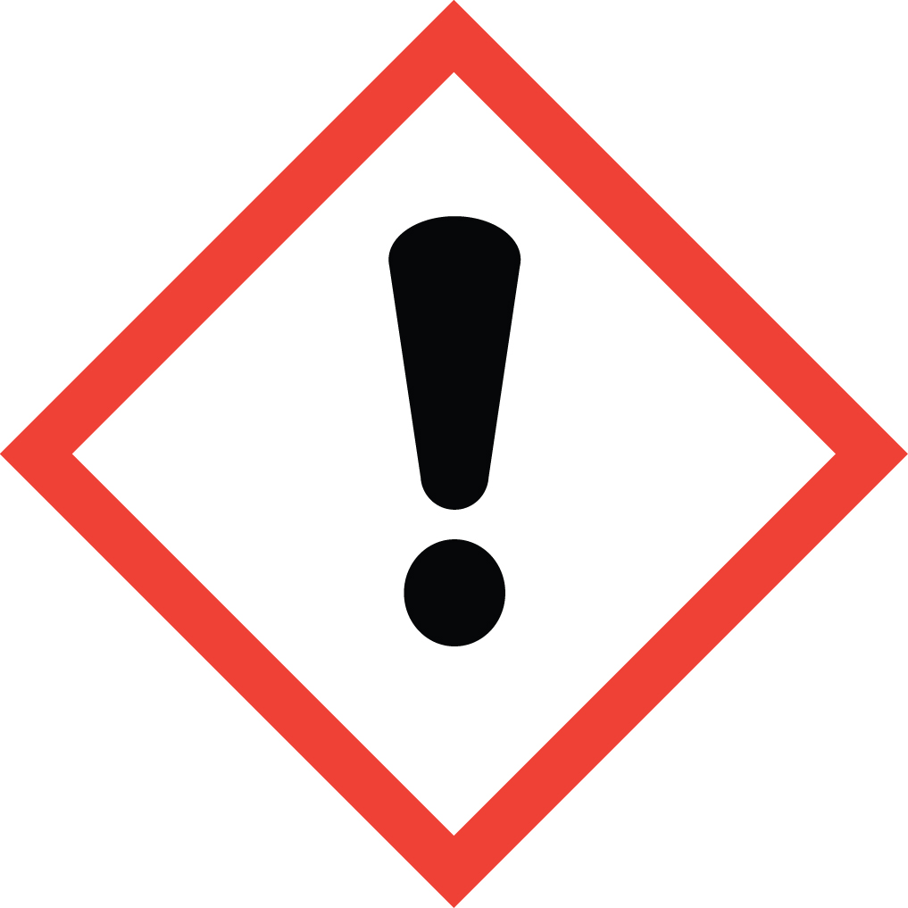 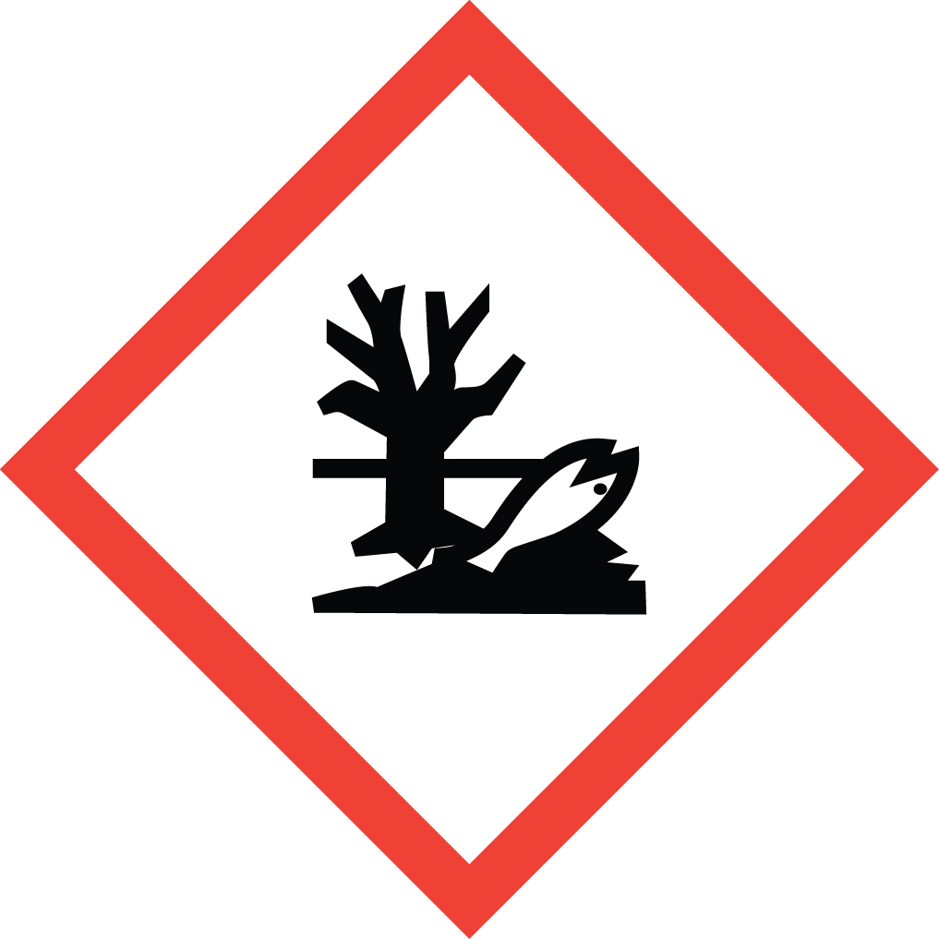 Signal Word: DANGER  Exposure Limits:  DOSH: TWA: 400 ppm; STEL: 500 ppm  NIOSH: TWA: 85 ppm; CEIL: 440 ppm [15 minutes]  ACGIH: TWA: 400 ppm; STEL: 500 ppm  Toxicological Data:  ORAL (LD50): >5,000 mg/kg [Rat]  DERMAL (LD50): >2,000 mg/kg [Rabbit]  INHALATION (LC50): 103,000 mg/m 4 hours [Rat]  *Always refer to the Safety Data Sheet for the most detailed information*
3. NAME OF TRAINER /  RESOURCE  PERSON | Principal Investigator Name, Building, Room, Phone Number  Secondary contact Name, Building, Room, Phone Number
- LOCATION OF  HEALTH & SAFETY  INFORMATION | The Safety Data Sheet (SDS) for n-Heptane is located in the Laboratory Safety Manual located in Building, Room.  Labeling: Containers shall either have original warning label affixed or a label identifying the contents and hazards.
5. PROTECTIVE  EQUIPMENT | Wear chemical safety goggles, nitrile gloves and a fully-buttoned lab coat. If gloves are contacted, replace them immediately. For more than incidental splash contact, wear Viton or PVA gloves. (Note: Always check the manufacturer’s glove compatibility chart for proper glove selection.) Wash hands after removing gloves. Always work within a properly functioning certified laboratory chemical fume hood.
- WASTE DISPOSAL  PROCEDURES | Waste n-Heptane must be collected in its pure form and solutions. It should be collected in a sealable, airtight, compatible waste container. The container should be stored away from incompatible materials such as strong oxidizers, acids (especially nitric acid), bases, halogens, metallic salts, fluorides and perchlorates.  A completed Dangerous Waste label should be attached when waste is first added to the container. When container is full or no longer being used, complete a Chemical Collection Request Form, and deliver to the Waste Accumulation Area Operator at Building, Room, Phone Number.
7. DESIGNATED AREA  INFORMATION | The n-Heptane is stored and dispensed in Building, Room.  Always work in a properly functioning, certified laboratory chemical fume hood.  The designated area(s) should be shown on the floor plan in Laboratories Chemical Hygiene Plan.
8. DECONTAMINATION  PROCEDURES | Upon Accidental Exposure:  In case of eye contact, flush eyes with copious amounts of water at an emergency eyewash station for at least 15 minutes and seek medical attention.  In case of skin contact, flush skin with copious amounts of water for 15 minutes and seek medical attention. For exposure over a large portion of the body, remove clothing and shoes and rinse thoroughly in an emergency shower for at least 15 minutes. Seek medical attention.  In case of inhalation, move person to fresh air and immediately seek medical attention.  In case of ingestion, immediately seek medical attention and follow instructions on SDS.  Upon Accidental Release:  Large Spill: If a large amount of n-Heptane is released outside the fume hood, immediately evacuate and secure area and call 911 to contact EH&S.  Small Spill: If a small amount of n-Heptane is released (it can be cleaned up in 10 minutes) and you have been appropriately trained to clean it up, you may do so. Trained personnel should wear at the minimum nitrile rubber, Viton, or PVA gloves, chemical safety goggles, and a fully-buttoned lab coat. (Note: Always check the manufacturer’s glove compatibility chart for proper glove selection.)  Additional PPE such as respirators may be necessary depending upon material and concentration. (Note: You must be medically cleared, fit tested and enrolled in WSU’s respiratory protection program to wear a respirator). If it is necessary to use a respirator and personnel are not cleared to wear a respirator and not trained to appropriately clean up the spill, the employee should immediately evacuate, secure area, and call 911 to contact EH&S.  Absorb with an inert dry material and place material in an appropriate waste disposal container (resealable bag, etc.) and dispose of as hazardous waste (see above WASTE DISPOSAL PROCEDURES).  As with all accidents, report any exposure as soon as possible to your Principal Investigator or Supervisor. Additional health and safety information on n-Heptane can be obtained by referring to the SDS or by calling the EH&S Office (335-3041).
- SPECIAL STORAGE  AND HANDLING  PROCEDURES | Store in a tightly closed container in a secured, cool, dry and well-ventilated area away from plastics, rubber and coatings. Store as a flammable material. Store away from direct sunlight, heat, sparks, flame or any other source of ignition.  Keep away from incompatibles such as strong oxidizers, acids (especially nitric acid), bases, halogens, metallic salts, fluorides and perchlorates.

Certification of Hazard Assessment

Is this document a certification of Hazard Assessment for the processes identified within? Yes No
If yes, provide the name of the person certifying the Hazard Assessment and the date it was performed:

____________________________________________________________________________________
Name Date

The location of the Hazard Assessment is indicated in the document preceding this form.

Certificate of Employee Training

Name of person providing training for employees working with this process:

___________________________________________________________________________________
The following employees have been trained in when, where and how to use selected PPE, the maintenance, limitations and disposal of the PPE selected, and have demonstrated the correct use of the PPE selected on the reverse of this certification.
Name Date Trained
________________________________________ _______________________________
________________________________________ _______________________________
________________________________________ _______________________________
________________________________________ _______________________________
________________________________________ _______________________________
________________________________________ _______________________________
________________________________________ _______________________________

