STANDARD OPERATING PROCEDURES FOR HAZARDOUS AND PARTICULARLY HAZARDOUS CHEMICALS
For

Formic Acid

1. PROCEDURE /  PROCESS | Formic Acid is used in Building, Room.  Insert procedure here:  REMEMBER! Always add acid to water to limit exothermic reactions such as splatter, bubbling and fuming.  A large amount of heat is generated when strong acids are mixed with water. Adding more acid releases more heat. Adding water to acid forms an extremely concentrated solution of acid. Heat causes the solution to boil violently, splashing concentrated acid out of the container.  Adding acid to water, the resulting solution is dilute and the heat released is absorbed by the water.  Always Add Acid to water.
2. CHEMICAL NAME(S)  and associated  PHYSICAL and  HEALTH  HAZARDS | Formic Acid- CAS # 64-18-6; also known as formic acid (85-95% in aqueous solution; hydrogen carboxylic acid; Methanoic acid; and aminic acid.  - Flammable liquid and vapor.  - Corrosive chemical. Causes severe skin burns and eye damage.  - Toxic when inhaled. Can irritate and damage the nose, throat and lungs.  - Ingestion can cause severe injury leading to death.  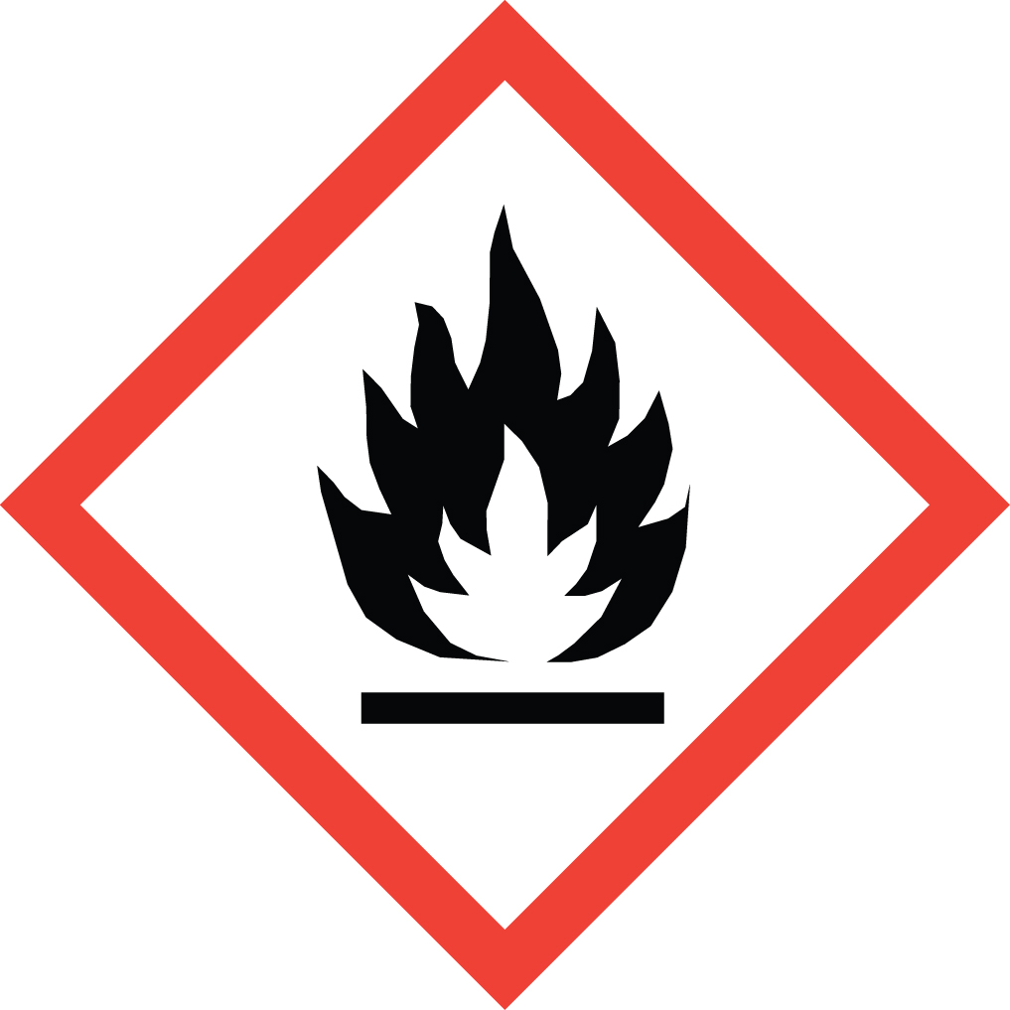 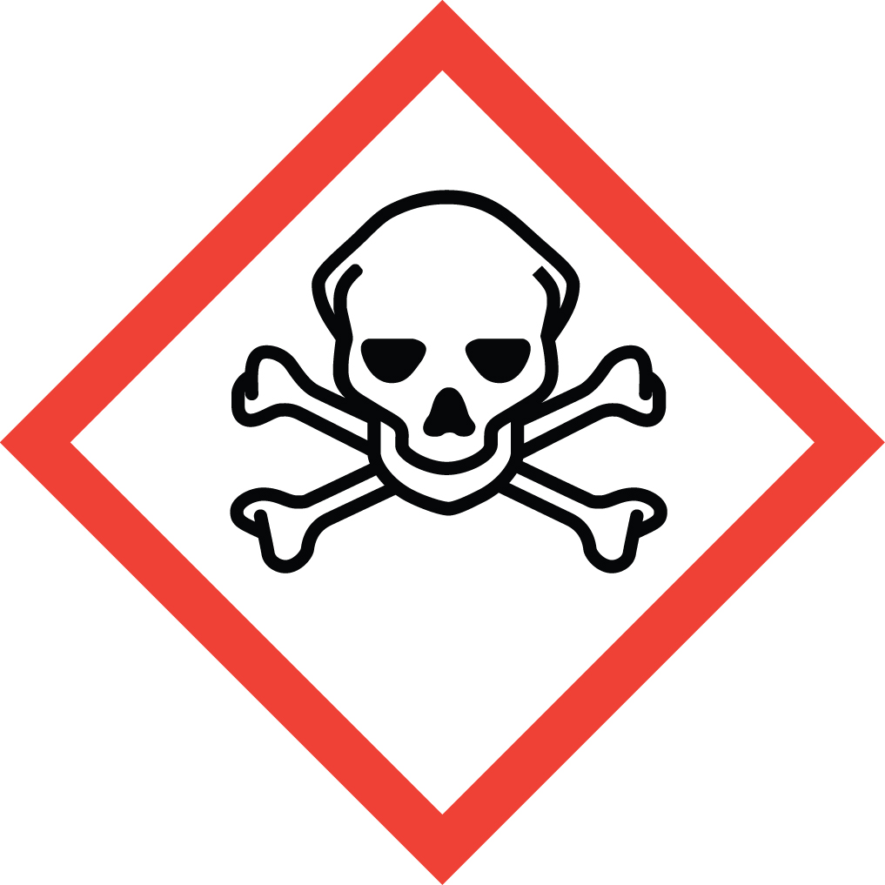 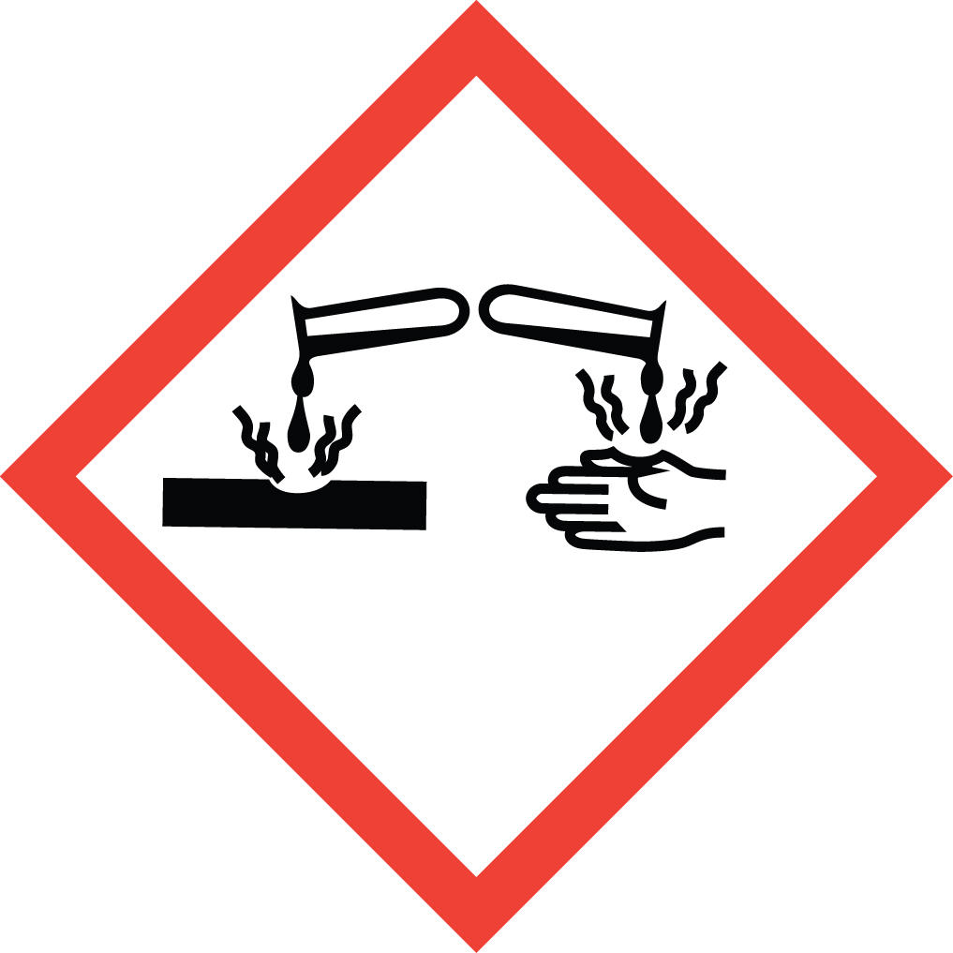 Signal Word: DANGER  Exposure Limits:  DOSH: TWA: 5 ppm; STEL: 10 ppm  NIOSH: TWA: 5 ppm  ACGIH: TWA: 5 ppm; STEL: 10 ppm  Toxicological Data:  ORAL (LD50): 730 mg/kg [Rat]  INHALATION (LC50): 7.4 mg/L 4 hours [Rat]  *Always refer to the Safety Data Sheet for the most detailed information*
3. NAME OF TRAINER /  RESOURCE  PERSON | Principal Investigator Name, Building, Room, Phone Number  Secondary contact Name, Building, Room, Phone Number
- LOCATION OF  HEALTH & SAFETY  INFORMATION | The Safety Data Sheet (SDS) for Formic Acid is located in the Laboratory Safety Manual in Building, Room  Labeling: Containers shall either have original warning label affixed or a label identifying the contents and hazards.
5. PROTECTIVE  EQUIPMENT | Wear at the minimum nitrile rubber gloves, chemical splash goggles, and a fully buttoned lab coat. For higher acid concentrations or for increased exposure potential, you may want to use neoprene or butyl rubber gloves. Wash hands after removing gloves. Always work within a properly functioning, certified laboratory chemical fume hood.
- WASTE DISPOSAL  PROCEDURES | Waste Formic Acid must be managed as a Dangerous Waste if it has a pH of 5 or lower or if it 1% or greater. Material should be collected in a compatible container with a vented lid designed for storage of acids and bases. The container should be stored away from incompatible materials such as strong oxidizers, strong caustics, concentrated sulfuric acid, and powdered metals.  A completed Dangerous Waste label should be attached when waste is first added to the container. When container is full or no longer being used, complete a Chemical Collection Request Form, and deliver to the Waste Accumulation Area Operator at Building, Room, Phone Number.  If the solution has a pH between 5 and 9 and is less than 1% it may be drained discharge. The solution cannot legally be diluted to alter the pH or concentration for disposal purposes.
7. DESIGNATED AREA  INFORMATION | The formic acid is stored and dispensed in Building, Room.  Diluted acid solutions using this chemical are prepared immediately prior to use in Building, Room.  Confine all work with formic acid to a properly functioning certified laboratory chemical fume hood.  The designated area(s) should be shown on the floor plan in Laboratories Chemical Hygiene Plan.
8. DECONTAMINATION  PROCEDURES | Upon Accidental Exposure:  In case of eye contact, flush eyes with copious amounts of water at an emergency eyewash station for at least 15 minutes and seek medical attention.  In case of skin contact, flush skin with copious amounts of water for 15 minutes and seek medical attention. For exposure over a large portion of the body, remove clothing and shoes and rinse thoroughly in an emergency shower for at least 15 minutes. Seek medical attention.  In case of inhalation, move person to fresh air and seek medical attention.  In case of ingestion, immediately seek medical attention and follow instructions on SDS.  Upon Accidental Release:  Large Spill: If a significant amount of formic acid is spilled outside the fume hood, immediately evacuate, secure area and call 911 to contact EH&S.  Small Spill: If a small amount of formic acid is spilled (it can be cleaned up in 10 minutes) and you have been appropriately trained to clean it up, you may do so. Trained personnel should wear at the minimum nitrile, neoprene, or butyl gloves, chemical splash goggles, and a fully-buttoned lab coat.  Additional PPE such as respirators may be necessary depending upon material and concentration. (Note: You must be medically cleared, fit tested and enrolled in WSU’s respiratory protection program to wear a respirator). If it is necessary to use a respirator and personnel are not cleared to wear a respirator and not trained to appropriately clean up the spill, the employee should immediately evacuate, secure area, and call 911 to contact EH&S.  Absorb with an inert dry material and place material in an appropriate waste disposal container (resealable bag, etc.) and dispose of as hazardous waste (see above WASTE DISPOSAL PROCEDURES).  Please do not use a neutralizer to clean up spill unless you are currently in the respiratory protection program and have been properly trained.  As with all accidents, report any exposure as soon as possible to your Principal Investigator or Supervisor. Additional health and safety information on formic acid can be obtained by referring to the SDS or by calling the EH&S Office (335-3041).
- SPECIAL STORAGE  AND HANDLING  PROCEDURES | Store in a secured, cool and well-ventilated area away from direct sunlight, heat, sparks, flame, or other sources of ignition. Store in a tightly closed container until ready for use. Store segregated from incompatible chemicals (below). Store in secondary containment such as a Nalgene/polypropylene tub.  Keep away from incompatible chemicals such as strong oxidizers, strong caustics, concentrated sulfuric acid, and powdered metals.

Certification of Hazard Assessment

Is this document a certification of Hazard Assessment for the processes identified within? Yes No
If yes, provide the name of the person certifying the Hazard Assessment and the date it was performed:

____________________________________________________________________________________
Name Date

The location of the Hazard Assessment is indicated in the document preceding this form.

Certificate of Employee Training

Name of person providing training for employees working with this process:

___________________________________________________________________________________
The following employees have been trained in when, where and how to use selected PPE, the maintenance, limitations and disposal of the PPE selected, and have demonstrated the correct use of the PPE selected on the reverse of this certification.
Name Date Trained
________________________________________ _______________________________
________________________________________ _______________________________
________________________________________ _______________________________
________________________________________ _______________________________
________________________________________ _______________________________
________________________________________ _______________________________
________________________________________ _______________________________

