STANDARD OPERATING PROCEDURES FOR HAZARDOUS AND PARTICULARLY HAZARDOUS CHEMICALS
For
Sodium Cyanide

1. PROCEDURE /  PROCESS | Sodium cyanide is used in Building, Room.  Insert procedure here:
2. CHEMICAL NAME(S)  and associated  PHYSICAL and  HEALTH  HAZARDS | Sodium Cyanide – CAS# 143-33-9; also known as sodium salt of hydrocyanic acid.  - Sodium Cyanide is an acute toxin and a chronic toxin that is rapidly absorbed through the skin.  - Fatal if swallowed or in contact with skin.  - Highly Toxic by inhalation, ingestion, & skin absorption. Contact can irritate the skin and eyes.  - Inhalation can irritate the nose, throat and lungs, resulting in possible lung damage, choking, unconsciousness or death.  - The substance may be toxic to the central nervous system (CNS), blood, lungs, cardiovascular system, and thyroid.  - There is limited evidence that sodium cyanide is a teratogen in animals. Until further testing has been done, it should be treated as a possible teratogen in humans.  - Chronic exposure to cyanide solutions may lead to "cyanide" rash with itching and vesicular eruptions with secondary infection.  - Small amounts of cyanide over long periods of time causes loss of appetite, headache, weakness, and respiratory irritation.  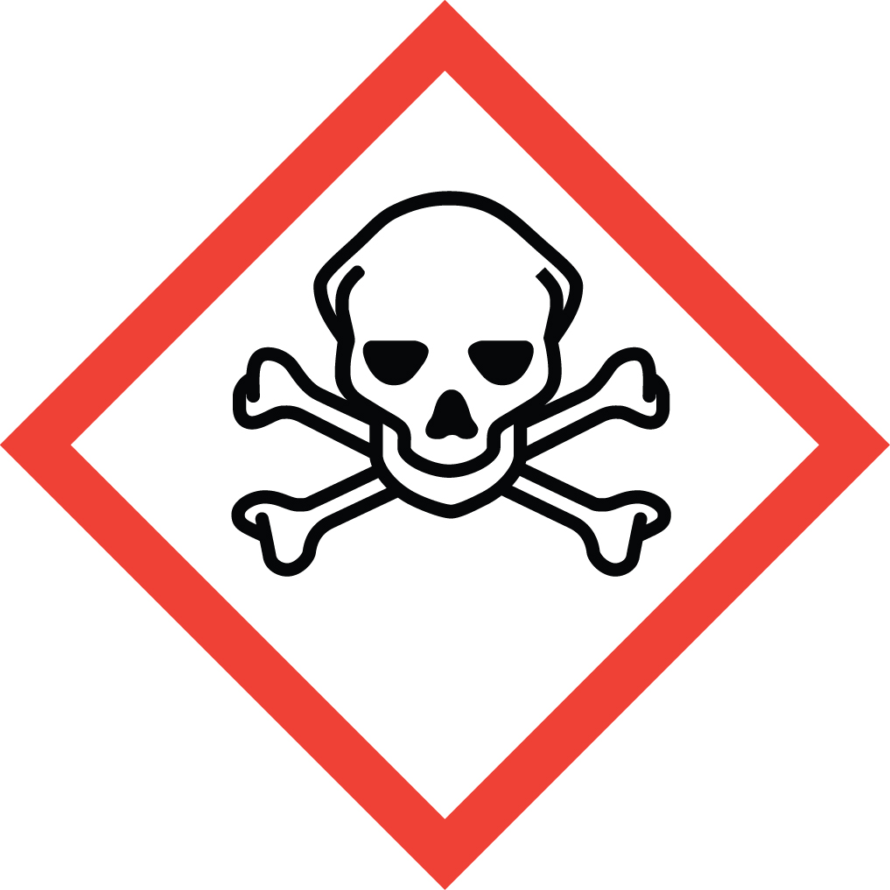 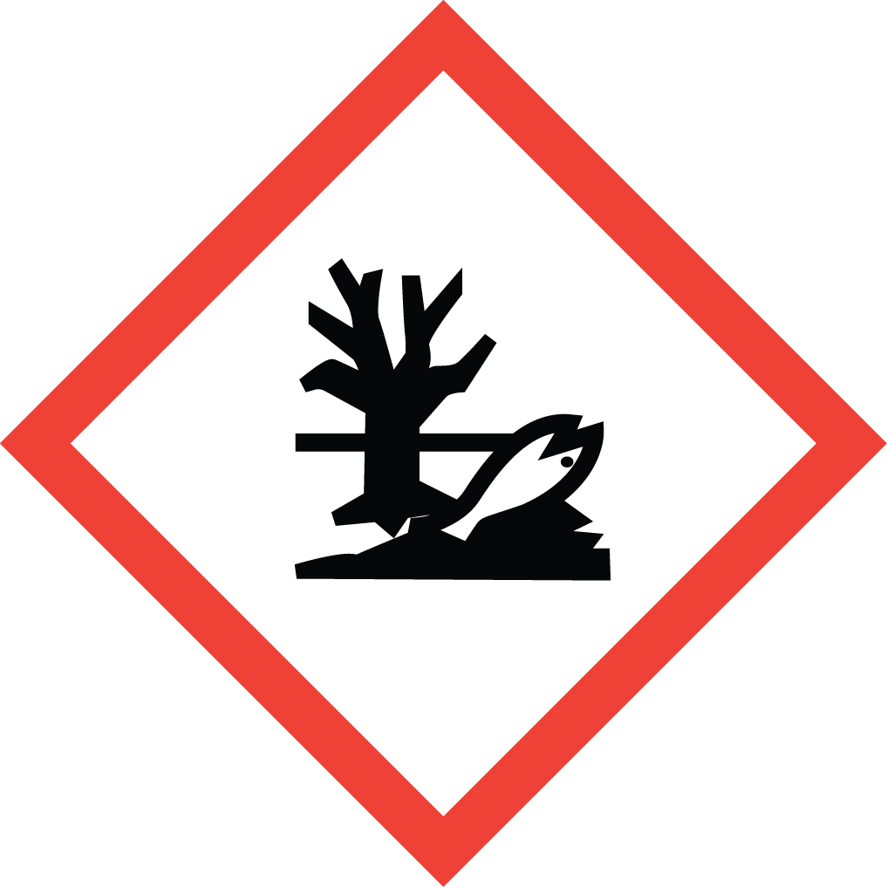 Signal Word: DANGER  Exposure Limits:  DOSH: TWA: 5 mg/m³ (8 Hour); STEL: 10 mg/m³  NIOSH: CEIL: 5 mg/m³ (10 Minute Period)  ACGIH: CEIL: 5 mg/m³ (Anytime)  Toxicological Data:  ORAL (LD50): 6.44 mg/kg [Rat].  DERMAL (LD50): 10.4 mg/kg [Rabbit].  INTRAMUSCULAR (LD50): 1.666 mg/kg [Rabbit].  INTRAPERITONEAL (LD50): 4.3 mg/kg [Rat]; 4.9 mg/kg [Mouse].  *Always refer to the Safety Data Sheet for the most detailed information*
3. NAME OF TRAINER /  RESOURCE  PERSON | Principal Investigator Name, Building, Room, Phone Number  Secondary contact Name, Building, Room, Phone Number
- LOCATION OF  HEALTH & SAFETY  INFORMATION | The Safety Data Sheet (SDS) for Sodium Cyanide is located in the Laboratory Safety Manual located in Building, Room.  Labeling: In addition to the standard label that identifies contents, hazards, precautionary measures, and emergency contact information, primary and secondary containers should also be marked as highly toxic.
5. PROTECTIVE  EQUIPMENT | Wear chemical safety goggles, appropriate gloves such as nitrile rubber gloves and a fully-buttoned lab coat. Always wash hands after removing gloves. Gloves with longer cuffs or arm length sleeves are recommended. If longer gloves are not selected, the cuffs of normal length gloves can be taped to lab coat to prevent skin exposure along the wrist and lower arm area between lab coat sleeve and gloves.  Always work within a properly functioning, certified laboratory chemical fume hood. Never use this substance outside of a fume hood unless correct PPE and an approved, certified respirator with the correct cartridges are worn. (Note: You must be medically cleared, fit tested and enrolled in WSU’s Respiratory Protection Program to wear a respirator). Respirator use should only be used as a last line of defense when administrative and engineering controls are not sufficient or not available.
- WASTE DISPOSAL  PROCEDURES | The following concentrations of sodium cyanide must be collected and managed as Dangerous Waste.  Unused solid or liquid sodium cyanide at any concentration must be collected as Dangerous Waste.  Waste solutions containing 0.01% sodium cyanide or greater must be collected and managed as Dangerous Waste. Waste solutions containing less than 0.01% sodium cyanide may be drain discharged.  Waste solids containing 100 ppm or greater sodium cyanide must be collected and managed as Dangerous Waste. Waste solids containing less than 100 ppm sodium cyanide maybe thrown away  Waste should be collected in a sealable, airtight, compatible waste container. The container should be stored away from incompatible materials such as oxidizing agents, acids, acid salts, chlorates, nitrates, and carbon dioxide (CO2). A completed Dangerous Waste label should be attached when waste is first added to the container. When container is full or no longer being used complete a Chemical Collection Request Form, and follow normal hazardous waste procedure.
7. DESIGNATED AREA  INFORMATION | Highly toxic substances must be stored and used in designated areas. The sodium cyanide is stored and dispensed in Building, Room.  Always work in a properly functioning, certified laboratory chemical fume hood.  The designated area(s) should be shown on the floor plan in Laboratories Chemical Hygiene Plan.
8. DECONTAMINATION  PROCEDURES | Upon Accidental Exposure:  *Contact a physician for any exposure to sodium cyanide. Immediately seek medical attention and follow instructions on SDS.*  In case of eye contact, flush eyes with copious amounts of water at an emergency eyewash station for at least 15 minutes and seek medical attention.  In case of skin contact, flush skin with copious amounts of water for 15 minutes and seek medical attention. For exposure over a large portion of the body, remove clothing and shoes and rinse thoroughly in an emergency shower for at least 15 minutes. Seek medical attention.  In case of inhalation, move person to fresh air and immediately seek medical attention.  In case of ingestion, do not induce vomiting. If alert, rinse mouth with water. Never give anything by mouth to an unconscious person. immediately seek medical attention and follow instructions on SDS  [NOTE: Known or suspected cyanide poisoning can be treated with Cyanokit, an FDA approved intravenous infusion treatment. Having this treatment kit on hand in the lab should be considered so that medical response personnel may administer it to a victim. Do NOT try to administer this treatment yourself. You may also wish to confirm with the local hospital that they have this treatment or others available for cyanide poisoning before working with the substance.]  Upon Accidental Release:  Large Spill: If a large amount of sodium cyanide is spilled outside the fume hood, immediately evacuate and secure area. Call 911. If safe to do so, prevent entry into sewer or wastewater systems. Discharge into the environment must be avoided.  Small Spill: If a small amount of sodium cyanide is spilled (it can be cleaned up in 10 minutes) and you have been appropriately trained to clean it up, you may do so.  Trained workers must wear appropriate personal protective equipment and clothing including fully buttoned lab coat or disposable coveralls, safety goggles, elbow length nitrile gloves or normal length gloves taped to sleeves and respiratory protection with correct cartridges. (Note: You must be medically cleared, fit tested, and enrolled in WSU’s Respiratory Protection Program to wear a respirator). If personnel are not cleared to wear a respirator and not trained to appropriately clean up the spill, the employee should immediately evacuate, secure area, and call 911 to contact EH&S.  After evacuating all non-trained personnel, trained personnel should don respirators and other PPE. Use appropriate tools to collect material and place material in an appropriate waste disposal container (resealable bag, etc.) and dispose of as hazardous waste (see above WASTE DISPOSAL PROCEDURES). Avoid dust formation.  As with all accidents, report any exposure as soon as possible to your Principal Investigator or Supervisor. Additional health and safety information on sodium cyanide can be obtained by referring to the SDS or by calling the EH&S Office (335-3041).
- SPECIAL STORAGE  AND HANDLING  PROCEDURES | Keep container tightly closed in a secure, cool, dry, well-ventilated area away from heat or sources of ignition. Store segregated from incompatible chemicals (below). Avoid dust generation, moisture, and heat. Absorbs moisture from air forming a syrup.  Keep away from incompatibles such as oxidizing agents, acids, acid salts, chlorates, nitrates, and carbon dioxide (CO2).  CAUTION: Toxic hydrogen cyanide gas may form when sodium cyanide is mixed with acids. Do not store with acids or water.

Certification of Hazard Assessment

Is this document a certification of Hazard Assessment for the processes identified within? Yes No
If yes, provide the name of the person certifying the Hazard Assessment and the date it was performed:

____________________________________________________________________________________
Name Date

The location of the Hazard Assessment is indicated in the document preceding this form.

Certificate of Employee Training

Name of person providing training for employees working with this process:

___________________________________________________________________________________
The following employees have been trained in when, where and how to use selected PPE, the maintenance, limitations and disposal of the PPE selected, and have demonstrated the correct use of the PPE selected on the reverse of this certification.
Name Date Trained
________________________________________ _______________________________
________________________________________ _______________________________
________________________________________ _______________________________
________________________________________ _______________________________
________________________________________ _______________________________
________________________________________ _______________________________
________________________________________ _______________________________

