STANDARD OPERATING PROCEDURES FOR HAZARDOUS AND PARTICULARLY HAZARDOUS CHEMICALS
For

Phenol

1. PROCEDURE /  PROCESS | Phenol is used in Building, Room.  Insert procedure here:
2. CHEMICAL NAME(S)  and associated  PHYSICAL and  HEALTH  HAZARDS | Phenol- CAS # 108-95-2; also known as Carbolic acid, Hydroxybenzene, Monohydroxybenzene, Phenyl alcohol, Phenyl hydroxide.  - Causes severe skin burns and eye damage.  - Toxic if swallowed, in contact with skin or if inhaled. Easily absorbed through skin.  - Suspected of causing genetic defects (mutagen).  - May cause damage to organs through prolonged or repeated exposure.  - Can cause central nervous system impairment, upper respiratory tract irritation, and lung damage.  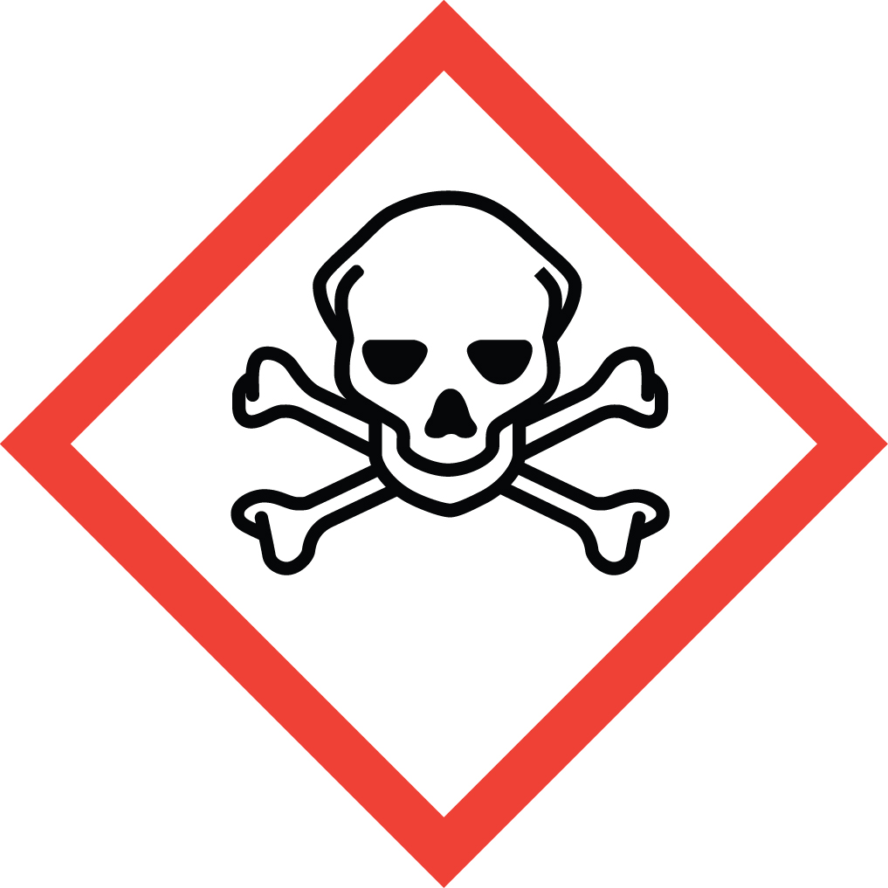 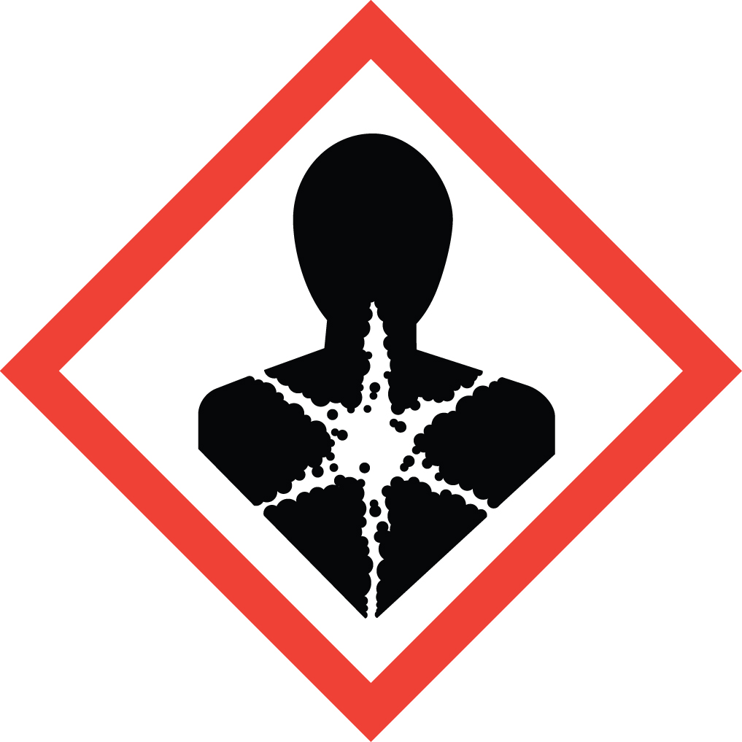 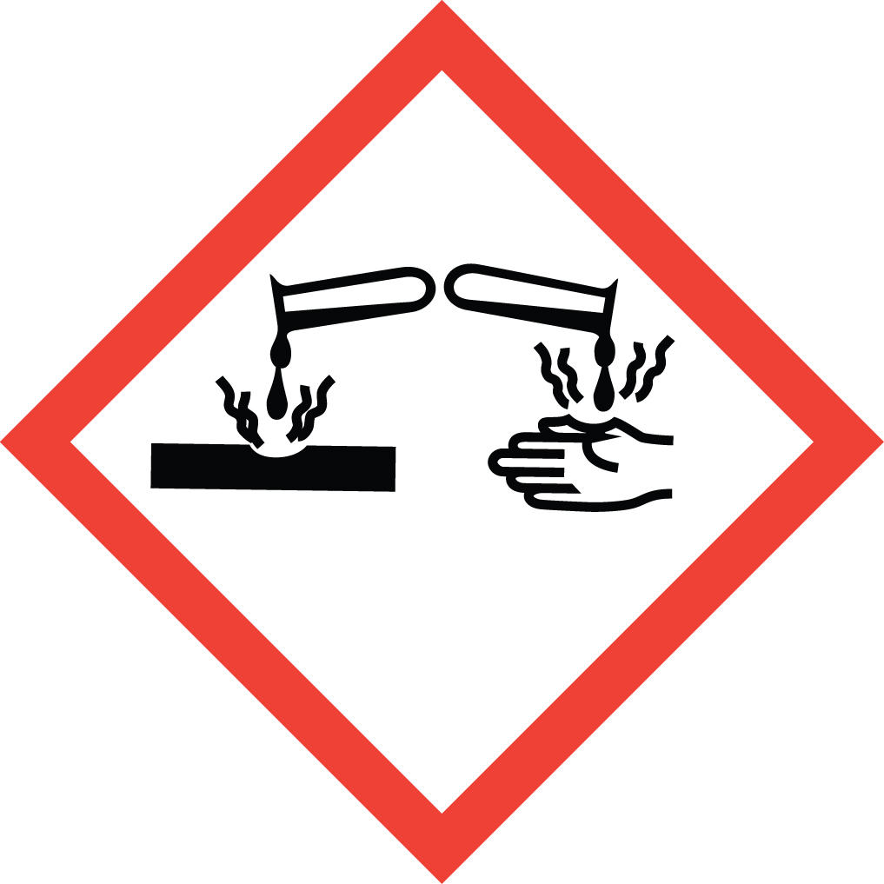 Signal Word: DANGER  Exposure Limits:  DOSH: TWA: 5 ppm; STEL: 10 ppm  NIOSH: TWA: 5 ppm; CEIL: 15.6 ppm (15 minute ceiling value)  ACGIH: TWA: 5 ppm  Toxicological Data:  ORAL (LD50): 317 mg/kg [Rat]. 270 mg/kg [Mouse].  DERMAL (LD50): 630 mg/kg [Rabbit]. 669 mg/kg [Rat].  *Always refer to the Safety Data Sheet for the most detailed information*
3. NAME OF TRAINER /  RESOURCE  PERSON | Principal Investigator Name, Building, Room, Phone Number  Secondary contact Name, Building, Room, Phone Number
- LOCATION OF  HEALTH & SAFETY  INFORMATION | The Safety Data Sheet (SDS) for Phenol is located in the Laboratory Safety Manual in Building, Room  Labeling: In addition to the standard label that identifies contents, hazards, precautionary measures, and emergency contact information, containers should also be marked as highly toxic.
5. PROTECTIVE  EQUIPMENT | Wear chemical safety goggles, butyl, neoprene or Viton gloves, and a fully buttoned lab coat. A face shield is also recommended. A rubber apron should be worn where a splash hazard exists. Avoid skin contact. Phenol is easily absorbed through the skin. Fatalities have been documented from skin absorption of a relatively small surface area. (NOTE: Nitrile gloves are a poor choice when working with phenol and therefore not recommended.)  Always work within a properly functioning certified laboratory chemical fume hood.
- WASTE DISPOSAL  PROCEDURES | Waste phenol in pure form must be managed as Dangerous Waste. It should be collected in a sealable, compatible waste container. The container should be stored away from incompatible materials such as strong acids, strong bases and strong oxidizing agents. A completed Dangerous Waste label should be attached when waste is first added to the container. When container is full or no longer being used, complete a Chemical Collection Request Form, and deliver to the Waste Accumulation Area Operator at Building, Room, Phone Number.  Waste Phenol solutions greater than 0.01% or 100 ppm must be managed as Dangerous Waste. It should be collected in a sealable, compatible waste container. The container should be stored away from incompatible materials such as strong acids, strong bases and strong oxidizing agents. A completed Dangerous Waste label should be attached when waste is first added to the container. When container is full or no longer being used, complete a Chemical Collection Request Form, and deliver to the Waste Accumulation Area Operator at Building, Room, Phone Number. Solutions containing less than 0.01% phenol may be drain discharged.
7. DESIGNATED AREA  INFORMATION | The Phenol is stored and dispensed in Building, Room.  Always work in a properly functioning, certified laboratory chemical fume hood.  The designated area(s) should be shown on the floor plan in Laboratories Chemical Hygiene Plan.
8. DECONTAMINATION  PROCEDURES | Upon Accidental Exposure:  In case of eye contact, flush eyes with copious amounts of water at an emergency eyewash station for at least 15 minutes and seek medical attention.  In case of skin contact, flush skin with copious amounts of water for 15 minutes and seek medical attention. For exposure over a large portion of the body, remove clothing and shoes and rinse thoroughly in an emergency shower for at least 15 minutes. Seek medical attention.  In case of inhalation, move person to fresh air and immediately seek medical attention.  In case of ingestion, immediately seek medical attention and follow instructions on SDS.  Upon Accidental Release:  Large Spill: If a significant amount of phenol is spilled outside the fume hood, immediately evacuate, secure area and call 911 to contact EH&S.  Small Spill: If a small amount of phenol is spilled (it can be cleaned up in 10 minutes) and you have been appropriately trained to clean it up, you may do so. Do not attempt if you have not been trained or the amount exceeds that which is used in normal laboratory operations. Trained personnel should wear the appropriate PPE including butyl, neoprene or Viton gloves, chemical safety goggles, fully buttoned lab coat.  Additional PPE such as respirators may be necessary depending upon material and concentration. (Note: You must be medically cleared, fit tested and enrolled WSU’s respiratory protection program to wear a respirator). If it is necessary to use a respirator and personnel are not cleared to wear a respirator and not trained to appropriately clean up the spill, the employee should immediately evacuate, secure area, and call 911 to contact EH&S.  Use appropriate tools to collect the spilled material and place material in an appropriate waste disposal container (resealable bag, etc.) and dispose of as hazardous waste (see above WASTE DISPOSAL PROCEDURES).  As with all accidents, report any exposure as soon as possible to your Principal Investigator or Supervisor. Additional health and safety information on phenol can be obtained by referring to the SDS or by calling the EH&S Office (335-3041).
- SPECIAL STORAGE  AND HANDLING  PROCEDURES | Phenol is easily absorbed through skin. Wash after handling.  Keep container locked up if possible. Keep container in a cool, dry, and well-ventilated area. Store segregated from incompatible chemicals (below). Keep container tightly closed and sealed until ready for use. Keep away from heat, sunlight, and other sources of ignition. Avoid dust and aerosol formation.  Phenol is air sensitive and sensitive to light. Store in light-resistant containers. Moisture sensitive. If possible, store saturated phenol in the cold (4ºC). Will discolor with light.  Phenol is incompatible with strong acids, strong bases and strong oxidizing agents. Store away from oxidizers such as chlorine, bromine and calcium hypochlorite.

Certification of Hazard Assessment

Is this document a certification of Hazard Assessment for the processes identified within? Yes No
If yes, provide the name of the person certifying the Hazard Assessment and the date it was performed:

____________________________________________________________________________________
Name Date

The location of the Hazard Assessment is indicated in the document preceding this form.

Certificate of Employee Training

Name of person providing training for employees working with this process:

___________________________________________________________________________________
The following employees have been trained in when, where and how to use selected PPE, the maintenance, limitations and disposal of the PPE selected, and have demonstrated the correct use of the PPE selected on the reverse of this certification.
Name Date Trained
________________________________________ _______________________________
________________________________________ _______________________________
________________________________________ _______________________________
________________________________________ _______________________________
________________________________________ _______________________________
________________________________________ _______________________________
________________________________________ _______________________________

