STANDARD OPERATING PROCEDURES FOR HAZARDOUS AND PARTICULARLY HAZARDOUS CHEMICALS
For

Mercury

1. PROCEDURE /  PROCESS | Mercury is used in Building, Room.  Insert procedure here:
2. CHEMICAL NAME(S)  and associated  PHYSICAL and  HEALTH  HAZARDS | Mercury – CAS# 7439-97-6; also known as Quick Silver, Colloidal Mercury, Metallic Mercury, Liquid Silver, and Hydragyrum.  - Fatal or extremely toxic if inhaled.  - Causes irritation and possible burns by all routes of exposure. Severe over-exposure can result in death.  - May irritate the skin, eyes and respiratory system. May be absorbed through intact skin.  - Reproductive toxin. May damage fertility or the unborn child.  - Causes damage to organs through prolonged or repeated exposure.  - Corrosive material.  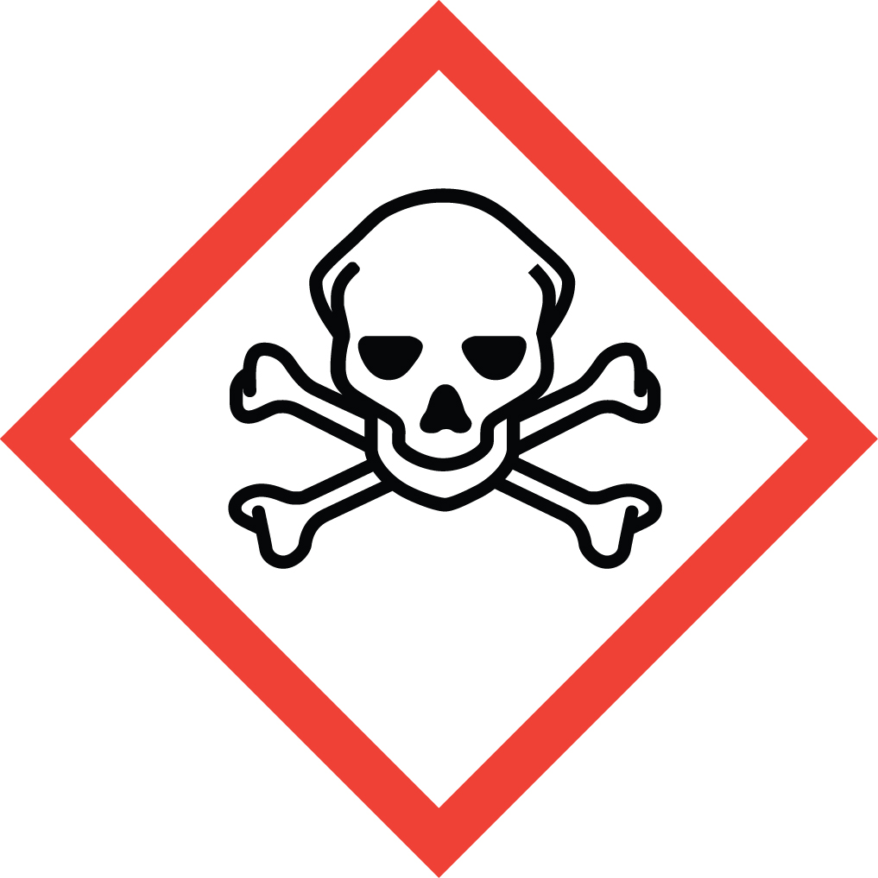 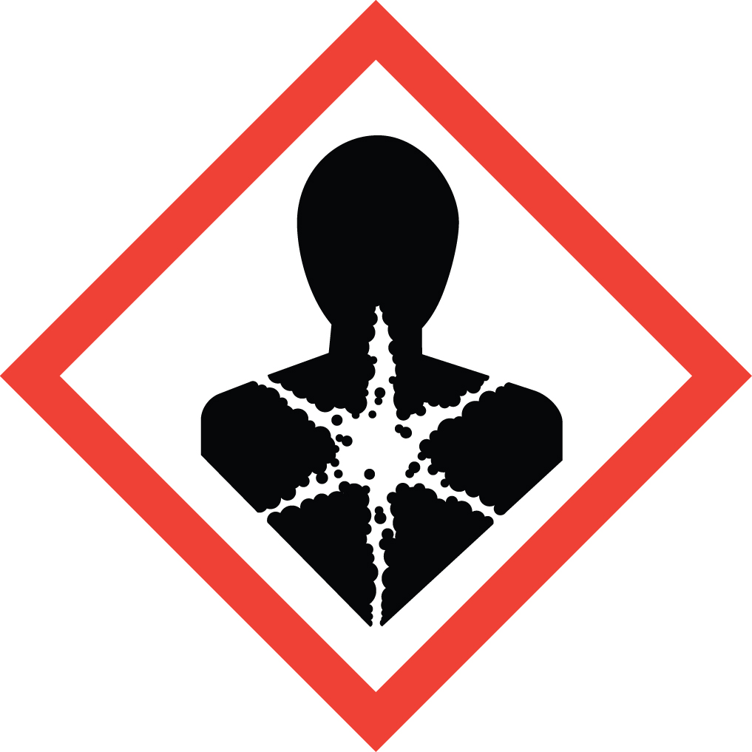 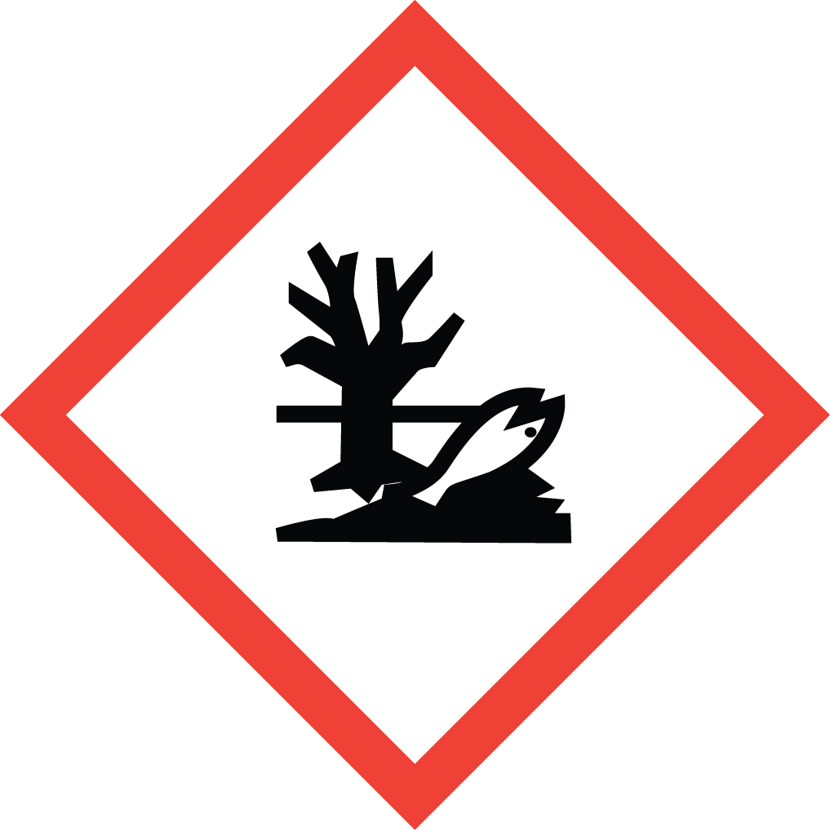 Signal Word: DANGER  Acute Potential Health Effects:  - Contact can irritate the skin and eyes.  - Inhaling Mercury can irritate the nose, throat and lungs causing coughing, wheezing and/or shortness of breath.  - Exposure can cause metallic taste in the mouth, nausea and vomiting, and abdominal pain.  - Inhalation of fumes may cause metal fume fever, a flu-like illness including fever, chills, nausea, headache, fatigue, muscle aches, joint pains, shortness of breath, chest pain, and cough. A sweet or metallic taste in the mouth may also be reported along with a dry or irritated throat which may lead to hoarseness.  - Symptoms of a more severe metal toxicity may also include a burning sensation in the body, shock, no urine output, collapse, convulsions, shortness of breath, yellow eyes or yellow skin, rash, vomiting, watery or bloody diarrhea or low blood pressure, which require prompt medical attention.  Chronic Potential Health Effects:  - Mercury is a possible sensitizer. It may cause a skin allergy. If allergy develops, very low future exposure can cause itching and a skin rash.  - Long-term contact can cause the skin to turn gray, brown staining in the eyes, and may affect peripheral vision (ability to see to the sides).  - May cause permanent central nervous system damage, liver and kidney damage, fatigue, weight loss, tremors, and personality changes.  - Chronic ingestion may cause accumulation of mercury in body tissues.  - Prolonged or repeated exposure may cause inflammation of the mouth and gums, excessive salivation, and loosening of the teeth.  - There is limited evidence that mercury may cause an increase in spontaneous abortions and menstrual disorders in exposed women.  - There is limited evidence that mercury may affect male fertility.  - Mercury may also damage the developing fetus in animals.  Exposure Limits:  DOSH: TWA: 0.1 mg/m³; STEL: 0.3 mg/m³ (Aryl and Inorganic)  TWA: 0.01 mg/m³; STEL: 0.03 mg/m³ (Organic-alkyl compounds)  TWA: 0.05 mg/m³; STEL: 0.15 mg/m³ (Vapor)  Toxicological Data:  INHALATION (LC50): < 27 mg/m3 2 Hour [Rat – Male]  *Always refer to the Safety Data Sheet for the most detailed information*
3. NAME OF TRAINER /  RESOURCE  PERSON | Principal Investigator Name, Building, Room, Phone Number  Secondary contact Name, Building, Room, Phone Number
- LOCATION OF  HEALTH & SAFETY  INFORMATION | The Safety Data Sheet (SDS) for Mercury is located in the Laboratory Safety Manual located in Building, Room.  Labeling: In addition to the standard label that identifies contents, hazards, precautionary measures, and emergency contact information, containers should also be marked as a reproductive toxin.
5. PROTECTIVE  EQUIPMENT | Wear butyl, nitrile, neoprene, polyvinyl chloride, or Viton gloves, chemical splash goggles, and a fully buttoned lab coat. Wash hands after removing gloves. Work within a properly functioning certified laboratory chemical fume hood.
- WASTE DISPOSAL  PROCEDURES | Waste Mercury, mercury contaminated debris and mercury contamination solution should be collected in a sealable, airtight, compatible waste container. The container should be stored away from incompatible materials such as oxidizing agents, metals (especially copper), strong acids, acetylene, azides, ammonia, nitrates, and chlorates.  A completed Dangerous Waste label should be attached when waste is first added to the container. When container is full or no longer being used, complete and submit a Chemical Collection Request Form, and deliver to the Waste Accumulation Area Operator at Building, Room, Phone Number.
7. DESIGNATED AREA  INFORMATION | The mercury is stored and dispensed in Building, Room.  Always work within the confines of a properly functioning, certified laboratory chemical fume hood.  The designated area(s) should be shown on the floor plan in Laboratories Chemical Hygiene Plan.
8. DECONTAMINATION  PROCEDURES | Upon Accidental Exposure:  In case of eye contact, flush eyes with copious amounts of water at an emergency eyewash station for at least 15 minutes and seek immediate medical attention.  In case of skin contact, flush skin with copious amounts of water for 15 minutes and seek immediate medical attention. For exposure over a large portion of the body, remove clothing and shoes and rinse thoroughly in an emergency shower for at least 15 minutes. Seek immediate medical attention.  In case of inhalation, move person to fresh air and seek immediate medical attention.  In case of ingestion, immediately seek medical attention and follow instructions on SDS.  Upon Accidental Release:  Large Spill: If a large amount of mercury is spilled outside the fume hood, immediately evacuate and secure area and call 911 to contact EH&S.  Small Spill: If a small amount of mercury is spilled, EH&S recommends that you do NOT try to clean it up. Call EH&S immediately at 335-3041 to report the release. EH&S will respond and clean up the mercury at no charge. Untrained lab users trying to clean up mercury often make the spill worse.  If you choose to clean up a small spill (it can be cleaned up in about 10 minutes), you must be appropriately trained. Trained personnel should wear at the minimum butyl, nitrile, neoprene, polyvinyl chloride, or Viton gloves, chemical splash goggles, and a fully buttoned lab coat.  Use appropriate tools and place the material in an appropriate waste disposal container and dispose of as dangerous waste (see above WASTE DISPOSAL PROCEDURES).  Additional PPE such as respirators may be necessary depending upon material and concentration. (Note: You must be medically cleared, fit tested, and enrolled in WSU’s respiratory protection program to wear a respirator). If it is necessary to use a respirator and personnel are not cleared to wear a respirator and not trained to appropriately clean up the spill, the employee should immediately evacuate, secure area, and call 911 to contact EH&S.  As with all accidents, report any exposure as soon as possible to your Principal Investigator or Supervisor. Additional health and safety information on mercury can be obtained by referring to the SDS or by calling the EH&S Office (335-3041).
- SPECIAL STORAGE  AND HANDLING  PROCEDURES | Store in a secured, cool, dry, and well-ventilated area away from direct sunlight, heat, sparks, flame, or other sources of ignition. Store segregated from incompatible chemicals (below). Store in a tightly closed container until ready for use. Store in properly labeled secondary containment such as a Nalgene/polypropylene tub.  Keep away from incompatibles such as oxidizing agents, metals (especially copper), strong acids, acetylene, azides, ammonia, nitrates, and chlorates.

Certification of Hazard Assessment

Is this document a certification of Hazard Assessment for the processes identified within? Yes No
If yes, provide the name of the person certifying the Hazard Assessment and the date it was performed:

____________________________________________________________________________________
Name Date

The location of the Hazard Assessment is indicated in the document preceding this form.

Certificate of Employee Training

Name of person providing training for employees working with this process:

___________________________________________________________________________________
The following employees have been trained in when, where and how to use selected PPE, the maintenance, limitations and disposal of the PPE selected, and have demonstrated the correct use of the PPE selected on the reverse of this certification.
Name Date Trained
________________________________________ _______________________________
________________________________________ _______________________________
________________________________________ _______________________________
________________________________________ _______________________________
________________________________________ _______________________________
________________________________________ _______________________________
________________________________________ _______________________________

