STANDARD OPERATING PROCEDURES FOR HAZARDOUS AND PARTICULARLY HAZARDOUS CHEMICALS
For
Formalin

1. PROCEDURE /  PROCESS | Formalin is used in Building, Room.  Insert procedure here:
2. CHEMICAL NAME(S)  and associated  PHYSICAL and  HEALTH  HAZARDS | Formalin is a mixture of 37% Formeldehyde and 10%-15% Methanol. Formalin is a combustible liquid that is harmful if inhaled or swallowed, causes skin irritation and allergic skin reactions, causes serious eye damage, causes damage to organs and may cause cancer. It should be handled based on the hazards of its constituents described below.  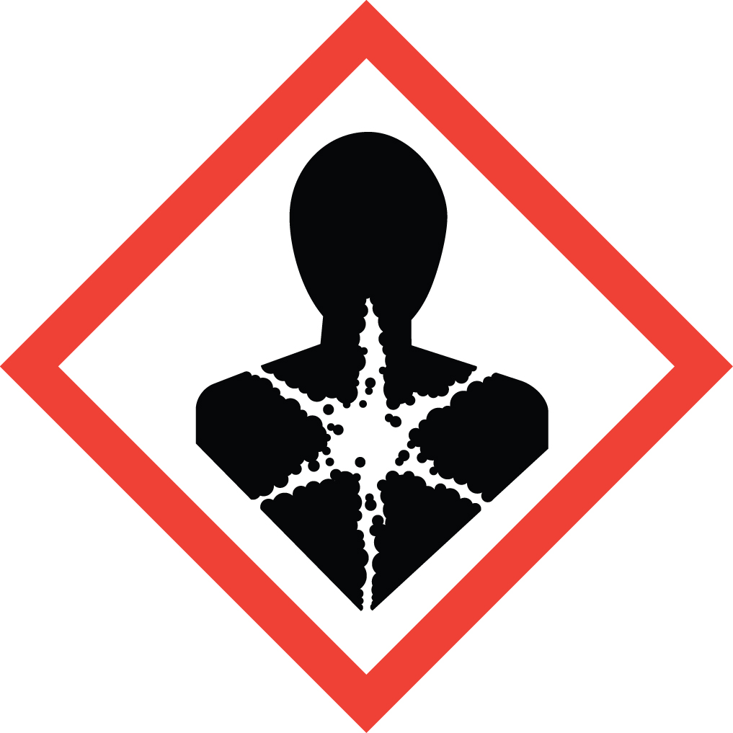 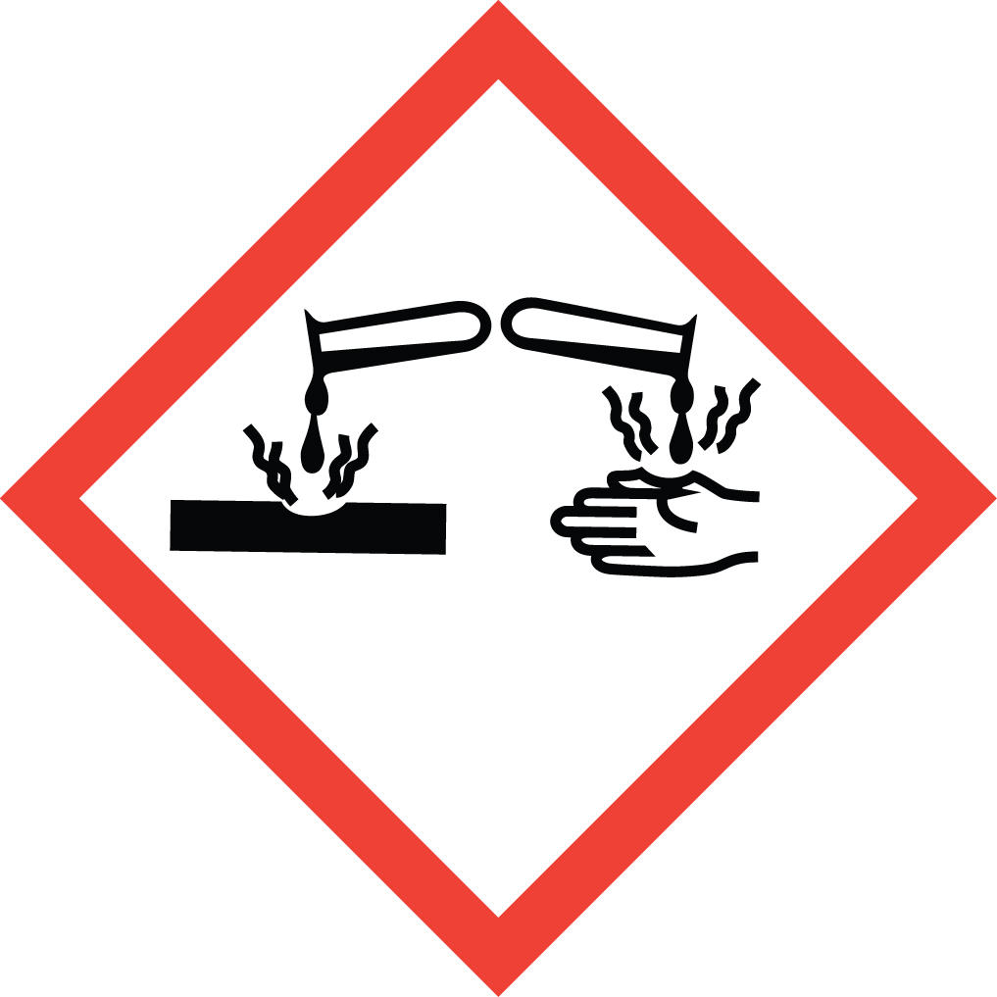 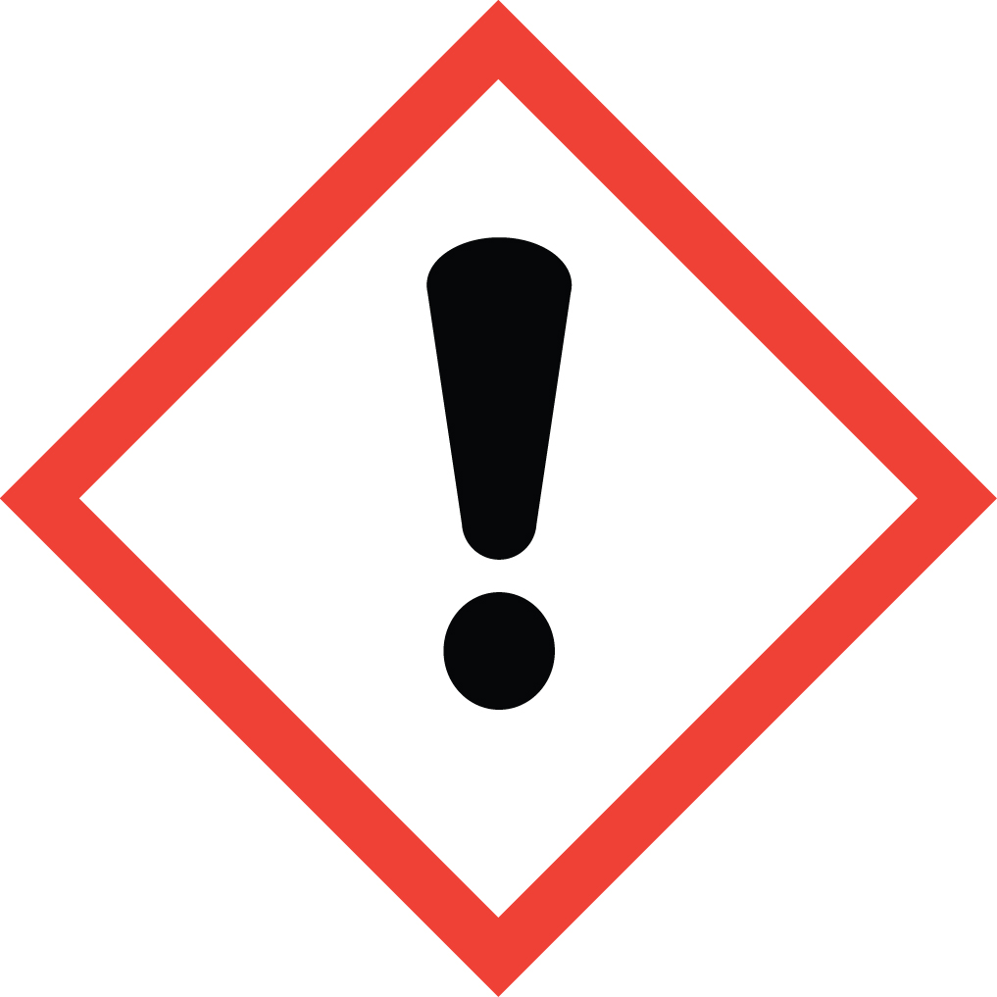 Signal Word: DANGER  Formeldehyde CAS# 50-00-0; also known as Formol, Formaldehyde (37% solution), Methanol, Formaldehyde Solution, Formalith, Formic Aldehyde solution, Methanol Solution, Formalin, Stabilized, Formaldehyde  - Formaldehyde is a known carcinogen, classified by IARC as Group 1: Carcinogenic to Humans and by the NTP as Known to be a Human Carcinogen.  - This substance is a highly toxic irritant, corrosive to the eyes and skin and may cause sensitization through exposure. May be absorbed through the skin.  - Inhaling Formaldehyde can irritate the lungs. Higher exposures may cause a build-up of fluid in the lungs (pulmonary edema).  - Classified as a possible teratogen for humans. It may damage the developing fetus and affect female fertility.  - The substance may be toxic to kidneys, liver, central nervous system (CNS). Repeated or prolonged exposure to the substance can produce target organs damage.  - May be combustible at high temperatures.  - Exposure Limits: DOSH: TWA 0.75 ppm; STEL 2.0 ppm  Methanol CAS 67-56-1; also known as methyl alcohol, wood alcohol, wood naphtha, wood spirits, or carbinal.  - Methanol is a highly flammable liquid and vapor and an acute toxin.  - Methanol may be fatal or cause blindness if swallowed.  - Toxic by inhalation, ingestion, and skin absorption.  - May irritate the eyes skin.  - May be a teratogen in humans since it is a teratogen in animals.  - Can damage the liver, kidneys, and nervous system.  - Exposure Limits: DOSH: TWA 200 ppm; STEL 250 ppm  *Always refer to the Safety Data Sheet for the most detailed information*
3. NAME OF TRAINER /  RESOURCE  PERSON | Principal Investigator Name, Building, Room, Phone Number  Secondary contact Name, Building, Room, Phone Number
- LOCATION OF  HEALTH & SAFETY  INFORMATION | The Safety Data Sheet (SDS) for Formalin is located in the Laboratory Safety Manual in Building, Room.  Labeling: In addition to the standard label that identifies contents, hazards, precautionary measures, and emergency contact information, containers should also be marked as Cancer Hazard.
5. PROTECTIVE  EQUIPMENT | Wear chemical safety goggles, nitrile gloves, and fully-buttoned lab coat. Other suitable gloves include butyl and Viton. A face shield may be worn to supplement safety goggles, but a face shield should NOT be worn in place of chemical safety goggles. Wash hands after removing gloves. Work within a properly functioning, certified laboratory chemical fume hood.
- WASTE DISPOSAL  PROCEDURES | Waste Formalin should be collected in a sealable, airtight, compatible waste container. The container should be stored away from incompatible materials such as Strong bases, Acids, Oxidizing agents, Alkali metals, Strong oxidizing agents, Amines, Strong acids, Acid chlorides, Acid anhydrides, Reducing agents, Peroxides, Isocyanates, Phenol, and Aniline.  A completed Dangerous Waste label should be attached when waste is first added to the container. When container is full or no longer being used complete a Chemical Collection Request Form, and deliver to the Waste Accumulation Area Operator at Building, Room, Phone Number.
7. DESIGNATED AREA  INFORMATION | The formalin is stored and dispensed in Building, Room.  Always work within the confines of a properly functioning, certified laboratory chemical fume hood.  The designated area(s) should be shown on the floor plan in the laboratory’s Chemical Hygiene Plan.
8. DECONTAMINATION  PROCEDURES | Upon Accidental Exposure:  In case of eye contact, flush eyes with copious amounts of water at an emergency eyewash station for at least 15 minutes and seek medical attention.  In case of skin contact, flush skin with copious amounts of water for 15 minutes. Seek medical attention. For skin contact over a large portion of the body, remove contaminated clothing and shoes then wash with copious amounts of water at an emergency shower station for at least 15 minutes. Seek medical attention.  In case of inhalation, move person to fresh air and seek immediate medical attention.  In case of ingestion, immediately seek medical attention and follow instructions on SDS.  Upon Accidental Release:  Large Spill: If a large amount of Formalin is spilled, immediately evacuate, secure area and call 911 to contact EH&S.  Small Spill: If a small amount of formalin is spilled (it can be cleaned up in 10 minutes) and personnel have been appropriately trained to clean it up, you may do so. Secure and ventilate the area of leak or spill. Trained workers must wear appropriate personal protective equipment and clothing including fully buttoned lab coat, safety goggles, nitrile, butyl, or Viton gloves and respiratory protection with correct cartridges. (Note: You must be medically cleared, fit tested and enrolled in WSU’s respiratory protection program to wear a respirator).  Use appropriate tools to dilute with water and mop up, or absorb with an inert dry material and place waste in appropriate containers and dispose of as hazardous waste (see above WASTE DISPOSAL PROCEDURES).  As with all accidents, report any exposure as soon as possible to your Principal Investigator or Supervisor. Additional health and safety information on Formalin can be obtained by referring to the Safety Data Sheet or by calling the EH&S Office (335-3041).
- SPECIAL STORAGE  AND HANDLING  PROCEDURES | Keep container tightly closed and stored in a cool, dry place away from sunlight, heat, sparks, flame and other ignition sources. Store segregated from incompatible chemicals (below).  Formalin is incompatible with Strong bases, Acids, Oxidizing agents, Alkali metals, Strong oxidizing agents, Amines, Strong acids, Acid chlorides, Acid  anhydrides, Reducing agents, Peroxides, Isocyanates, Phenol, and Aniline.  Training should include the following: Review of this SOP, current SDS, DOSH Lab Standard, DOSH Formaldehyde Standard, WSU Chemical Hygiene Plan, and special training provided by the department/supervisor.

Certification of Hazard Assessment

Is this document a certification of Hazard Assessment for the processes identified within? Yes No
If yes, provide the name of the person certifying the Hazard Assessment and the date it was performed:

____________________________________________________________________________________
Name Date

The location of the Hazard Assessment is indicated in the document preceding this form.

Certificate of Employee Training

Name of person providing training for employees working with this process:

___________________________________________________________________________________
The following employees have been trained in when, where and how to use selected PPE, the maintenance, limitations and disposal of the PPE selected, and have demonstrated the correct use of the PPE selected on the reverse of this certification.
Name Date Trained
________________________________________ _______________________________
________________________________________ _______________________________
________________________________________ _______________________________
________________________________________ _______________________________
________________________________________ _______________________________
________________________________________ _______________________________
________________________________________ _______________________________

