STANDARD OPERATING PROCEDURES FOR HAZARDOUS AND PARTICULARLY HAZARDOUS CHEMICALS
For
Chloroform

1. PROCEDURE /  PROCESS | Chloroform is used in Building, Room.  Insert procedure here:
2. CHEMICAL NAME(S)  and associated  PHYSICAL and  HEALTH  HAZARDS | Chloroform CAS# 67-66-3; Also known as Trichloromethane, methane trichloride.  - This substance is suspected of causing cancer. Chloroform is classified by the IARC as Group 2B: Possibly Carcinogenic to Humans and by the NTP as Reasonably Anticipated to be a Human Carcinogen.  - Chloroform is a possible teratogen. Some animal studies show evidence of reproductive and developmental toxicity from chloroform exposure.  - May cause damage to organs through prolonged or repeated exposure. May damage the liver, kidneys, and nervous system.  - Harmful by ingestion or inhalation. Inhalation of vapors may cause headaches, drowsiness, dizziness, and nausea.  - Causes skin and serious eye irritation.  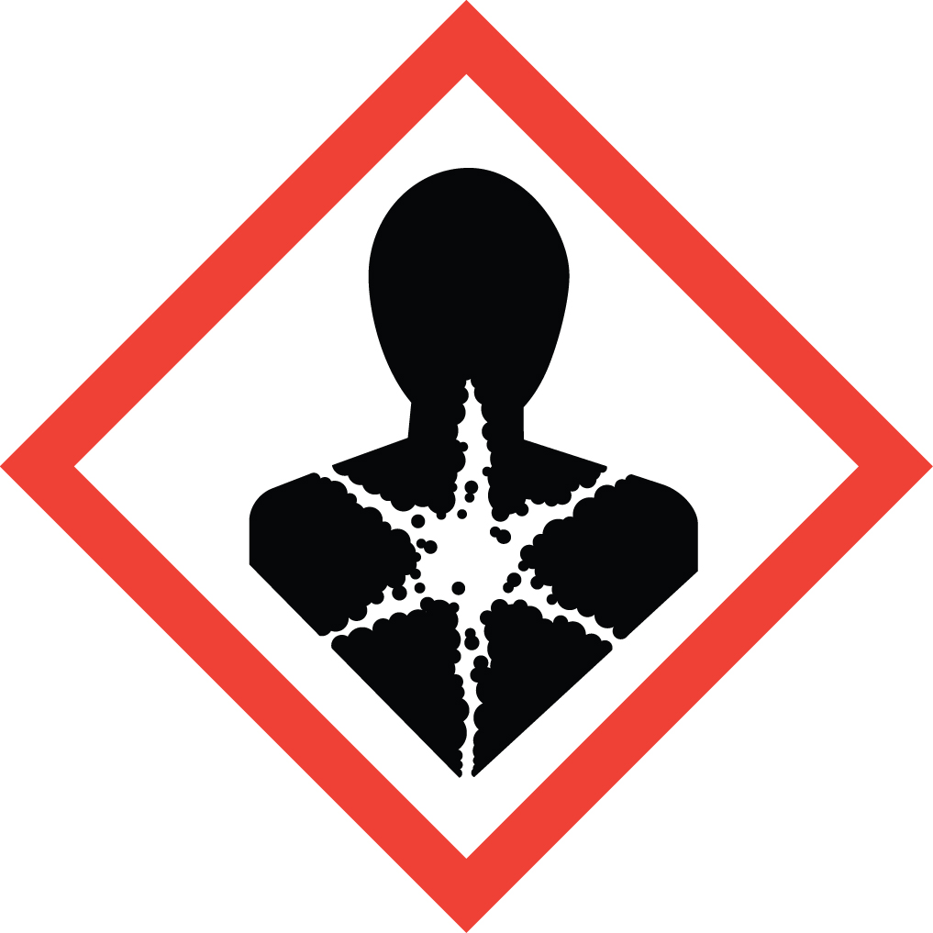 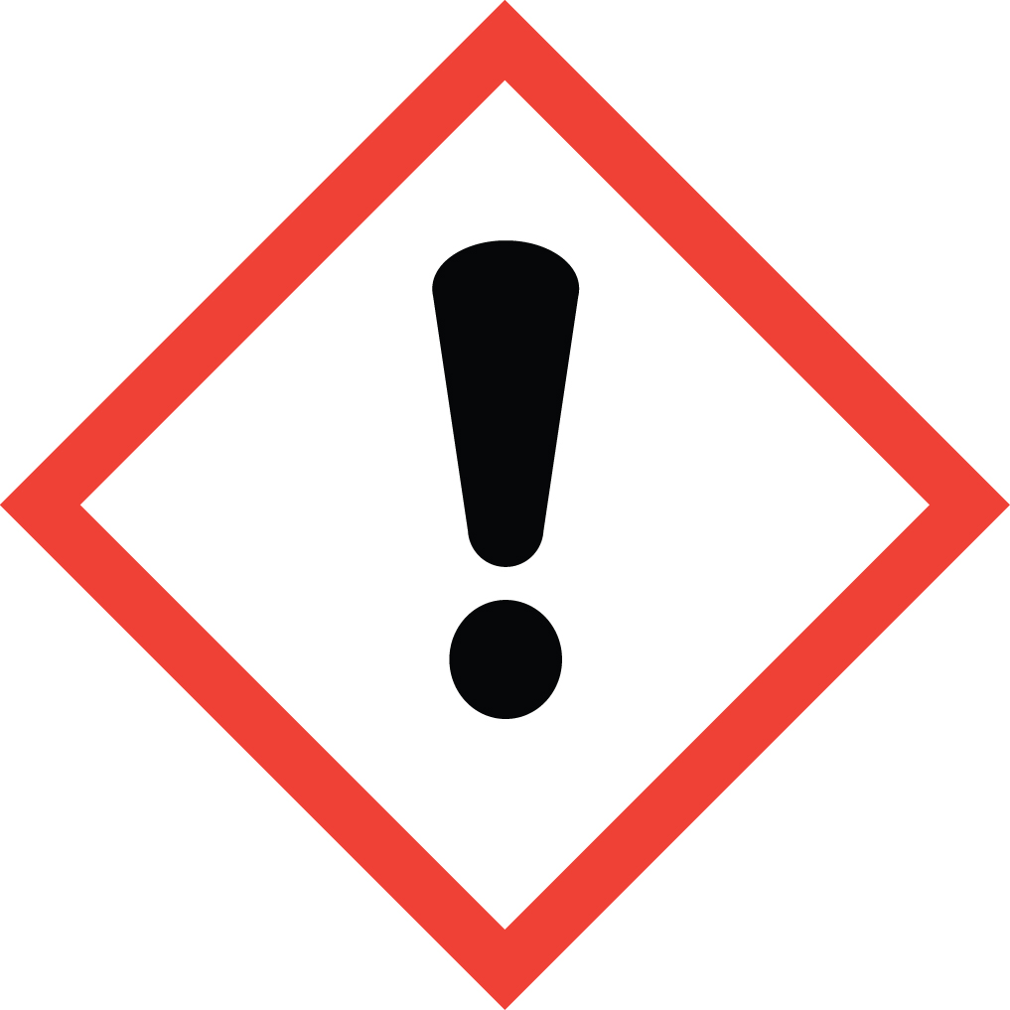 Signal Word: WARNING  Exposure Limits:  DOSH: TWA: 2 ppm; STEL: 4 ppm  OSHA: CEIL: 50 ppm [Not to be exceeded at any time]  ACGIH: TLV: 10 ppm [8 hour]  NIOSH: STEL: 2 ppm [Not to be exceeded in any 60 minute work period]  Toxicological Data:  ORAL (LD50): 695 mg/kg [Rat]. 36 mg/kg [Mouse]. 820 mg/kg  [Guinea pig].  DERMAL (LD50): >20,000 mg/kg [Rabbit].  INHALATION (LC50): 47,702 mg/m 4 hours [Rat].  Odor threshold: Ranges from 85-307 ppm (above OSHA’s ceiling limit), so it does not have good warning properties.  *Always refer to the Safety Data Sheet for the most detailed information*
3. NAME OF TRAINER /  RESOURCE  PERSON | Principal Investigator Name, Building, Room, Phone Number  Secondary contact Name, Building, Room, Phone Number
- LOCATION OF  HEALTH & SAFETY  INFORMATION | The Safety Data Sheet (SDS) for Chloroform is located in the Laboratory Safety Manual in Building, Room.  Labeling: In addition to the standard label that identifies contents, hazards, precautionary measures, and emergency contact information, containers should also be marked as a cancer hazard.
5. PROTECTIVE  EQUIPMENT | Chloroform readily penetrates standard nitrile laboratory gloves (and many other types of gloves).  - Wear two pairs of standard nitrile gloves and work so that gloves do not contact chloroform.  - Remove outer gloves immediately if splashed. Remove inner gloves also if degradation is noted.  - For increased protection, especially when more than a splash hazard exists, wear PVA, Viton, or Viton/Butyl gloves instead of nitriles.  Also wear chemical safety goggles and a fully buttoned lab coat. If a splash may occur, wear a face shield with chemical splash goggles, and an impervious apron over the lab coat. Work within a certified laboratory fume hood.  If phenol and chloroform will be used together: Please note that phenol is a severe skin hazard and chloroform’s easy penetration of nitrile gloves increases the risk of skin contact. Plan work to avoid glove contact, wear doubled 4-mil thick nitrile gloves (or a single pair of 8-mil thick nitrile gloves; most lab gloves are 4 mils thick), and change gloves immediately if there is a splash. If extensive work with phenol and chloroform is done in the lab, consider the reusable ChemTek Viton/Butyl glove which provides good protection from both of these chemicals.
- WASTE DISPOSAL  PROCEDURES | Waste Chloroform must be collected in its pure form and solutions. It should be collected in a sealable, airtight, compatible waste container. The container should be stored away from incompatible materials such as acetone, alkalis, strong bases and reactive metals (aluminum, magnesium, lithium, sodium, potassium), dinitrogen, tetroxide, disilane, fluorine, triisopropyl phosphine, solid potassium tert-butoxide and oxidizers.  A completed Dangerous Waste label should be attached when waste is first added to the container. When container is full or no longer being used complete a Chemical Collection Request Form, and deliver to the Waste Accumulation Area Operator at Building, Room, Phone Number.
7. DESIGNATED AREA  INFORMATION | The chloroform is stored and dispensed in Building, Room.  Always work in a properly functioning, certified laboratory chemical fume hood.  The designated area(s) should be shown on the floor plan in Laboratories Chemical Hygiene Plan.
8. DECONTAMINATION  PROCEDURES | Upon Accidental Exposure:  In case of eye contact, flush eyes with copious amounts of water at an emergency eyewash station for at least 15 minutes and seek medical attention.  In case of skin contact, flush skin with copious amounts of water for 15 minutes and seek medical attention. For exposure over a large portion of the body, remove clothing and shoes and rinse thoroughly in an emergency shower for at least 15 minutes. Seek medical attention.  In case of inhalation, move person to fresh air and immediately seek medical attention.  In case of ingestion, immediately seek medical attention and follow instructions on SDS.  Upon Accidental Release:  Large Spill: If a significant amount of chloroform is spilled outside the fume hood, immediately evacuate, secure area and call 911 to contact EH&S.  Small Spill: If a small amount of chloroform is spilled (it can be cleaned up in 10 minutes) and you have been appropriately trained to clean it up, you may do so. Trained personnel should wear at the minimum Silvershield, PVA, Viton, Chemtek Viton/Butyl or other gloves protective for spills (not nitrile), splash goggles, lab coat (and impermeable apron, if available).  Additional PPE may be necessary depending upon material and concentration (Note: You must be medically cleared, fit tested and enrolled in WSU’s respiratory protection program to wear a respirator). If it is necessary to use a respirator and personnel are not cleared to wear a respirator and not trained to appropriately clean up the spill, the employee should immediately evacuate, secure area, and call 911 to contact EH&S.  Absorb with an inert dry material and place material in an appropriate waste disposal container (resealable bag, etc.) and dispose of as hazardous waste (see above WASTE DISPOSAL PROCEDURES).  As with all accidents, report any exposure as soon as possible to your Principal Investigator or Supervisor. Additional health and safety information on chloroform can be obtained by referring to the SDS or by calling the EH&S Office (335-3041).
- SPECIAL STORAGE  AND HANDLING  PROCEDURES | Store in a tightly closed container in a secured, cool, dry and well-ventilated area. Store segregated from incompatible chemicals (below). Store away from direct sunlight, heat, sparks, flame or any other source of ignition. Sensitive to light. Store in light-resistant containers.  Keep away from incompatible chemicals such as acetone, alkalis, strong bases and reactive metals (aluminum, magnesium, lithium, sodium, potassium), dinitrogen, tetroxide, disilane, fluorine, triisopropyl phosphine, solid potassium tert-butoxide and oxidizers.  Chloroform is not combustible but exposure to fire or high temperatures may lead to formation of phosgene, a highly toxic gas.

Certification of Hazard Assessment

Is this document a certification of Hazard Assessment for the processes identified within? Yes No
If yes, provide the name of the person certifying the Hazard Assessment and the date it was performed:

____________________________________________________________________________________
Name Date

The location of the Hazard Assessment is indicated in the document preceding this form.

Certificate of Employee Training

Name of person providing training for employees working with this process:

___________________________________________________________________________________
The following employees have been trained in when, where and how to use selected PPE, the maintenance, limitations and disposal of the PPE selected, and have demonstrated the correct use of the PPE selected on the reverse of this certification.
Name Date Trained
________________________________________ _______________________________
________________________________________ _______________________________
________________________________________ _______________________________
________________________________________ _______________________________
________________________________________ _______________________________
________________________________________ _______________________________
________________________________________ _______________________________

