STANDARD OPERATING PROCEDURES FOR HAZARDOUS AND PARTICULARLY HAZARDOUS CHEMICALS
For
Capsaicin

1. PROCEDURE /  PROCESS | Capsaicin is used in Building, Room.  Insert procedure here:
2. CHEMICAL NAME(S)  and associated  PHYSICAL and  HEALTH  HAZARDS | Capsaicin – CAS# 404-86-4; also known as (E)-8-Methyl-N-vanillyl-6-nonenamide; trans-8-Methyl-N-vanillyl-6-nonenamide; 6-Nonenamide, 8-methyl-N-vanillyl-,(E)- (8CI); E-Capsaicin; Capsaicin, natural; Capsaicine; trans-N-((4-Hydroxy-3-methoxyphenyl)methyl)-8-methyl-6-nonenamide  - Toxic if swallowed.  - Causes skin irritation.  - May cause an allergic skin reaction.  - Causes serious eye irritation.  - May cause allergy or asthma symptoms or breathing difficulties if inhaled.  - May cause respiratory irritation.  - Severe over-exposure can result in death.  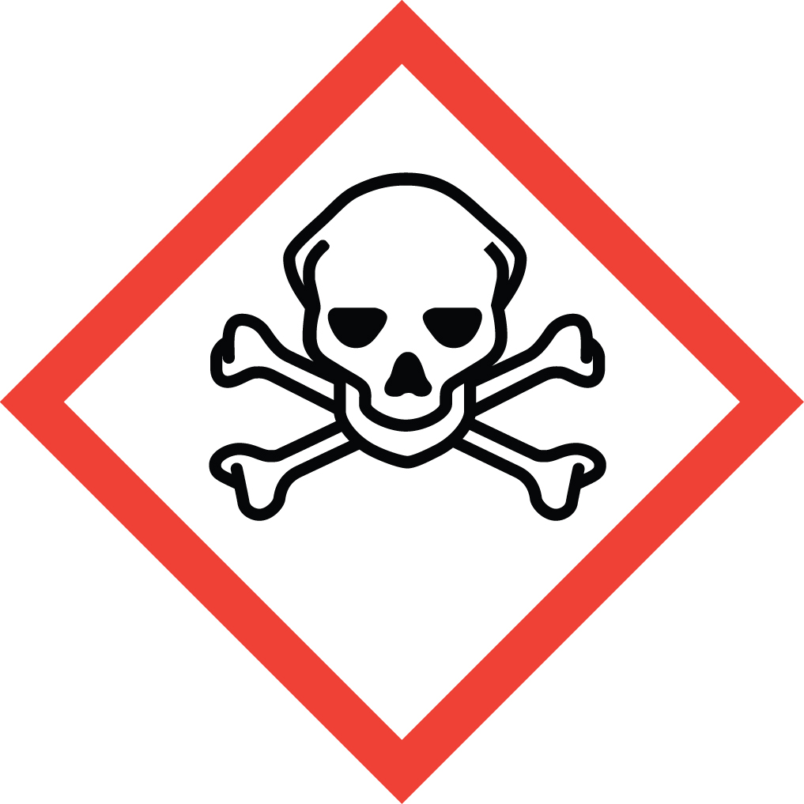 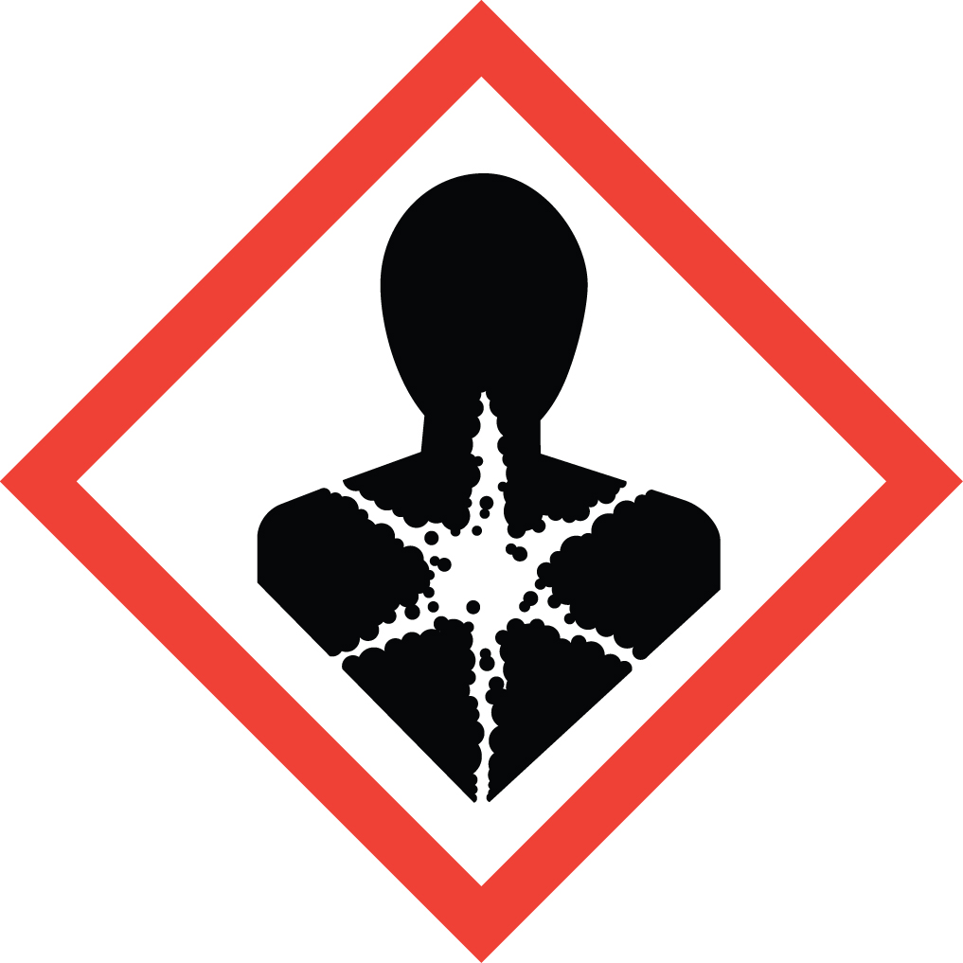 Signal Word: DANGER  Toxicological Data:  ORAL (LD50): 47.2 mg/kg [Mouse]; 161.2 mg/kg [Rat-Male]; 148.1 mg/kg [Rat-Female]  DERMAL (LD50): >512 mg/kg [Mouse].  *Always refer to the Safety Data Sheet for the most detailed information*
3. NAME OF TRAINER /  RESOURCE  PERSON | Principal Investigator Name, Building, Room, Phone Number  Secondary contact Name, Building, Room, Phone Number
- LOCATION OF  HEALTH & SAFETY  INFORMATION | The Safety Data Sheet (SDS) for Capsaicin is located in the Laboratory Safety Manual in Building, Room.  Labeling: In addition to the standard label that identifies contents, hazards, precautionary measures, and emergency contact information, containers should also be marked as highly toxic.
5. PROTECTIVE  EQUIPMENT | Wear chemical safety goggles, appropriate gloves such as nitrile rubber, and a fully-buttoned lab coat. Wash hands after removing gloves.  Work within a properly functioning, certified laboratory chemical fume hood. If using outside of fume hood correct PPE and an approved, certified respirator with the correct cartridges should be worn. (Note: You must be medically cleared, fit tested and enrolled in WSU’s Respiratory Protection Program to wear a respirator).
- WASTE DISPOSAL  PROCEDURES | Waste Capsaicin in pure form must be managed as Dangerous Waste. It should be collected in a sealable, compatible waste container. A completed Dangerous Waste label should be attached when waste is first added to the container. When container is full or no longer being used complete a Chemical Collection Request Form, and deliver to the Waste Accumulation Area Operator at Building, Room, Phone Number.  Waste Capsaicin solutions greater than 1% or 1000 ppm must be managed as Dangerous Waste. It should be collected in a sealable, compatible waste container. A completed Dangerous Waste label should be attached when waste is first added to the container. When container is full or no longer being used complete a Chemical Collection Request Form, and deliver to the Waste Accumulation Area Operator at Building, Room, Phone Number. Solutions containing less than 1% capsaicin may be drain discharged.  Empty Capsaicin containers must be managed as Dangerous Waste. Do not rinse out the container, simply attach a completed Dangerous Waste label, complete a Chemical Collection Request Form, and deliver to the Waste Accumulation Area Operator at Building, Room, Phone Number.
7. DESIGNATED AREA  INFORMATION | The capsaicin is stored and dispensed in Building, Room.  Always work in a properly functioning, certified laboratory chemical fume hood. Use process enclosures, local exhaust ventilation, or other engineering controls to reduce dust/aerosol generation.  If used outside of enclosure, ensure that appropriate certified respiratory protection and PPE is worn. (Note: You must be medically cleared, fit tested and enrolled in WSU’s Respiratory Protection Program to wear a respirator).  The designated area(s) should be shown on the floor plan in the laboratory’s Chemical Hygiene Plan.
8. DECONTAMINATION  PROCEDURES | Upon Accidental Exposure:  In case of eye contact, flush eyes with copious amounts of water at an emergency eyewash station for at least 15 minutes and seek medical attention.  In case of skin contact, flush skin with copious amounts of water for 15 minutes and seek medical attention. For exposure over a large portion of the body, remove clothing and shoes and rinse thoroughly in an emergency shower for at least 15 minutes. Seek medical attention.  In case of inhalation, move person to fresh air and immediately seek medical attention.  In case of ingestion, immediately seek medical attention and follow instructions on SDS.  Upon Accidental Release:  Large Spill: If a large amount of capsaicin is released outside the fume hood, immediately evacuate and secure area and call 911 to contact EH&S.  Small Spill: If a small amount of capsaicin is released (it can be cleaned up in 10 minutes) and you have been appropriately trained to clean it up, you may do so. Trained personnel should wear at the minimum nitrile rubber gloves, chemical safety goggles, and a fully-buttoned lab coat.  Additional PPE such as respirators may be necessary depending upon material and concentration. (Note: You must be medically cleared, fit tested and enrolled in WSU’s Respiratory Protection Program to wear a respirator). If it is necessary to use a respirator and personnel are not cleared to wear a respirator and not trained to appropriately clean up the spill, the employee should immediately evacuate, secure area, and call 911 to contact EH&S.  Use appropriate tools to collect material and place in a waste disposal container. Place waste in appropriate containers and dispose of as hazardous waste (see above WASTE DISPOSAL PROCEDURES).  As with all accidents, report any exposure as soon as possible to your Principal Investigator or Supervisor. Additional health and safety information on Capsaicin can be obtained by referring to the Safety Data Sheet or by calling the EH&S Office (335-3041).
- SPECIAL STORAGE  AND HANDLING  PROCEDURES | Store in a cool, dry, well-ventilated area away from sources of heat or ignition. Keep container tightly closed. Do not ingest. Store highly toxic or infectious materials separately in a locked safety storage cabinet or room.  Keep away from incompatible materials such as oxidizing agents.

Certification of Hazard Assessment

Is this document a certification of Hazard Assessment for the processes identified within? Yes No
If yes, provide the name of the person certifying the Hazard Assessment and the date it was performed:

____________________________________________________________________________________
Name Date

The location of the Hazard Assessment is indicated in the document preceding this form.

Certificate of Employee Training

Name of person providing training for employees working with this process:

___________________________________________________________________________________
The following employees have been trained in when, where and how to use selected PPE, the maintenance, limitations and disposal of the PPE selected, and have demonstrated the correct use of the PPE selected on the reverse of this certification.
Name Date Trained
________________________________________ _______________________________
________________________________________ _______________________________
________________________________________ _______________________________
________________________________________ _______________________________
________________________________________ _______________________________
________________________________________ _______________________________
________________________________________ _______________________________

