STANDARD OPERATING PROCEDURES FOR HAZARDOUS AND PARTICULARLY HAZARDOUS CHEMICALS
For

Ammonium Nitrate

1. PROCEDURE /  PROCESS | Ammonium Nitrate is used in Building, Room.  Insert procedure here:
2. CHEMICAL NAME(S)  and associated  PHYSICAL and  HEALTH  HAZARDS | Ammonium Nitrate- CAS# 6484-52-2; also known as nitram; ammonia nitrate; ammonium saltpeter; nitric acid, ammonium salt.  - Ammonium nitrate is a strong oxidizer, contact with other material may cause or intensify fire.  - Ammonium nitrate is reactive and a dangerous explosion hazard.  - Contact can irritate and burn the skin and eyes. May be absorbed through the skin.  - Inhalation can irritate the nose, throat and lungs.  - High levels may cause methemoglobinemia with headache, fatigue, and a blue color to the skin and lips.  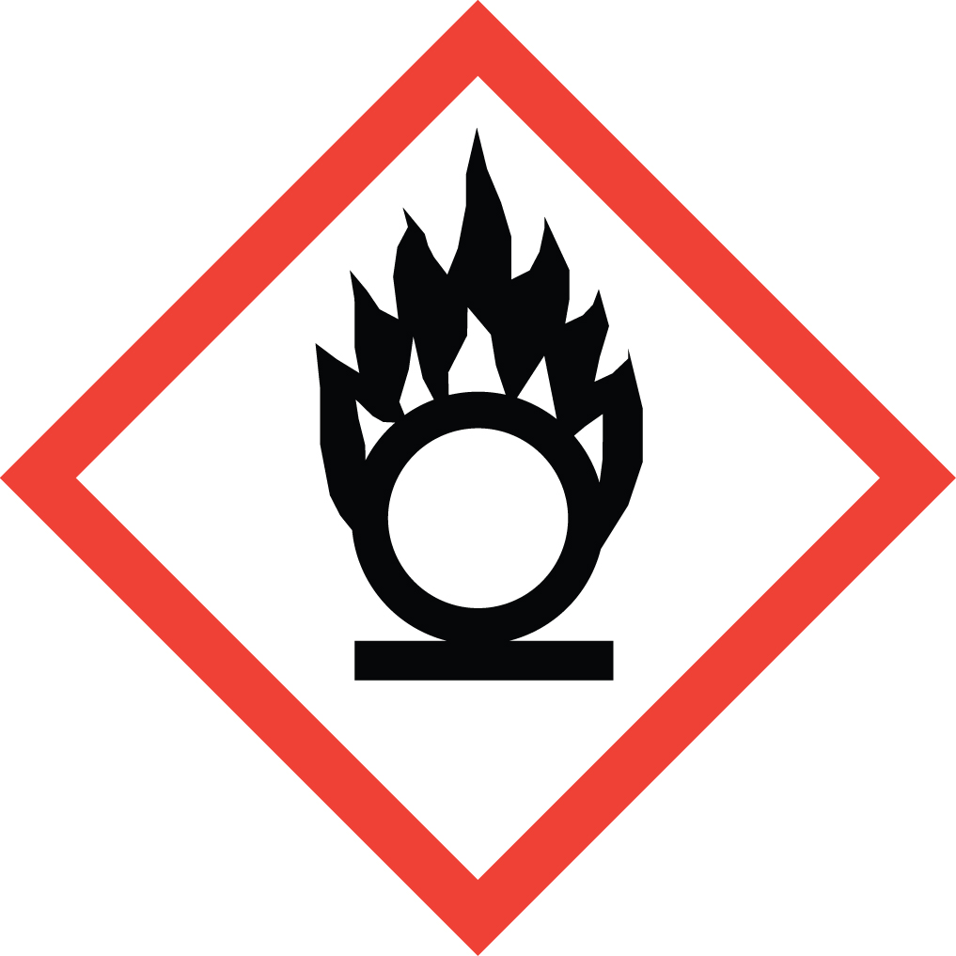 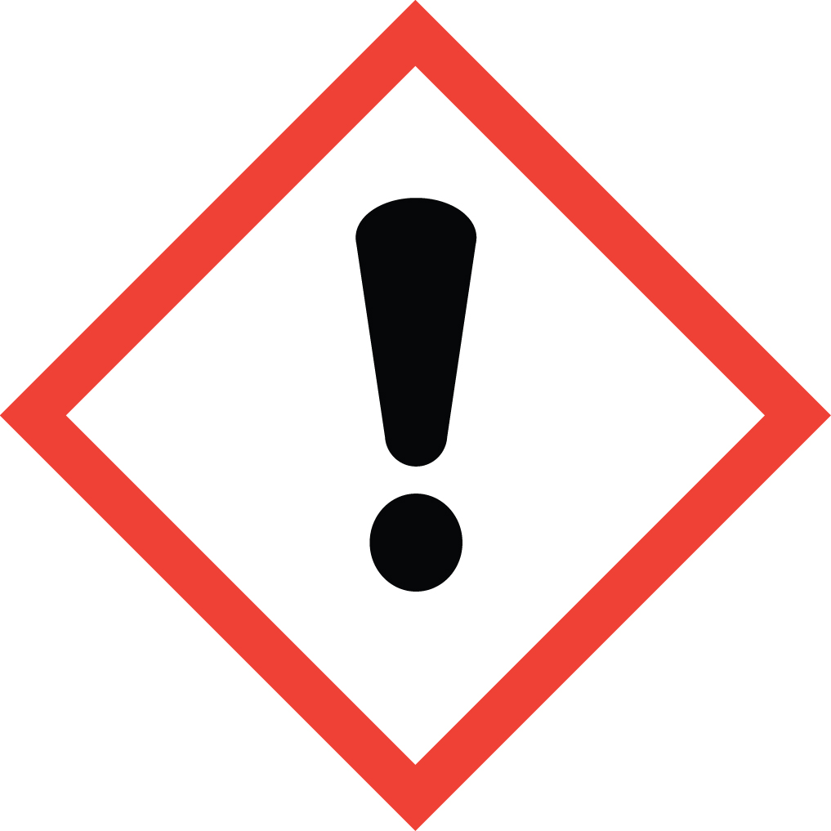 Signal Word: WARNING  Exposure Limits:  - No occupational exposure limits have been established for Ammonium Nitrate. This does not mean that this substance is not harmful. Safe work practices should always be followed.  - It should be recognized that Ammonium Nitrate can be absorbed through your skin, thereby increasing your exposure.  Toxicological Data:  ORAL (LD50): 2,217 mg/kg [Rat].  *Always refer to the Safety Data Sheet for the most detailed information*
3. NAME OF TRAINER /  RESOURCE  PERSON | Principal Investigator Name, Building, Room, Phone Number  Secondary contact Name, Building, Room, Phone Number
- LOCATION OF  HEALTH & SAFETY  INFORMATION | The Safety Data Sheet (SDS) for Ammonium Nitrate is located in the Laboratory Safety Manual in Building, Room  Labeling: Containers shall either have original warning label affixed or a label identifying the contents and hazards.
5. PROTECTIVE  EQUIPMENT | Wear at the minimum nitrile gloves, chemical splash goggles, and a fully buttoned lab coat. (Note: Always check the manufacturer’s glove compatibility chart for proper glove selection.) Wash hands after removing gloves. Always work within a properly functioning, certified laboratory chemical fume hood.
- WASTE DISPOSAL  PROCEDURES | Waste Ammonium Nitrate must be collected in a sealable, compatible waste container. If used with trace organic materials, a vented cap must be used. A completed Dangerous Waste label should be attached when waste is first added to the container. When container is full or no longer being used complete a Chemical Collection Request Form, and deliver to the Waste Accumulation Area Operator at Building, Room, Phone Number.
7. DESIGNATED AREA  INFORMATION | The ammonium nitrate is stored and dispensed in Building, Room.  Confine all work with ammonium nitrate to a properly functioning certified laboratory chemical fume hood.  The designated area(s) should be shown on the floor plan in Laboratories Chemical Hygiene Plan.
8. DECONTAMINATION  PROCEDURES | Upon Accidental Exposure:  In case of eye contact, flush eyes with copious amounts of water at an emergency eyewash station for at least 15 minutes and seek medical attention.  In case of skin contact, flush skin with copious amounts of water for 15 minutes and seek medical attention. For exposure over a large portion of the body, remove clothing and shoes and rinse thoroughly in an emergency shower for at least 15 minutes. Seek medical attention.  In case of inhalation, move person to fresh air and seek medical attention.  In case of ingestion, immediately seek medical attention and follow instructions on SDS.  Upon Accidental Release:  Large Spill: If a significant amount of ammonium nitrate is released outside the fume hood, immediately evacuate, secure area and call 911 to contact EH&S.  Small Spill: If a small amount of ammonium nitrate is released (it can be cleaned up in 10 minutes) and you have been appropriately trained to clean it up, you may do so. Trained personnel should wear at the minimum nitrile gloves, chemical splash goggles, and a fully-buttoned lab coat. (Note: Always check the manufacturer’s glove compatibility chart for proper glove selection.)  Additional PPE such as respirators may be necessary depending upon material and concentration. (Note: You must be medically cleared, fit tested and enrolled in WSU’s respiratory protection program to wear a respirator). If it is necessary to use a respirator and personnel are not cleared to wear a respirator and not trained to appropriately clean up the spill, the employee should immediately evacuate, secure area, and call 911 to contact EH&S.  Use appropriate tools to collect material and place in a waste disposal container. Place waste in appropriate containers and dispose of as hazardous waste (see above WASTE DISPOSAL PROCEDURES).  As with all accidents, report any exposure as soon as possible to your Principal Investigator or Supervisor. Additional health and safety information on ammonium nitrate can be obtained by referring to the SDS or by calling the EH&S Office (335-3041).
- SPECIAL STORAGE  AND HANDLING  PROCEDURES | Store in a secured, cool and well-ventilated area away from direct sunlight, heat, sparks, flame, and other sources of ignition. Avoid formation of dust and aerosols. Store in a tightly closed container until ready for use. Avoid storing on wood surfaces. Recommend storing in secondary containment such as a Nalgene/polypropylene tub labeled as “Explosion Risk & Strong Oxidizer”.  Keep away from incompatibles such as reducing agents, powdered metals, and strong acids. This substance is an oxidizing agent and can self-ignite/detonate when in contact with powdered metals and some organic materials such as  Urea and Acetic Acid.

Certification of Hazard Assessment

Is this document a certification of Hazard Assessment for the processes identified within? Yes No
If yes, provide the name of the person certifying the Hazard Assessment and the date it was performed:

____________________________________________________________________________________
Name Date

The location of the Hazard Assessment is indicated in the document preceding this form.

Certificate of Employee Training

Name of person providing training for employees working with this process:

___________________________________________________________________________________
The following employees have been trained in when, where and how to use selected PPE, the maintenance, limitations and disposal of the PPE selected, and have demonstrated the correct use of the PPE selected on the reverse of this certification.
Name Date Trained
________________________________________ _______________________________
________________________________________ _______________________________
________________________________________ _______________________________
________________________________________ _______________________________
________________________________________ _______________________________
________________________________________ _______________________________
________________________________________ _______________________________

