STANDARD OPERATING PROCEDURES FOR HAZARDOUS AND PARTICULARLY HAZARDOUS CHEMICALS
For
Alcohols (Methanol, Ethanol, Propanol, etc.)

1. PROCEDURE /  PROCESS | Alcohols, such as Ethyl Alcohol (Ethanol), Methyl Alcohol (Methanol), and Propyl Alcohol (Propanol) are used in Building, Room.  Insert procedure here:
2. CHEMICAL NAME(S)  and associated  PHYSICAL and  HEALTH  HAZARDS | Methanol (CAS# 67-56-1), Ethanol (CAS# 64-17-5) and Propanol (CAS# 71-23-8) Alcohols, etc.  - Highly Flammable liquid and vapor.  - Toxic to organs. These substances may affect the kidneys, liver, heart, central nervous system, and eyes.  - May cause skin irritation.  - Causes severe eye irritation and possible injury. Can cause blurred vision and blindness.  - Toxic by inhalation, ingestion, and skin absorption.  - May cause respiratory and digestive tract irritation.  - May be fatal or cause blindness if swallowed.  - May be teratogens in humans. May affect reproductive systems or the fetus. Handle with extreme caution.  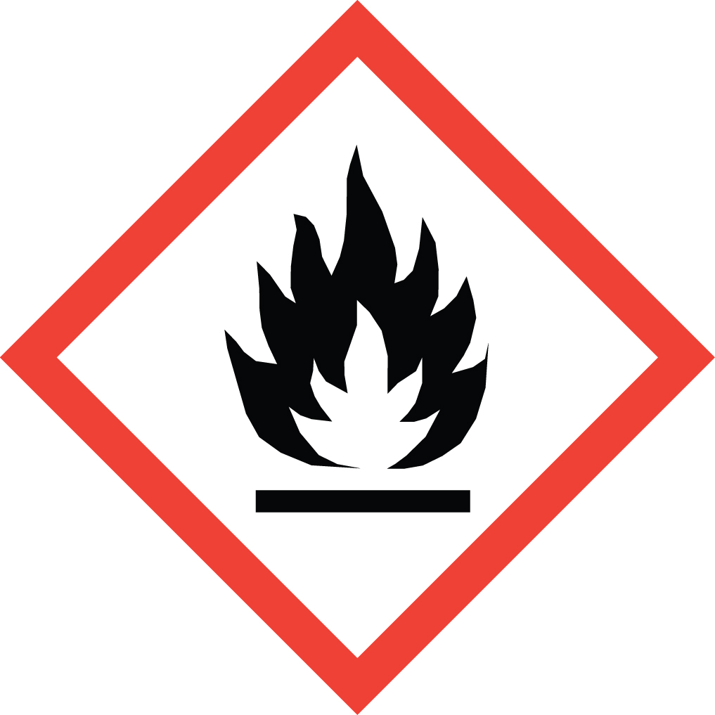 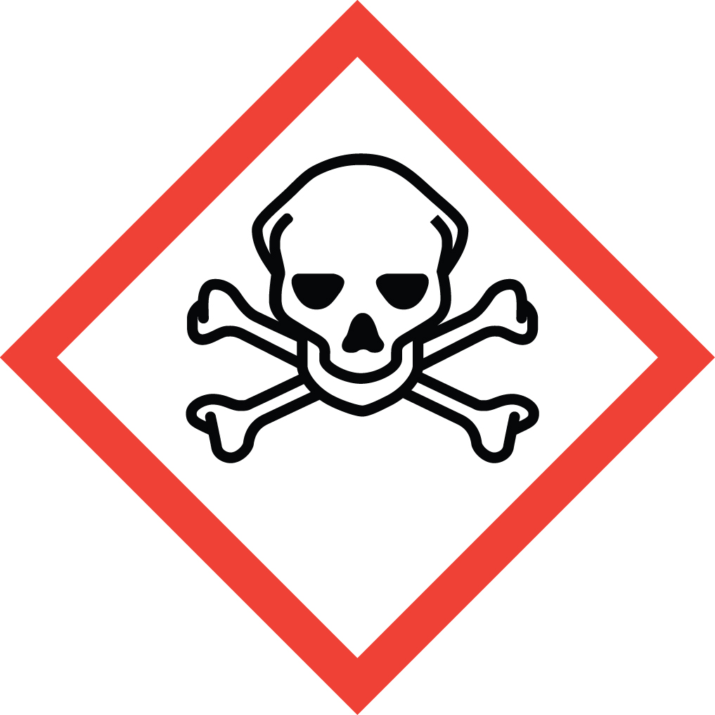 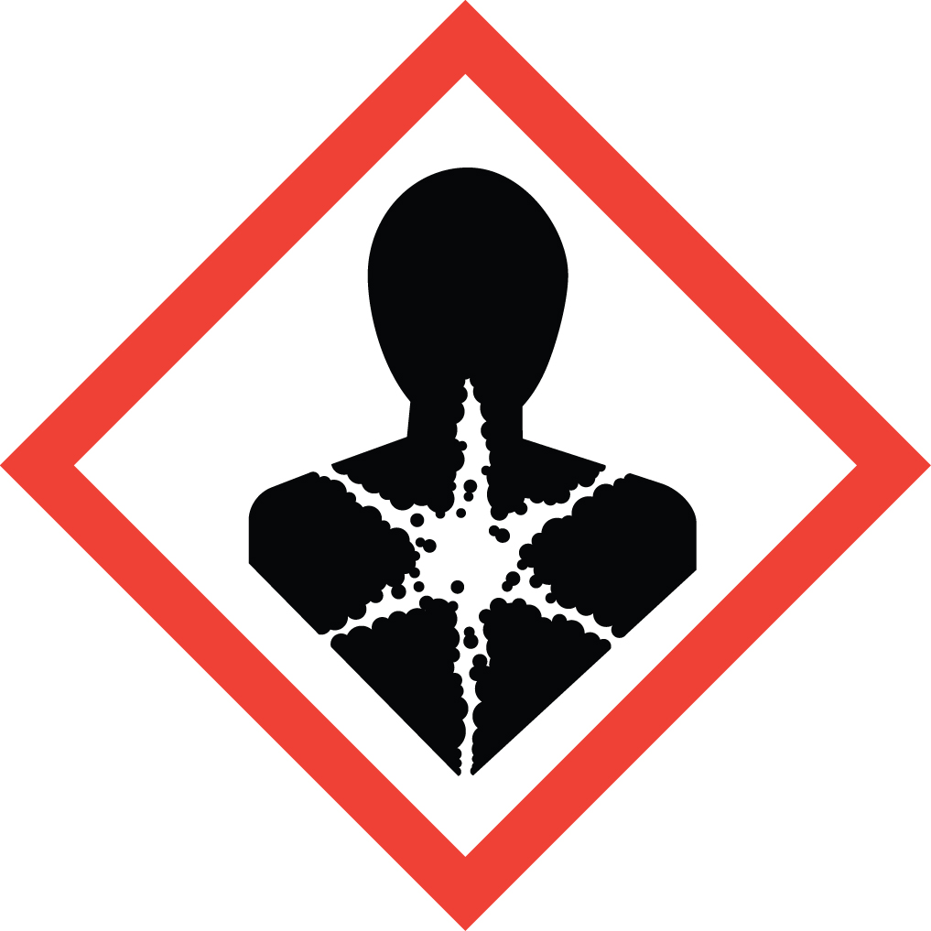 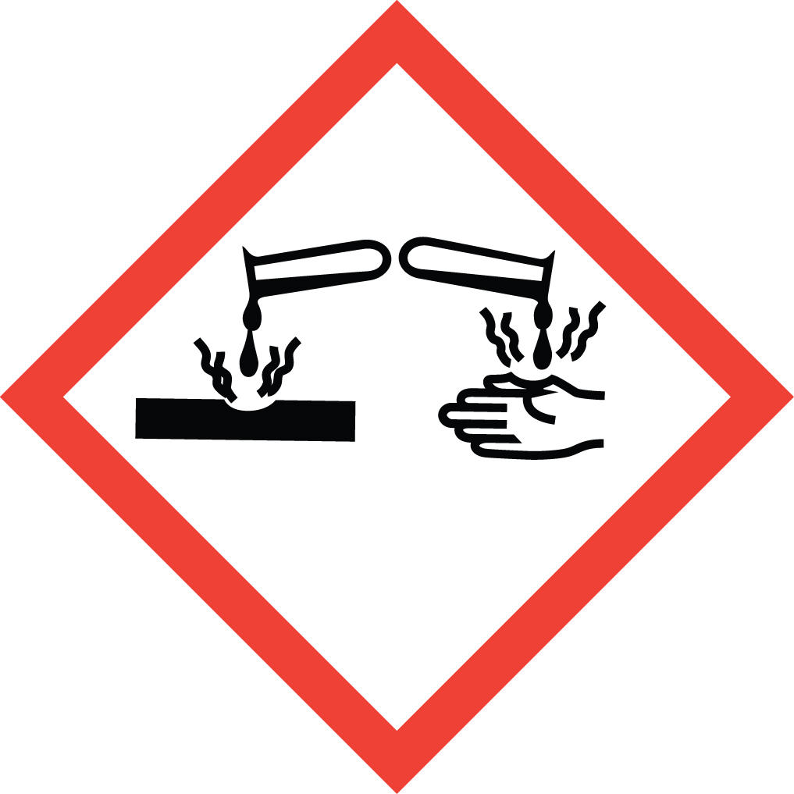Signal Word: DANGER  Methanol Exposure Limits  DOSH: TWA: 200 ppm; STEL: 250 ppm  NIOSH: TWA: 200 ppm: STEL: 250 ppm  ACGIH: TWA: 200 ppm; STEL: 250 ppm  Ethanol Exposure Limits  DOSH: TWA: 1,000 ppm; STEL: 1,250 ppm  NIOSH: TWA: 1,000 ppm  ACGIH: STEL: 1,000 ppm  Propanol Exposure Limits  DOSH: TWA: 200 ppm; STEL: 250 ppm  NIOSH: TWA: 200 ppm; STEL: 250 ppm  ACGIH: TWA: 100 ppm  *Always refer to the Safety Data Sheet for the most detailed information*
3. NAME OF TRAINER /  RESOURCE  PERSON | Principal Investigator Name, Building, Room, Phone Number  Secondary contact Name, Building, Room, Phone Number
- LOCATION OF  HEALTH & SAFETY  INFORMATION | The Safety Data Sheet (SDS) for alcohol is located in the Laboratory Safety Manual in Building, Room.  Labeling: In addition to the standard label that identifies contents, hazards, precautionary measures, and emergency contact information, containers should also be marked as a toxic.
5. PROTECTIVE  EQUIPMENT | Wear chemical safety goggles, nitrile or butyl gloves, and a fully-buttoned lab coat. Wash hands after removing gloves. Work within a properly functioning, certified laboratory chemical fume hood.
- WASTE DISPOSAL  PROCEDURES | Waste alcohol is to be collected in a compatible waste container. A completed Dangerous Waste label should be attached when waste is first added to the container. The container should be stored away from incompatible materials such as oxidizing agents, reducing agents, acids, alkalis. When container is full or no longer being used complete a Chemical Collection Request Form, and deliver to the Waste Accumulation Area Operator at Building, Room, Phone Number.
7. DESIGNATED AREA  INFORMATION | The alcohols are stored and dispensed in Building, Room.  Always work in a properly functioning, certified laboratory chemical fume hood.  The designated area(s) should be shown on the floor plan in Laboratories Chemical Hygiene Plan.
8. DECONTAMINATION  PROCEDURES | Upon Accidental Exposure:  In case of eye contact, flush eyes with copious amounts of water at an emergency eyewash station for at least 15 minutes and seek medical attention.  In case of skin contact, flush skin with copious amounts of water for 15 minutes and seek medical attention. For exposure over a large portion of the body, remove clothing and shoes and rinse thoroughly in an emergency shower for at least 15 minutes. Seek medical attention.  In case of inhalation, move person to fresh air and seek medical attention.  In case of ingestion, immediately seek medical attention and follow instructions on SDS.  Upon Accidental Release:  Large Spill: If a large amount of alcohol is spilled outside the fume hood, immediately evacuate, secure area and call 911 to contact EH&S.  Small Spill: If a small amount of alcohol is spilled (it can be cleaned up in 10 minutes or less) and you have been appropriately trained to clean it up, you may do so. Trained personnel should wear at the minimum nitrile or butyl gloves, chemical splash goggles, and a fully-buttoned lab coat.  Additional PPE such as respirators may be necessary depending upon material and concentration. (Note: You must be medically cleared, fit tested and enrolled in WSU’s respiratory protection program to wear a respirator). If it is necessary to use a respirator and personnel are not cleared to wear a respirator and not trained to appropriately clean up the spill, the employee should immediately evacuate, secure area, and call 911 to contact EH&S.  Absorb with an inert dry material and place material in an appropriate waste disposal container (resealable bag, etc.) and dispose of as hazardous waste (see above WASTE DISPOSAL PROCEDURES).  As with all accidents, report any exposure as soon as possible to your Principal Investigator or Supervisor. Additional health and safety information on alcohols can be obtained by referring to the SDS or by calling the EH&S Office (335-3041).
- SPECIAL STORAGE  AND HANDLING  PROCEDURES | Alcohols (Methanol, ethanol, and propanol) are flammable liquids.  Store away from sunlight, heat, sparks, flame and other sources of ignition. Store in a tightly closed container in a cool, dry, well-ventilated area away from incompatible substances. Store segregated from incompatible chemicals (below).  Keep away from incompatible chemicals such as oxidizing agents, reducing agents, acids, alkalis.

Certification of Hazard Assessment

Is this document a certification of Hazard Assessment for the processes identified within? Yes No
If yes, provide the name of the person certifying the Hazard Assessment and the date it was performed:

____________________________________________________________________________________
Name Date

The location of the Hazard Assessment is indicated in the document preceding this form.

Certificate of Employee Training

Name of person providing training for employees working with this process:

___________________________________________________________________________________
The following employees have been trained in when, where and how to use selected PPE, the maintenance, limitations and disposal of the PPE selected, and have demonstrated the correct use of the PPE selected on the reverse of this certification.
Name Date Trained
________________________________________ _______________________________
________________________________________ _______________________________
________________________________________ _______________________________
________________________________________ _______________________________
________________________________________ _______________________________
________________________________________ _______________________________
________________________________________ _______________________________

