Direct Billing Purchasing Card Instructions – Federal Express
WSU personnel may create a FedEx shipper account and attach the purchasing card to all account shipments. To setup this direct-charge method of payment, call FedEx at 800-622-1147 and request “credit card updates.” After this process is established with FedEx, the associated purchasing card will automatically be charged for each shipment processed on the FedEx account.
Copies of the invoices and detailed shipping information can be accessed by logging in to FedEx Billing Online. This will allow you to print and retain copies of the invoices for your purchasing card reconciliation.
Once logged in to FedEx Billing Online, locate the “Invoice List.” Below is a screenshot:
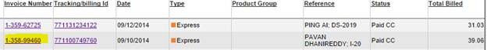
After FedEx charges the associated purchasing card, the transaction will be available for reconciliation in PNet4.
If you have multiple charges for multiple shipments, it can be easily deciphered in PNet4 by using the customer code field. FedEx inputs the invoice number in this field. See the following screenshot:
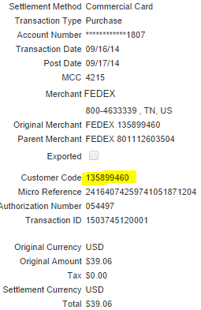
Once the charges are identified, the reconciler can proceed with standard protocol in transaction reconciliation.

