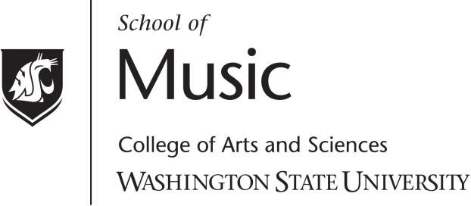

Faculty Artist Series
presents

Program

This concert was presented via livestream in accordance with restrictions related to the containment of COVID-19. No audience was present at the
time of this performance.
music.wsu.edu/faculty-artist-series

PROGRAM NOTES

