Spring 2020
Faculty Artist Series

Friday, January 17, 2020
An Evening of Piano Music With Yoon-Wha Roh
7:30 pm Bryan Hall Theatre

Friday, January 24
Cantiamo!
7:30 pm Bryan Hall Theatre

Friday, January 31
Equinox
7:30 pm Bryan Hall Theatre

Tuesday, February 11
Jazz Northwest “Collective Excellence”
7:30 pm Kimbrough Music Hall

Friday, February 28
The Palouse Trio
7:30 pm Bryan Hall Theatre

Friday, March 6
Jake Svendsen, piano
7:30 pm Bryan Hall Theatre

Friday, April 10
Albert Miller, euphonium with Sarah Miller, trombone and Yoon-Wha Roh, piano
7:30 pm Bryan Hall Theatre

Friday, April 17
American Monuments: Works for Flute and Piano by American Composers
7:30 pm Bryan Hall Theatre

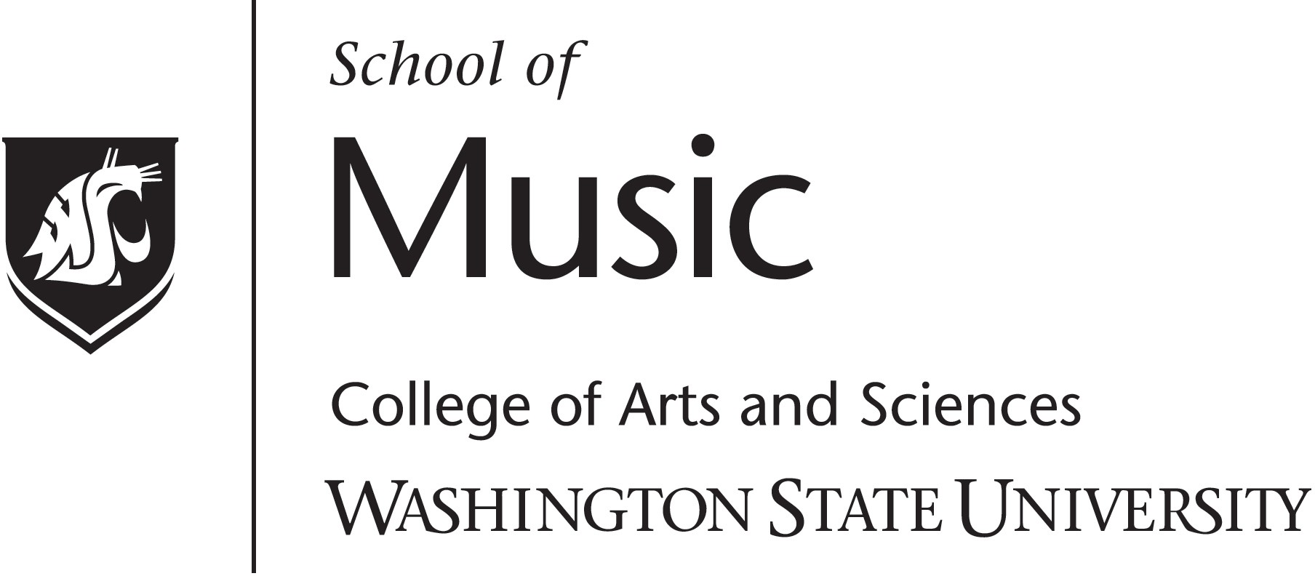
Faculty Artist Series
presents

TITLE ITALICS PALATINO 24

Performers Italics Palatino, 20

Date Italics Palatino 14 , 2019
7:30 p.m.
Venue Italics Palatino 14

rulers: 1/4 , 5 1/4, 5 3/4, 10 3/4 top 1/4 bottom 8 1/4
Palatino Linotype

music.wsu.edu/faculty-artist-series
All proceeds from the Faculty Artist Series – admissions and donations – directly fund music student scholarships.
Step Out .....

rulers: 1/4 , 5 1/4, 5 3/4, 10 3/4 top 1/4 bottom 8 1/4
Palatino Linotype 11

Program

Intermission

The use of recording devices or photographic equipment during the performance is prohibited without permission from the School of Music.
Please turn off all cell phones and electronic devices.

... and become Engaged in the Arts at WSU!

