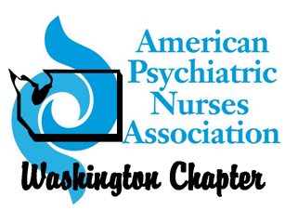
SAVE THE DATE!!!!!!
1st ANNUAL APNA-WA CONFERENCE

Advocacy for Psychiatric Nurses and Our Patients

Central Washington University
Ellensburg, Washington
Apr 29th, 2017 8am-4:30pm

Key note speaker: Nick Croce, MA
“Your Professional Organization and You”
Executive Director American Psychiatric Nurses Association
Plenary speaker: Mary Moller DNP, ARNP, PMHCNS-BC
“Psychiatric Nurses: Champions of Advocacy”
Associate Professor, Coordinator, PMH-DNP Program
Pacific Lutheran University School of Nursing
Workshops:
Critical legislation affecting psychiatric care in WA
Nursing advocacy at the individual and community level
Resiliency and the safety of nurses and patients
The process of detaining patients
6 CEUs
Afterwards, wine tasting
This event will be catered.
$75 for members, $140 for non-members, $30 for students
Hotel block available Friday and Saturday night

