**MCj02932000000[1]MCj02932000000[1]**

**Coffee & Politics Series**

Christopher Faricy Ph.D.

**The 99 Percent Movement and the Politics of Income Inequality**

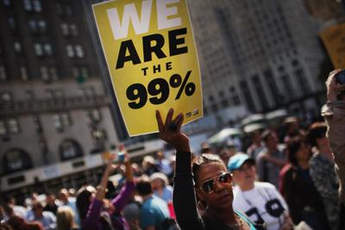How does politics influence income inequality in the U.S.? How does rising income inequality affect American democracy? Will the 99 Percent Movement be successful in facilitating political change? Professor Faricy discusses the most recent political science research on the politics of income inequality in America.

**Dr. Christopher Faricy** is Assistant Professor of Political Science at Washington State University. He is a past recipient of MPSA’s Pi Sigma Alpha Award and the James W. Prothro Award. He has authored numerous articles on the relationship among political parties, public policy, and income inequality including two in The Journal of Politics. His current book manuscript is entitled *The Great Political Divide: Republican vs. Democratic Social Spending in America*.

Join us for pizza, pop and discussion of income inequality in the U.S.

RSVP to relgar@wsu.edu

**Wednesday, November 30**

**12-1pm**

**CUE 518**