**MCj02932000000[1]MCj02932000000[1]**

**Coffee & Politics Series**

with EU Fellow Anne Burrill

**Environmental Policy in Europe: New Directions and Challenges**

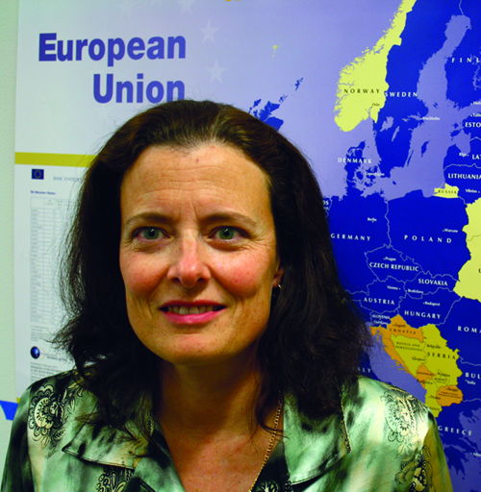European Union environment legislation now includes more than 300 important directives and legislation, ranging from early 'end-of-pipe' rules, to comprehensive 'framework' legislation in water, air, waste and marine environment. How well is this comprehensive policy addressing the challenges of Europe today? What are the priorities for the future?

**Anne Burrill** works for the European Commission where she is Deputy Head of International Relations and Enlargement in the Directorate-General for Environment. Before joining the Commission, Anne worked as an environmental information consultant, including at the United Nations Environment Programme in Nairobi. Anne holds a BA from Dartmouth College, an MA from Columbia University and a post-graduate diploma from the University of London. She is presently a visiting Fellow at the University of Washington in Seattle.

Join us for pizza, pop and discussion of environmental policy in the EU.

RSVP to relgar@wsu.edu

**Tuesday, November 29**

**12-1pm**

**CUE 518**