4-H Public Presentations
General Guidelines & Tips

Why Do 4-Hers Make Public Presentations?
The logo above is a good reminder of the “4 Essential Elements” for youth development: a sense of belonging, mastery, independence, and generosity. In combination, these essential elements help youth to grow into competent, caring, and contributing adults. When it comes to the element of “mastery” in particular, all youth want to be good at something (adults do too!). Mastery is building knowledge, skills, and attitudes and then demonstrating the competent use of the knowledge and skills. Youth need to feel and believe that they are capable, and experience success at solving problems and meeting challenges to develop their self-confidence.

Practicing and offering 4-H public presentations give youth an ideal opportunity to stretch and grow in the “mastery” of the activities. Settings that promote mastery – like 4-H Club meetings, County Fair, State Fair – encourage youth to take risks, seek out challenges, and focus on self-improvement rather than comparing themselves to their peers.

Types of 4-H Presentations
- A DEMONSTRATION puts words into action. An effective demonstration teaches others how to do something by showing while telling. At the end of a demonstration, you should have a finished product to show your audience.
Examples include: how to cook an egg, how to groom a dog, how to needle-felt
- An ILLUSTRATED TALK makes us of posters, pictures, PowerPoint (at County Fair: for Intermediate and Senior 4-Hers only), or other visuals to show how to do something or illustrate a process. No finished product is required.
Example include: how to plan a garden, how to distinguish horse markings, how to lead a fun and effective carwash
- PUBLIC SPEAKING is a prepared speech on a specific subject for an audience. Usually, no props or visual aids are used. 4-Hers use this type of presentation to teach, entertain, and/or inform their audiences.
Examples include: why I like the 4-H cat project, 4-H around the world, what compassion looks like in my community
(For more on Public Speaking, please see “Public Speaking 4-H Member Manual,” WSU Publication #EM4903E.)

Individual and Team Presentations
Presentations can be given by individuals or by teams. When trying to decide between the two, ask yourself, “Can I do this best by myself or with someone else?” While individual presentations tend to take less time in planning and presenting, team presentations are a great way to learn team planning and cooperation. And, they offer the viewing audience a change of voices and personalities and, perhaps, understand a subject from different perspectives. Teamwork is encouraged throughout the planning and presentation itself. Shifting the presentation from one team member to another should occur at natural, and relatively equal intervals.
Here are a few things to keep in mind with team presentations:
- If you plan to compete at State Fair, only members of the same age division should compete as a team.
- Be sure that all members of the team share in the preparation, doing, and telling.
- Team presentations take more practice in order to flow as if only one person is giving the demonstration. So, allow for plenty of practice time.

Recommended Time Limits for 4-H Presentations
For demonstrations and illustrated talks the minimum time is 3 minutes and the maximum is 20 minutes, depending on 4-H “age” (your age on Oct. 1 of the current 4-H year). For public speeches the minimum time is 5 minutes and a maximum time is 10 minutes (at State Fair, a penalty of 5 points per minute under or over is deducted).
4-H Age Division | Age | Time limits
Cloverbuds | 5-7 years old | Less than 5 minutes
Juniors | 8-10 years old | 3-8 minutes
Intermediates | 11-13 years old | 5-15 minutes
Seniors | 14-<19 years old | 10-20 minutes

Getting Ready to Present
Shaping the Presentation
- Choose a topic that is of great interest to you! If you need ideas, talk with your 4-H friends and Leader; look at the 4-H catalog: http://cru.cahe.wsu.edu/CEPublications/em2778/EM2778_16.pdf; talk with other adults and youth in your life; or look in the library, magazines, newspaper, and other media.
- Choose a title that gives an interesting hint at what your topic is about. For example, if you are going to do an illustrated talk about rabbits’ eyelids, you might want to call it “The Eyes Have It” instead of “Rabbit Eyelids.”
- Prepare a written outline of the 3 main parts of your presentation. You are welcome (and encouraged) to use your outline and brief notes as you present (no need to memorize!). You might want to use the template on the next page help you with your outline:

ANATOMY OF A 4-H PRESENTATION
INTRODUCTION
- Start with an attention-grabbing line (e.g., “I didn’t know that the boat was going to sink… really I didn’t!"), a quotation, or an appropriate trick.

- Introduce yourself: “Hello, my name is _________________________________.
I am a member of the ______________ 4-H Club/Project. This is my ______ year in 4-H, and my ______ year in the _______ project. This is my presentation on __________________________________ (e.g., “How To Keep Your Boat Afloat”).

- Share WHY you selected this topic and why you think this topic might be important to the audience.

BODY
This is the part of the presentation in which you show and/or tell HOW you will address the heart of your topic – your MAIN IDEA. What do you need to DO, SHOW, and/or SAY to express your main idea? Pay close attention to the ORDER in which you put your ideas – your audience should be able to follow your ideas in a logical, natural order.
WHAT WILL YOU…
DO or SHOW? | SAY? | NEED (supplies, equipment, visuals)?
SUMMARY STATEMENT and Q&A
- This is your last chance to express your main idea to your audience. What do you really want your audience to remember? What was accomplished? What does this really mean to you? (Never introduce new material in the summary.)
- Then ask your audience “Do you have any questions?” The audience will have 3-5 minutes to ask questions. Before responding, always REPEAT the question being asked. If you do not know an answer, you might say something like, “I don’t know, but I suspect that you can find your answer [on __ website, in the library, etc.].”
- Tell your audience where you found your information (e.g., _____ website, ___ library).
- Thank your audience for listening to your presentation on: ______________________
[restate the title of your presentation].

General Preparation Tips
- Choose a different topic each year.
- Decide whether you’d like to present as an individual or as a team.
- Use the template on the previous page to help you structure your presentation.
- Use illustrations, posters, and visuals (including models, tools, etc.) to help your audience understand your presentation – avoid any visuals that DISTRACT attention from your main idea. Make sure lettering and images on graphics can be viewed from the back of the room and at every angle (easels are available). Live animals are not permitted in 4-H public demonstrations.
- Have your material well organized in a logical order. Perhaps trays, boxes, bowls etc. will help your to manage your materials. If you use these, look for transparent containers so that your audience can see the contents. Also consider labeling containers so that your audience sees the materials and the process.
- Plan what you’ll wear. Your clothes should be simple, neat, and clean. Those doing food presentations should wear short sleeves. Hair should be under control. Don’t wear DISTRACTING clothes, jewelry, or makeup. Choose clothing appropriate for your presentation: e.g., clown gear for a clowning presentation, period clothing for a presentation on John Muir.
- Prepare to bring any reference materials to your presentation and be prepared to share your references with your audience at the end of your presentation.
- PRACTICE often, out loud, and pull in lots of different people to serve as your audience. Be sure to ask your practice audience questions like: “What was not clear in my presentation?” “What really struck you?” “How can I make my presentation even better?”

Presentation Day!
Gearing Up Tips
- Attend to your basic needs. Get a good night sleep and healthy meal before your presentation. If you think you’ll need a glass of water, have one ready. (No gum chewing please. And clean hands and nails are a plus!)
- Get to know your equipment well – especially if you’re planning to use computer and/or projection equipment.
- Arrange equipment and supplies neatly and so that the audience can see clearly. Place any extra equipment on a second table away from the main demonstration table. Keep a hand towel, paper towels, garbage can, etc. handy if needed.
- If using posters, be prepared to remove or turn posters as soon as you have made your point.

Presentation Tips
You’ll find lots of tips in the “38 Tips for Persuasive Presentations” handout; here are a few more:
- Show enthusiasm for your topic. Look like you enjoy what you’re presenting (others will too). Weave personal experience into your presentation where appropriate.
- Have good, gentle eye contact with your audience. Stand tall.
- Again, bring notes, but do not read directly from them (this cuts down on eye contact.)
- Make your voice gentle, appropriately loud, and clear. (You’ll have a microphone at Fair.)
- Name any supplies and hold them up so that your audience can see.
- Keep your work/demonstration area organized – move materials from right to left if you are right-handed, or left to right if you are left-handed.
- Label the backs of posters, books, etc. that you’ll want to reference during your presentation (but you don’t want your audience to necessarily see).
- Goof-ups happen to everyone! Go right ahead with your presentation; explain what happened.
- Thank your audience for their attention.

Presentation Score Card
This is the “score card” that Judges use to evaluate 4-H Demonstrations, Illustrated Talks, and Presentations (for the Public Speaking scorecard, go to: http://cru.cahe.wsu.edu/CEPublications/C0431E/C0431E.pdf.)

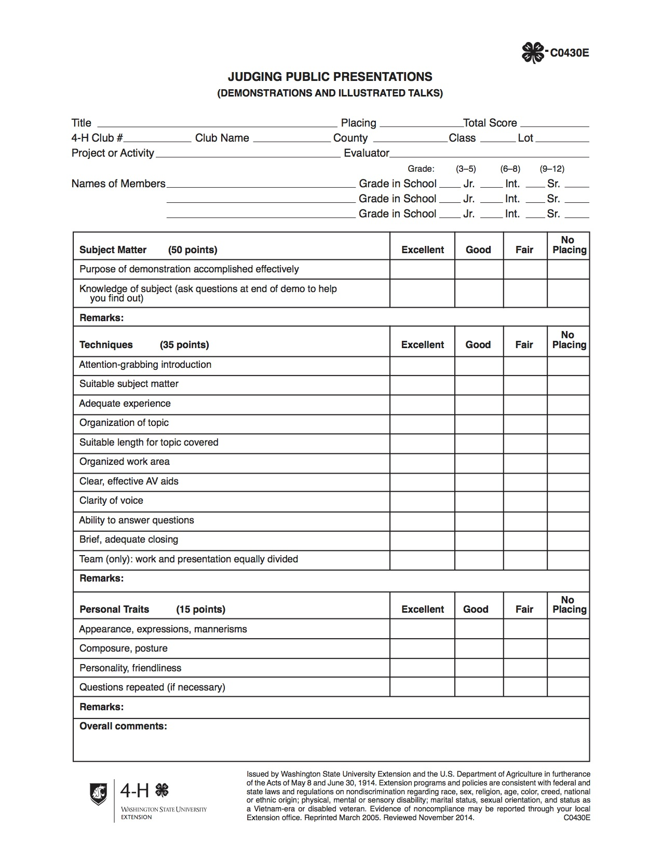
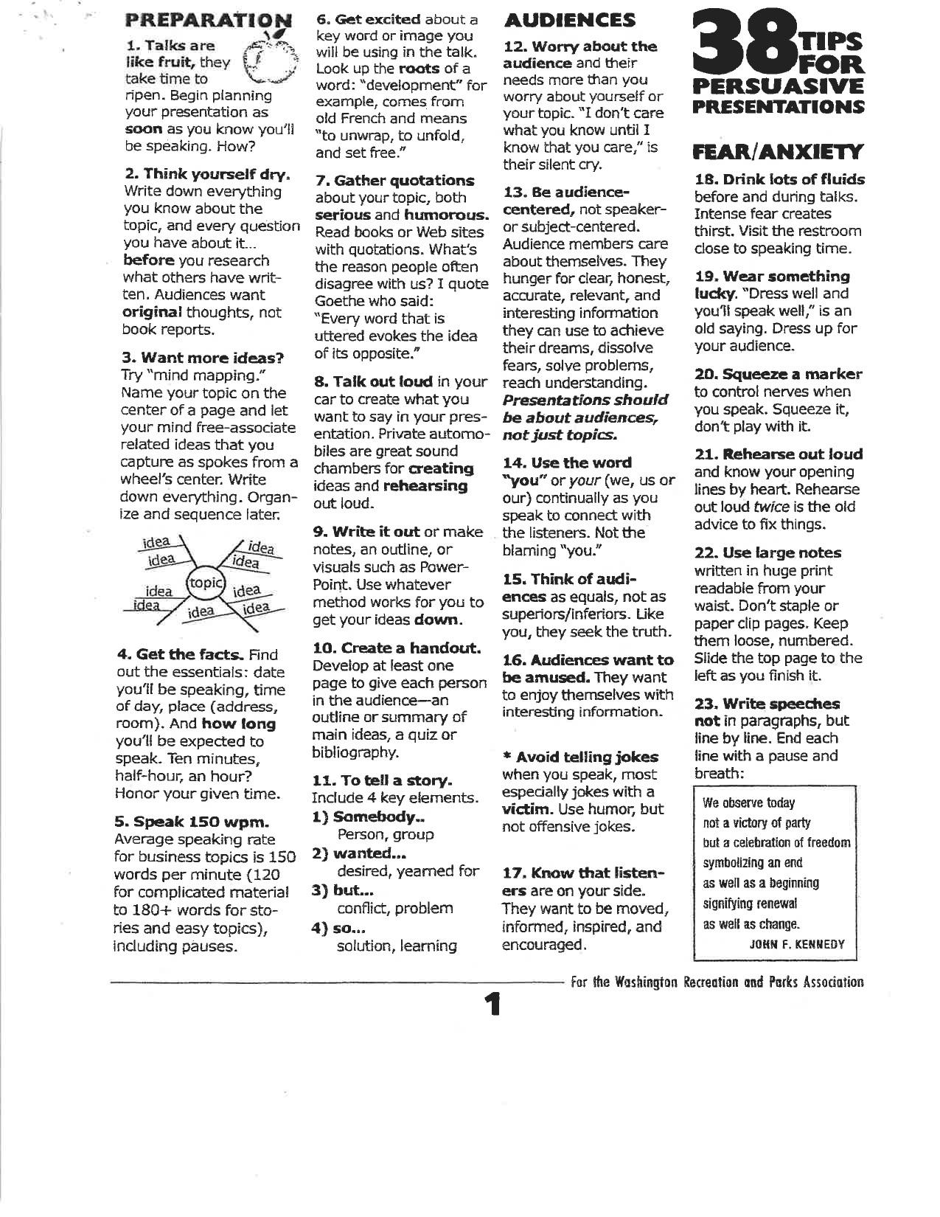
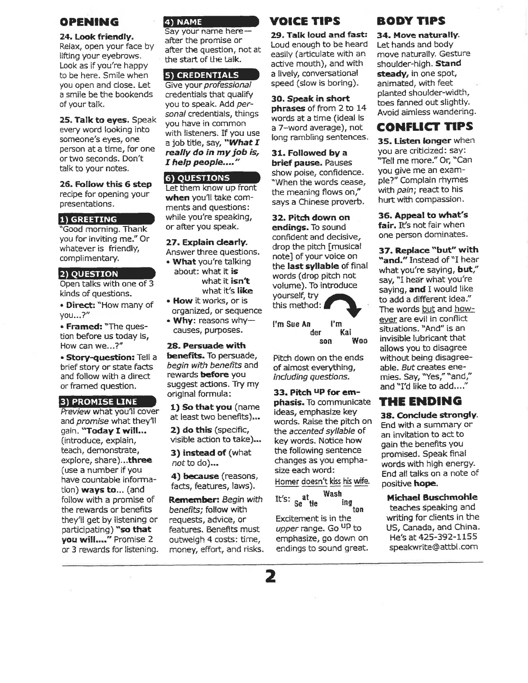

This handout was produced by Jefferson County (WA) 4-H and is an adapted consolidation of three WSU resources: “How to Make a 4-H Public Presentation” (WSU publication #EM4787), “4-H Public Presentations,” and “How to Give a Public Demonstration.”

