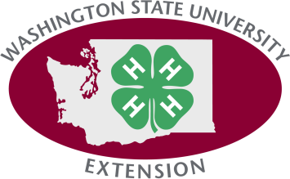
4-H Graduate Survey for the ____________________________ 4-H Club of Spokane County
To the best of your knowledge, please answer the following questions for the end of the 4-H year 2017. This information will help us further validate the value of the Washington State 4-H Program in our county.
Part I: How many of the former members of your 4-H club program were:
- “Graduates” or “Program Completers” in 2017: _________________ (total) That is, the total number of those 4-Hers in your club completing the 4-H program by receiving a high school diploma or GED and/or reached the age 19 (too old to be a 4-H’r)
Part II: Among your 4-H program completers, how many of them:
- Are now attending/enrolled in a post high school educational program* and are not working? _________________

- Are now attending/enrolled in a post high school educational program* and are working? _________________

- Have a full or part-time job and are not attending/enrolled in a post high school educational program? _________________

- Do not have a full or part-time job and are not attending/enrolled in a post high school educational program? _________________

- Have an unknown status (i.e., you just don’t know)? _________________

Thank you!

If you have questions about this survey please contact Gary Varrella at 509-435-3369 or at gvarrella@wsu.edu.
Remember: The total for questions B through F must equal the number you entered for the number of “graduates/program completers” in A.

*May include certificate programs, cosmetology/beauty school, military, vocational school, apprentice programs, community college, 4 year college or university, etc.
(9/20/17)

WSU Extension programs and employment are available to all without discrimination. Evidence of noncompliance may be reported through your local Extension office.

