2017 PATCH DESIGN CONTEST
Washington State 4-H Fair

Open to all Washington State 4-H members!

Help your State 4-H Fair Board, while expressing your own creativity!

Guidelines for entering:
- You must use an official entry form (available from your County Extension Office).
- The design must be in color.
- Patch design must contain the words “Washington State 4-H Fair” or “WA State 4-H Fair”
- You must include the year (2017).
- Design must include the 4-H clover.

***The winning patch design will be selected by members of the Washington State 4-H Fair Board, 4-H State Fair Manager, and a representative from the company who manufactures our patches***

***The creator of the winning patch design will receive a patch and a cash award.

General Rules:
- There is a limit of two entries per 4-H member
- Entrant must be a currently enrolled member (Grades K-12)
- Primary and Junior members may accept help from leaders, parents, or other club members, however, the “design concept” should be that of the member.

For more information, contact:
Tom Gwin, WA State 4-H Fair Manager
Phone: (253) 445-4630
Fax: (253) 445-4649
Email: tagwin@wsu.edu

OFFICIAL ENTRY FORM

2017 PATCH DESIGN CONTEST
WASHINGTON STATE 4-H FAIR

Name___________________________________________________________

Mailing Address___________________________________________________

City________________________________ State_______ Zip______________

Phone_________________________ Age_____ Grade_____ Year in 4-H_____

Use the outline below for your design. The design must be in color and include the following:
- A 4-H clover
- The words “Washington State 4-H Fair” or “WA State 4-H Fair”
- The year (2017)
We have included the patch outline and the border space around the edges. Please be sure to “color” in that area.

***ALL ENTRIES ARE DUE BY MAY 15, 2017***

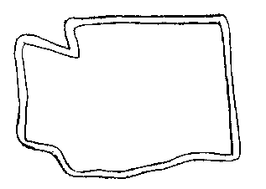

Send completed entries to:
Washington State 4-H Fair
Attn: Tom Gwin, Manager
WSU Puyallup
2606 W. Pioneer
Puyallup, WA 98371

