4-H Community Clubs – Come Join the Fun!

4-H Youth Development is the largest youth serving organization in the United States. 4-H is alive and well right here is Mason County! 4-H Community Clubs are the foundation of the 4-H program.
The 4-H club is where youth get the opportunity learn leadership skills such as decision making, communication, team work, problem solving, compromise, event planning, and follow-through. Youth members can serve in leadership positions such as President, Vice-President, Treasurer, Secretary, and other important leadership roles needed. Caring adult volunteer work with youth members in the 4-H club to achieve their goals. The sky is the limit on what a 4-H club can do!
Right here in Mason County, approximately 20 4-H clubs work on various projects that include horses, dogs, sewing, robotics, archery, leadership, forestry education, and more. The 4-H program is always looking to add new clubs.
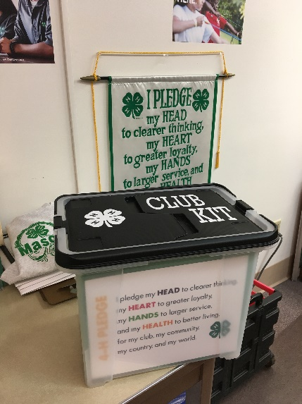
A new resource available to assist members and volunteers start a new 4-H club is here! The “4-H Club Starter Kit” is a resource that will help any dedicated volunteer have the resources and tools needed to start and operate a 4-H club. The kit includes sample activities, meeting agendas, promotional tools, curriculum guides, stickers, bracelets, and even a flag set! This kit is available to all interested people looking to start a 4-H club. If being a 4-H volunteer and starting a 4-H club interests you, please contact us!

For more information regarding the Mason County WSU Extension office call 360-427-9670 Ext. 680, or visit our website at http://mason.wsu.edu

Cooperating agencies: Washington State University U.S. Department of Agriculture, and Washington counties. Extension programs and employment are available to all without discrimination. Evidence of noncompliance may be reported through your local Extension office

