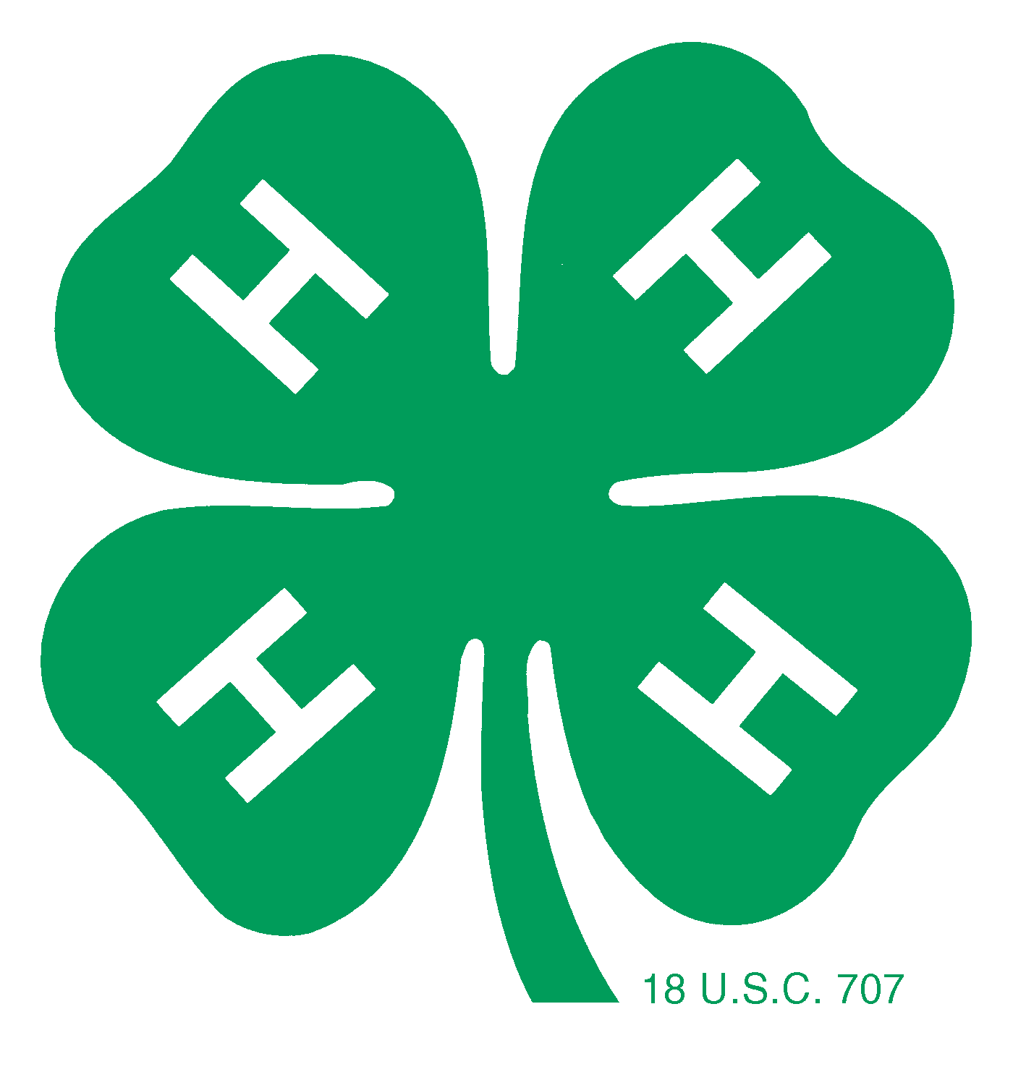KLICKITAT COUNTY ANNUAL 4-H AWARDS
4-H Record Book Judging

Awarded to All Ages | Awarded to All Ages
Ray E. Miller Award  Sponsored by the Miller Family  -All 4-H horse project members  -Based on sportsmanship, growth of project, humane treatment & safety  -Awarded once only  -Awarded a traveling trophy with the winner’s name & year and a keeper trophy  -Record book & interview required | Pioneer Surveying and Engineering Large Animal Award  Sponsored by Pioneer Surveying and Engineering  -4-H Member carrying large animal project  -project taken to one or more shows or fairs  -shows leadership and community service  -has participated in judging for species  -Can be won once  -Awarded a trophy and $25.00 scholarship  -Record book and interview required
4-H Spirit Award  In memory of George and Georgiana Gunkel  -All 4-H members. One girl and one boy recognized each year  -Active in 4-H, helpful to others and a good role model  -Chosen by Extension office staff with input from leaders  -Awarded an engraved wooden plaque with their name to keep  -Record book required, no interview required | The Power of Youth Award  Sponsored by Klickitat County PUD  -Awarded to the youth with the most community service or special community service project  -Award to be announced at 4-H Achievement Day  -Awarded an engraved wooden plaque with their name to keep  -Record book & interview required
Nina L. Miller Award  Sponsored by the Nina L Miller Family  -4-H Member  -Awarded to a 4-H Member who has overcome a difficult 4-H experience  -Awarded only once  -Awarded a traveling trophy with the winner’s name & year and a keeper trophy  -Record book & interview required | Still Life Award  Sponsored by Leader’s Council  -3 Still life projects  -shows outstanding achievement in projects  -One 4-H member  -May be awarded one time only in each age division  -Awarded $25 and a certificate  -Record book & interview required
Eagles Award  Sponsored by Eagles  -Leadership shown-not necessarily as a project  -Community service-not repetitive community service  -Record book with multiple projects showing growth and depth  -Awarded $20 to each 1 Junior, 2 Intermediates and 2 Seniors  -Can be won 1 time in each age bracket  -Record book & interview required | Small Animal Award  Sponsored by 4-H Leaders’ Council  -4-H Member carrying small animal project  -shows outstanding achievement in project  -demonstrates leadership and community service  -can be won once in each age division  -Awarded a trophy and $25  -Record book & Interview required
Primary Award | Primary Award
Primary Achievement  Sponsored by Tim and Anita Clever  -Medallion awarded to each primary age member turning in a record book  -Certificates to all Primaries that complete a record book  -Record book required, no interview required | Primary Accomplishment  Awarded by Spring Creek Ag/J. P. and Linda Enderby  -Monetary award and certificate awarded to each primary age member turning in a record book  -Record book required, no interview required
Junior Award | Junior Award
Quarter Moon Ranch Junior Achievement Award  Sponsored by Quarter Moon Ranch of Glenwood  -One boy and girl recognized each year  -Multiple projects (minimum of 3)  -Overall accomplishments  -Awarded only once with a trophy to keep  -Record book and interview required | Chisholm Surveying Junior Achievement Award  Sponsored by Stuart & Lauriellen Chisholm  -Can be won once  -One or more projects  -Overall accomplishments  -Trophy and $25  -Record book and interview required
Intermediate Award | Intermediate and Senior Award
Grace and Wallace Davis Memorial Award  Sponsored by the Trout Lake Grange  -All intermediate 4-H Members  -Based on leadership, depth of projects and/or multiple project achievements  -Awarded $25 each  -Record book and interview required | Elks Leadership Award  Sponsored by the BPOE #1868 of White Salmon  -Four 4-H Members awarded yearly  -Enrolled in a Leadership project  -Shows leadership accomplishments and activities  -Awarded only once in each age division, Intermediate and Senior  -Award is $25 each  -Record book and interview required
Senior Award | Senior Award
Danforth “I Dare You” Award  Sponsored by Randy & Penny Dyche  -All Senior 4-H members  -Based on depth of projects  -Making the most of the 4-H learning experience  -Awarded only once  -Awarded a “I Dare You” book  -An opportunity to attend their leadership camp in Michigan or Vermont  -May apply for a $400 camp scholarship  -Record book and interview required | Pomona Cup Award  Sponsored by East & West Pomona Grange  -One boy and one girl awarded yearly  -Senior 4-H members who have been awarded five project medals  -Based on overall 4-H career achievement  -Multiple projects with depth of involvement  -Awarded $25 and Pomona Cup trophy  -Record book and interview required

