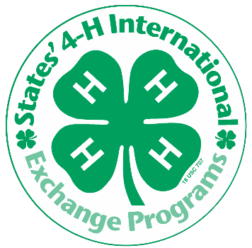
States’ 4-H International Exchange Programs
WA 4-H 2018 INBOUND PROGRAMS
Host a delegate in your home this summer and give your family a global perspective!

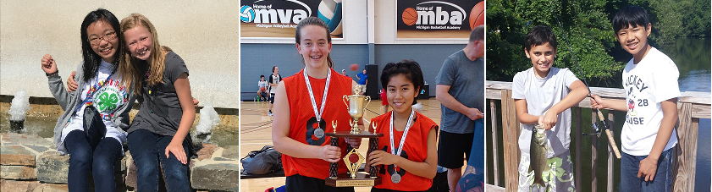

Host a Japanese, Korean, Finnish, or Costa Rican Youth in Summer 2018 through States’ 4-H International!
Invite an international youth into your home for four weeks and share an American experience. Expand your family’s cultural understanding, learn about new foods and customs, and possibly a new language all while sharing your own. Your children will build lifelong friendships and will gain new perspectives on their own country too!

Open your home to an exchange student and open your lives to the world!

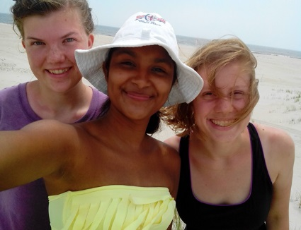
HOSTING PERIOD: 4 weeks from June to July for Costa Rica; and July to August for Japan and South Korea

• 12-18 years old or host an adult chaperone
• Youth have a range of English language abilities, host families should be prepared to communicate imaginatively

HOST FAMILY REQUIREMENTS

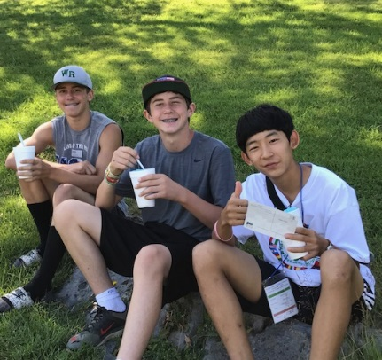
• You must have a child of the same gender and within 3 years of the hosted youth
• Families without children of the appropriate age may host an adult chaperone
• No special activities need to be planned, these youth want to experience American culture, make new friends, and improve their English by staying with your family
• Volunteer to participate in the program
• You don’t need to be involved with 4-H to host

For more information, visit
http://extension.wsu.edu/4h/youth/global-4-h/international-exchanges/
or contact us by email dianna.ullery@wsu.edu or by phone at 360-867-2153

Facebook Page https://www.facebook.com/wastates4Hexchange/ Instagram @states4hinternational

Please note: Host family selection is dependent on completion of an application and screening process as well as student availability and personality compatibility

